Blindata Release Note 3.8.9 

12 February 2008

Bug Fixes and Enhancements

2172. Invoice – Laser Printer

The selling price for stock items now displays to 3 decimal places.

2173. Bought In Purchase Orders

- This now only shows fabric description, not fabric code and fabric description.
- The valance size and return sizes now print when relevant.

2174. Works Order – Bespoke 17

The works order was showing the invoice address – it now shows the delivery address instead.

2176. Sales Lead / Fitters Sheet Full

The quantity no longer includes non blinds ie it does not include miscellaneous or carriage lines.

2177. Fitter Sheet / Sales Leads > General Diary Entry

The text in the details field is now wrapping round.

2178. Acknowledgement – Laser Print (Letterhead Logo)

- The addresses have been tidied up. There is now room to print the company name on one line, so it does not have to wrap round, and it should stay inside the rectangle.
- The horizontal lines between the total fields are now wide enough.

2179. Label Print – Bespoke 18

- This now prints the ‘Support type’ option.
- This now prints the ‘Blind Shape’ option, not ‘Shape’.

2180. Quotation – Bespoke 21

- ‘Inc packing’ was being chopped off.
- The margin has been moved in slightly.
- The detail line total was the base price + options. It is now the line nett price.
- The footer has been reduced slightly.
- ‘Page ..’ has been moved left slightly.
- There is a slightly bigger gap between ‘Our Ref’ and ‘Subject’ line.
- There is a slightly bigger gap after the title.

New Work and Customer Requests

818. Order Processing > Contact Management

The form has been tidied up significantly.

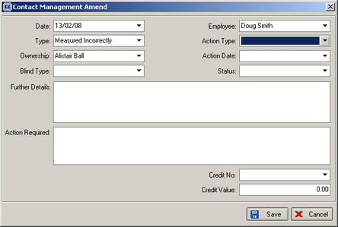

841. Order Processing > Orders > Bought In Detail Line Entry

It is possible for a customer to buy the same type of blind from more than one supplier. Previously a problem could arise where the wrong fabric is selected for the relevant supplier. Therefore we have created a new parameter in the blind type record called ‘Use Fabric Supplier’. If this is set to true, then the supplier from the fabric record is used as the bought in supplier. This supplier should already be set up in the Blind Type > Bought In Blinds form.

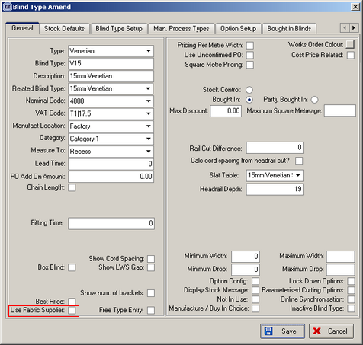

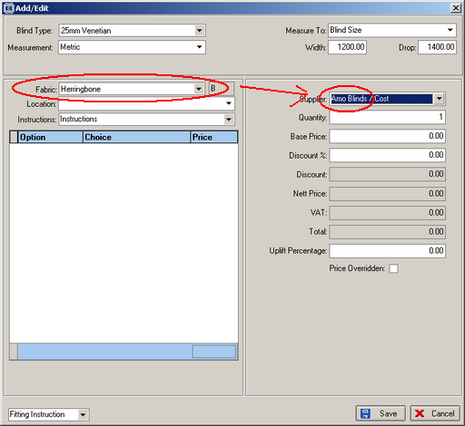

848. EDI Enquiry > EDI Import

The EDI Log now includes non-imported files.

873. Order Processing > Orders > Window Blind Amend Enquiry

We have included ‘Measure To’ as a column on this form.

874. Blind Details > Blind Types

For ‘vanes only’ blinds, there is a new flag called ‘Per Metre Pricing’. If this is set to true, the total vane length in a detail line will be multiplied by the fabric selling price to give the base price.

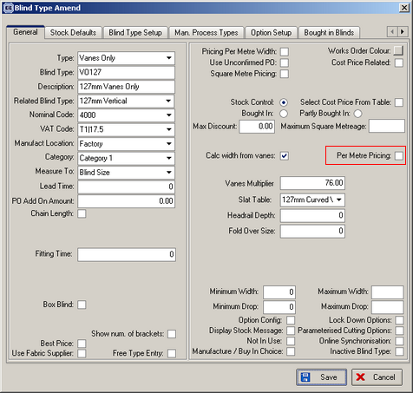

877. Bought In Purchase Orders (All)

If a pelmet size and return size has been entered, it now appears on the purchase order report.

898. Order Processing > Orders

It is now possible to email an invoice if order status = Invoice Printed. Previously it was only possible to email an invoice if the status = ‘Invoice Created’.

914. Stock Setup > Stock Items

We have included ‘To Be Discontinued’ ‘Calculator’, ‘Default Code’, ‘Stock in hand’, ‘On sales order’, and ‘On purchase order’ as field column choices on the stock enquiry form.

928. Invoice – Bespoke 22

A new invoice layout is available called ‘Invoice – Bespoke 22’.

