Blindata Release Note 3.8.8 

4 February 2008

Bug Fixes and Enhancements

2155. Blind Details > Blind Types

The ‘Duplicate’ button was not working properly. All link options are now being duplicated (they used to be). We also now duplicate Brackets, Cutting Options, Spare parts and Blind Type Weights.

2162. Export Order

The value now prints in the same way it does for the ‘Invoice for Customs’.

2163. Hardware Cutting Sheet

The shading now changes each time the tube diameter changes. This is not working properly at the moment.

2164. Invoice For Customs

We have removed ‘EXPORT INVOICE FOR’ from the title. It is no longer required as it is picked up from the text field in ‘Invoice by Area’.

2165. Order Processing > Quotations

The ‘Up’ and ‘Down’ buttons now work prior to saving a new quotation.

2167. Order Processing > Quotations > Technical Data Sheet

The weights shown on the totals page now include the weights multiplier and not just show the total of the weights entered in the blind weights tab in the blind types section.

2168. Packing List

The additional item quantity is now calculated as the number of blinds in the order multiplied by the multiplier, and then always rounded up to the next whole number.

For example, if the multiplier is 0.01 and you have 1-10 blinds, the additional quantity = 1 item, 2-20 = 2 or if you put a multiplier of 0.6 it will show 2 items if 2 blinds are entered.

2169. Box Assembly Instructions

- The title now only says ‘Blind Box Assembly Instructions’.
- The details now print in increasing cassette type order with shading to change between cassette types.

2170. Spare Parts List

The title now says ‘Spare Parts List’.

2171. Item Listing

The title of this report now says ‘Blind Item Listing’.

New Work and Customer Requests

883. Order Processing > Quotations / Orders

We have made a couple of significant changes to the way the quotation detail lines are displayed, concerning quotation text lines and free type blind types.

- If a ‘Quotation Text’ line is entered as a detail line, the ‘Lookup Type’ instead of the blind type description is displayed.
- If a blind type is a free type, the free type entry instead of the blind type description is displayed.
- If the blind type is a free type, the fabric free type entry here instead of the fabric description is displayed.

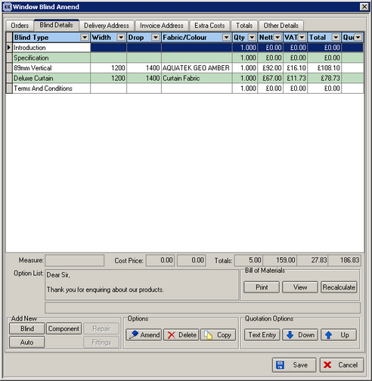

910. Order Processing > Orders > Valance Calculation

If blind type field ‘box blind’ = true, and ‘Uncut’ is selected for option Valance Type, the valance length now defaults to the maximum valance length available for that blind type. The maximum valance length is held in the ‘Box Blind Minimum Width’ table.

913. Order Processing > Quotations

There is now a function to put a quotation on hold. If a quotation is on hold, it is not possible to print it out, email it or convert it to an order.

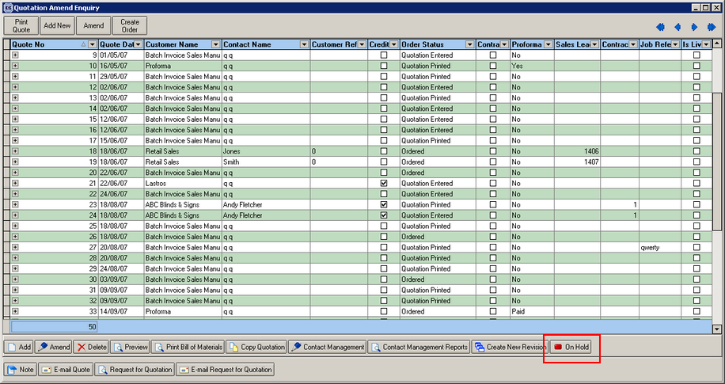

We also have a history record to show that it has been put on hold and taken off hold.

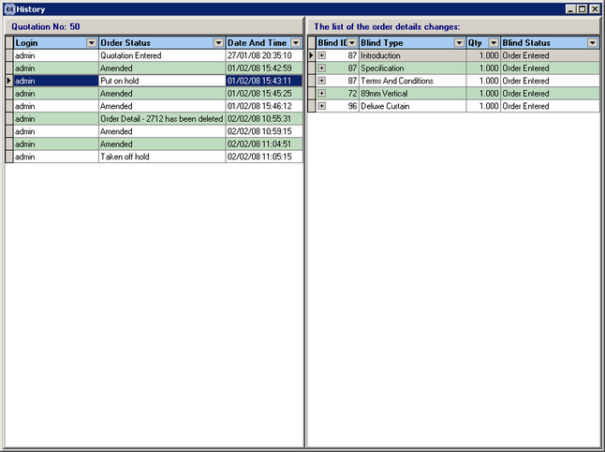

916. Order Processing > Quotations > Contact Management

We now display telephone number, mobile number and email in the title of the contact management form.

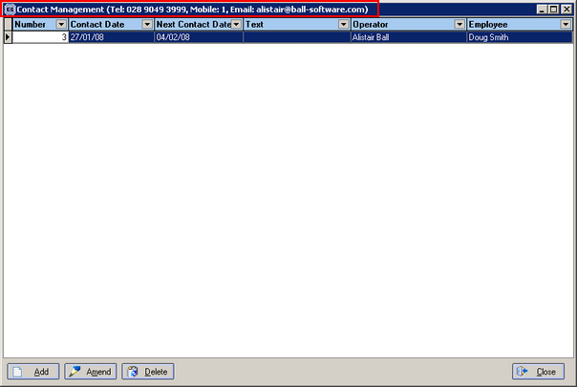

917. Order Processing > Quotations

We now hold an extra uplift percentage in the totals tab. This is to allow for discount being given to contractors. When a quotation is printed, it will add this percentage to all the detail lines. The field is called ‘Contractor Discount’, and has replaced ‘VAT %’, which is not required in the Totals tab.

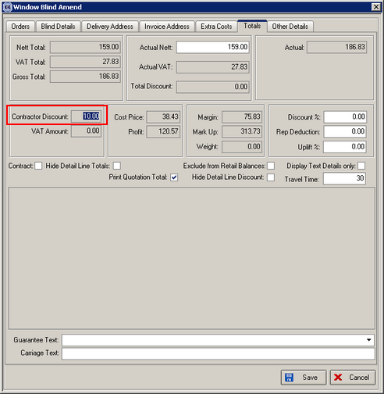

The purpose of this to allow a contractor to make some money on the order. For example, if the customer says to the contractor that the value of an order is £100 + VAT, the contractor has to hand the quotation/order to their actual customer. The contractor may want to make some money themselves so will tell the user to add 10% onto the price. The contractor will then show the quotation/order to their customer for £110 + VAT. But the actual value of the invoice from the Blindata user to the contractor will still be £100 + VAT.

At the moment the contractor discount calculation has only been put into ‘Quotation – Bespoke 16’. It will be added to other quotation prints on request.

919. Quotations > Request for Quotation

The following changes have been made.

- The logo to go where company name previously was.
- Fax number is now on the report
- Removed cost column on report and also total price.
- Added the notes field to the report

921. Site Survey Sheet

There is a new report called ‘Site Survey Sheet’, based on the ‘Sales Lead Sheet Individual’. The following changes were made.

- The title says ‘Site Survey Sheet’.
- The department company name and address appear at the top if the department filter is switched on..
- Mobile No has been moved left to underneath customer telephone number.
- The price column has been removed and the ‘Other’ column made wider.
- Totals are not printed.

922. Fitters Worksheet

We have made some changes to this report.

- Carriage lines no longer print on this report.
- The totals are often not required. We have created a new report parameter called ‘Totals on Fitters Worksheet’ which defaults to true.
- We have created an option to group blinds by blind type and fabric and show the quantity. Again, this is a parameter called ‘Group Fitters Worksheet detail lines’ and defaults to false. If true, width, drop and options do not print.

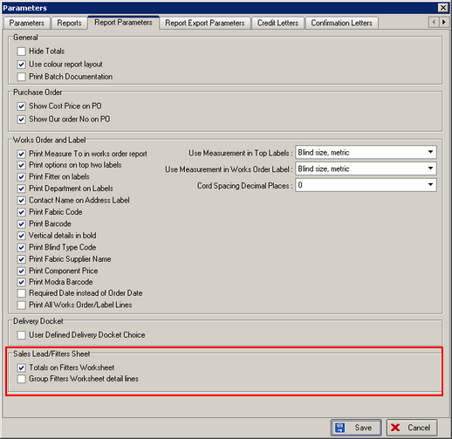

923. Box Assembly Instructions

The guarantee text prints out here, centred. The extra box assembly instructions can be held in Administration > System Tables > Guarantee. In the order, the guarantee text can be selected in the totals tab.

924. Invoice for Customs / Invoice for Payment

For one customer, we can now print one of each of these reports. Previously we only printed one or the other. The report is dependent on area, so for one area, there should only be one report and it should be called ‘Invoice for Payment’. For another area two invoices should print – one called ‘Invoice for Customs’ and one called ‘Invoice for Payment’. The area will appear in brackets after this.

We have achieved this by creating another system table called ‘Invoices by Area’. The table contains area and text. This is then looked at when printing the invoice, and the number of copies will depend on the number of records for the area in the table.

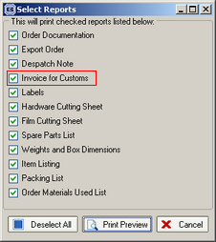

925. Invoice - Bespoke 17

We have added a new field in the customer record called ‘Customer add Ref’. This can be found in the ‘Order Defaults’ tab. If it is filled, then it will be used as the account reference on ‘Invoice – Bespoke 17’.

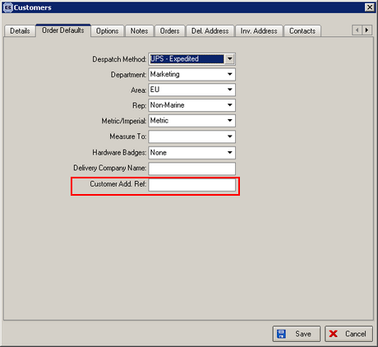

926. Fitters Sheet / Sales Lead > Sales Lead Enquiry

There is now an option to ‘Copy to Clipboard’ on the context menu of the sales lead enquiry form (right click on form to see context menu).

927. Film Cutting Sheet

The column heading ‘Blind Shape’ now says ‘Shape’.

