Blindata Release Note 3.8.7 

28 January 2007

Bug Fixes and Enhancements

2146. Order Processing > Quotations

The ‘Set Filter’ now has the following choices.

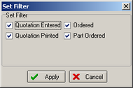

2147. Order Processing > Quotations

- When amending quotation notes, option list was not being refreshed on window blind form.
- Also, if the quotation group was changed, it was not refreshed on the form.

These are both fixed.

2148. Order Processing > Quotations

If you entered a roller blind with a fabric with square metre pricing = true, it was not working out the cost prices properly. All the bill of materials had their quantities based on square metreage, when it should look at the calculator set up against the respective item. Fixed.

2149. Order Processing > Orders / Quotations

After entering a free type blind type, it is now possible to tab out of the free type field and the fabric free type field.

2150. Order Processing > Orders

If an order has a status ‘Part Posted’, it is now possible to print the invoice. This was a temporary bug.

2151. Order Processing > Quotations

There is an issue if ‘Use Quotation Revision’ is switched on. If the first quote is flagged as an estimate then you no matter what you do with a revision you can't convert to an order unless you amend the first quote so it is not an estimate. The system has been designed this way.

2152. Sales Lead / Fitters Sheet Full

The ‘Comments’ text was overlapping. Fixed.

2153. Order Processing > Quotations

If an email address was over 30 characters long, it would not go through to Outlook properly when an email quotation is sent. Fixed.

2154. Label Print – 3 ½ x 2

‘Fabric’ has been moved to the right slightly as the ‘F’ was being cut off by the left hand printer margin.

2156. Quotation – Bespoke 21

Carriage is no longer printed out in the detail line. It is already mentioned above the detail lines in the totals.

2157. Hardware Cutting Sheet

The report is now sorted by ‘Tube Diam’ size, not ‘Roll Tube’ size.

2158. Export Order

‘Thrirty’ is now spelt ‘Thirty’.

2159. Spare Parts List

There is now a space between the brackets and the text.

2160. Packing List

In the ‘Additional Items’ box items only appear if we put > 0 in the quantity field in Blind Details > Blind Types > Spare Parts.

New Work and Customer Requests

847. EDI Enquiry > EDI Import

When an order is imported, previously the detail lines were flagged as out of stock if there was a stock shortage. There is now a parameter in Administration > Parameters > EDI called ‘Check Stock at EDI Import Create Order Stage?’. If this is set to true, stock should be checked and OOS updated if necessary. If it is set to No, OOS will not be updated at all.

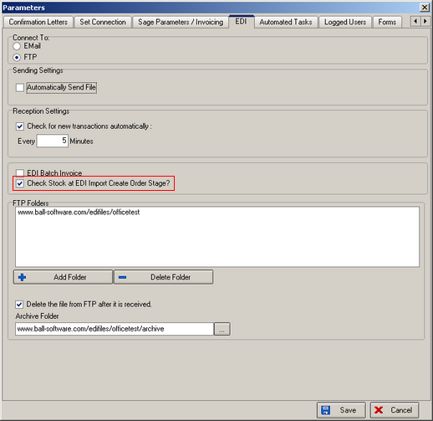

876. Order Processing > Orders

We now have the quotation number as a column choice in the order amend enquiry form.

879. Order Processing > Quotations

After a new quotation has been created, it is now possible to create a quotation contact record automatically. This sets the next contact date to the default.

Not all customers will want this, so we have added a new parameter in Administration > Parameters called ‘Auto Create Quotation Contact Record’. This defaults to false.

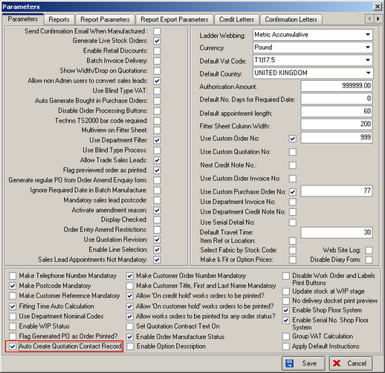

If it is set to true, then when a quotation is saved for the first time, the following form will be automatically displayed with a new contact record in it.

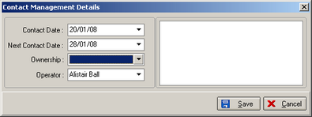

880. Reports > System Reports > Next Quotation Contact

There is now a choice to print this report by employee.

881. Reports > System Reports > Last Quotation Contact Report

A new report has been created. This is the same as the contact management report, but has only last contact record text, and also nett value and telephone number.

888. Purchase Order Enquiry

The email button now appears on the purchase order enquiry form.

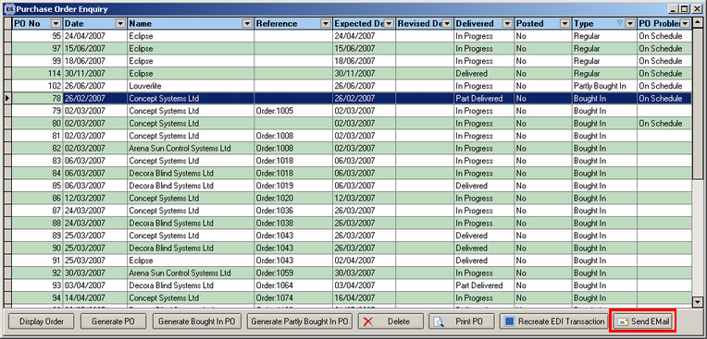

900. Order Processing > Orders > Email PO

There is now a button to email PO from this form. This will only work if there is a purchase order attached to a sales order.

903. EDI / Online Discount

We have introduced discounts for customers that place orders online or come through EDI. This discount is by blind type and is cumulative. For example, if a customer already gets 10% discount for roller blinds, but also gets 2% discount for the order coming via online or EDI, the discount for that order will be 12%. If the same customer sends an order in by another method, the discount will only be the normal 10%.

We have created another discount table that holds id, customer id, blind type id, and discount %. This is held in Pricing > EDI / Online Discounts, which is a new menu option, below the existing Discounts option.

This EDI / online discount only applies when entering the online discount (the customer should be able to see it) or when the order is imported via EDI. But if an order is entered normally using the order entry program, this discount will not apply.

It works for EDI mode only in this version.

915. Order Processing > Quotations

‘Don’t Follow Up’ is now on the column list in the quotation amend enquiry form.

