Blindata Release Note 3.8.6 

18 January 2007

Bug Fixes and Enhancements

2050. Stock Setup > Type of Roller (Low Priority)

This menu option is no longer used and has been replaced by ‘Auto stock codes’.

2134. Consolidated Delivery

In the drop down list in Consolidated Delivery, it was showing employees that are ticked as “Is Service”. The drop down list is now showing Employees ticked that are “Is Despatch”.

2135. Order Processing > Fitters Sheet / Diary

If an appointment is dragged across to the calendar, a check was not being made to see if there was a time conflict. This could have happened for any type of appointment. Fixed.

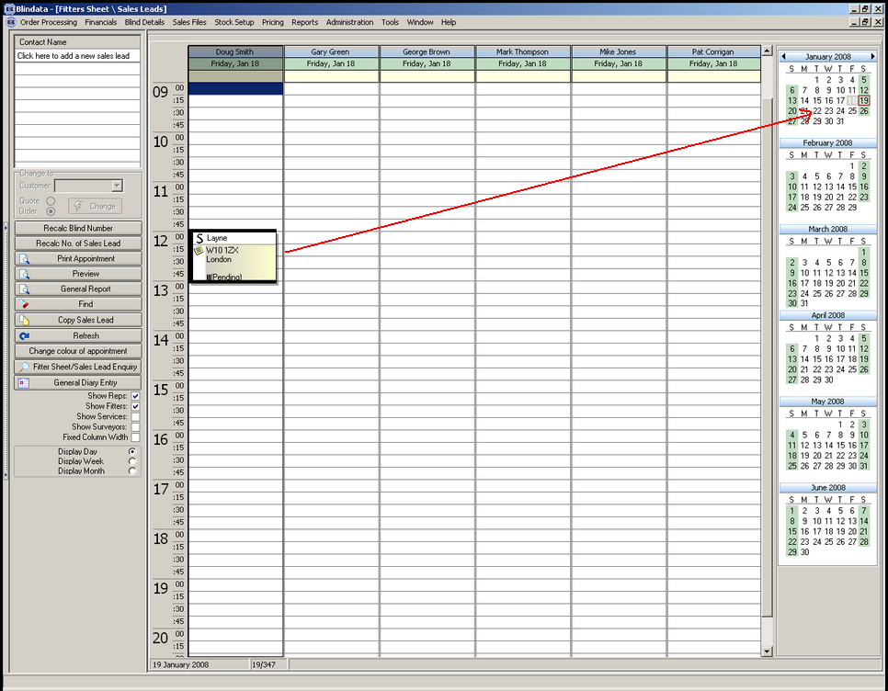

2136. Order Processing > Fitters Sheet / Diary

The company type and title fields have been swapped round.

2137. Blind Details > Blind Types

An error message was appearing when you try to save a blind type record. Fixed.

2139. Order Processing > Orders

If an order was amended, sometimes it was losing the discount that has been calculated for a detail line in the order. This was caused because the discount date was being checked against the current date and not the order date. Fixed.

2140. Order Processing > Orders

Sometimes the number of slats was not being stored properly for a wood blind. Fixed.

2142. Financials > Create Invoices

The department was only enabled if ‘Use Department Invoice No’ was switched on in Administration > Parameters. The department is now enabled regardless of the parameter setting.

2143. Works Order – Bespoke 17

Special instructions now print on this report.

2144. Order Processing > Orders

If you entered a pleated blind and selected a certain fabric, the no of pleats calculates correctly. However if you then amended the order and changed the fabric to a fabric that uses a different pleat table, the no of pleats did not update on the bill of materials. Fixed.

2145. Quotation – Bespoke 16

- The footer should only appear on the last page of the quotation. The whole footer should be moved down slightly.

New Work and Customer Requests

861. Order Processing > Fitters Sheet / Sales Leads

It is now possible to print a sales lead from the sales lead enquiry form before the appointment is made. The three buttons highlighted below are now enabled if the status of the sales lead = Entered. In the reports the appointment time will be blank.

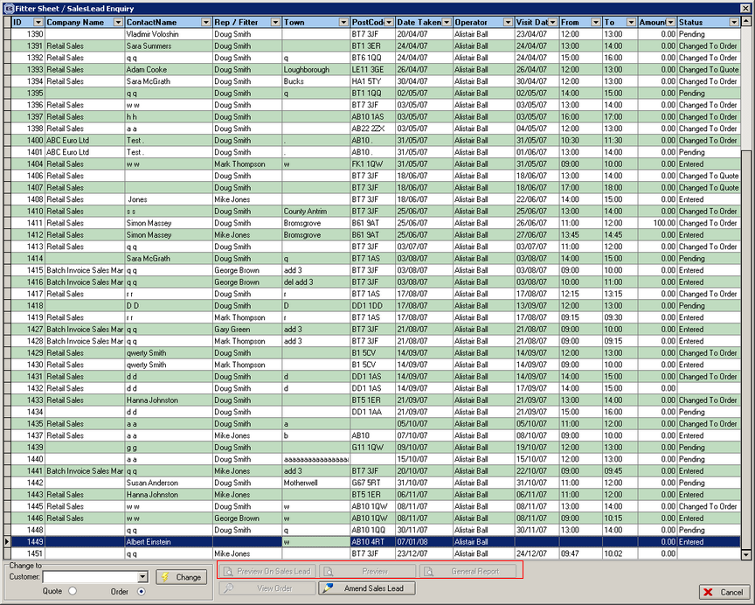

862. Order Processing > Fitters Sheet / Sales Leads

It is now possible to email the sales lead appointment report (Sales Lead Bespoke 19) to the rep from the sales lead enquiry form as a pdf. There is a new button on the form called ‘Email to Rep’.

The email address is picked up by holding the operator identity against the rep in Administration > Employees.

863. Order Processing > Fitters Sheet / Sales Leads

There is a new table called ‘Company Type’. This is held in System tables and has an id and a Description field. It is now possible to record a company type against the sales lead but it is not mandatory.

864. Order Processing > Fitters Sheet / Sales Leads

It is now possible to select columns on the ‘Sales Lead Enquiry’ forms, in the same style as columns can be selected in other forms (right click, and select ‘Columns’ from the menu). We have added a number of fields, including address fields, and these can now be configured and saved.

865. Order Processing > Fitters Sheet / Sales Leads

The sales lead enquiry form can now replace the diary form when going into this menu option. This is a new parameter in Administration > Parameters called ‘Disable Diary Form’ and this defaults to false. If set to true, the diary form will be replaced by the ‘Sales Lead Enquiry’ form.

866. Order Processing > Fitters Sheet / Sales Leads

If you select a sales lead that has a status = Entered and then convert it to an order, the sales lead number is now copied across to the order. This already happened if the sales lead is converted to an order from the diary form.

867. Order Processing > Orders

In Extra Costs, the focus now goes to ‘Add’ when you go into this form.

868. Order Processing > Orders

The WIP button now appears on the order amend enquiry form if ‘WIP Status’ is enabled in Administration > Parameters.

There is also a new advanced permission for this new button in Administration > Users > Advanced Permissions.

869. Order Processing > Orders

We have removed the ‘On Hold’ button from the order amend enquiry form.

870. Acknowledgement – Bespoke 19

A new order acknowledgement report has been created.

871. Invoice – Bespoke 19

A new invoice report has been created.

889. Reports > Sales Analysis > Sales Analysis by Customer (Credit Notes)

There is a new sales analysis report indicating the value of credits issued, defined by department, customer and date. This looks exactly like the ‘Sales Analysis by Customer’ report, except the report title is ‘Sales Analysis by Customer (Credit Notes) and the column heading is ‘Nett Credit’. It looks at credit notes between a start and end date and has all other criteria the same as all the other sales analysis reports.

890. Invoice – Bespoke 2

we have incorporated www.Acmeblinds.com on the invoice below the tel and fax number (these have been moved up slightly. The line says ‘Website: www.acmeblinds.com’ (the website address is taken from the department record.

891. Quotation – Bespoke 16 (Email)

We have made this quotation layout available in Administration > Parameters > Report Export Parameters > PDF Quotation.

892. Order Processing > Orders > Auto Detail Entry

We have new functionality available so a blind can be entered just by entering a stock code. The following work has been done.

- A new table has been created called Auto Stock. This hold an id, a stock code, blind type id, fabric id, width and drop. There is a menu option for this in Stock Setup > Stock Items called ‘Auto Stock Codes’. It has replace the ‘Type of Roller’ menu option, which is no longer required. (See bug 2050). The form is a grid form and shows ‘Auto Stock Code’ (16 characters max), blind type description, fabric description, width (mm), drop (mm).
- In the window blind amend form, there is a new button called ‘Auto’.

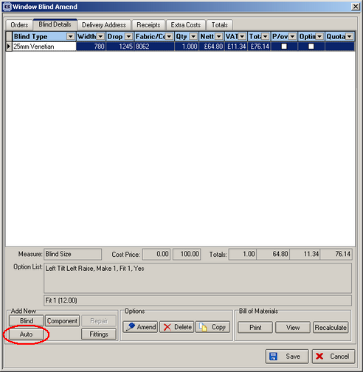

- When this button is clicked, the user is asked to select an auto stock code from a drop down list of auto stock codes in the ‘Auto Stock Codes’ table. When a code is selected, the window blind amend form will be displayed and the blind type, Measurement (will always be metric), Measure To (default to Blind Size (from customer record)), width, drop and fabric description will already be filled and the price will have been found, the options displayed and the bill of materials calculated.
- This auto stock code also appears on ‘Delivery Docket – Laser print (Special)’ if it has been used, and replace the stock code that is there.
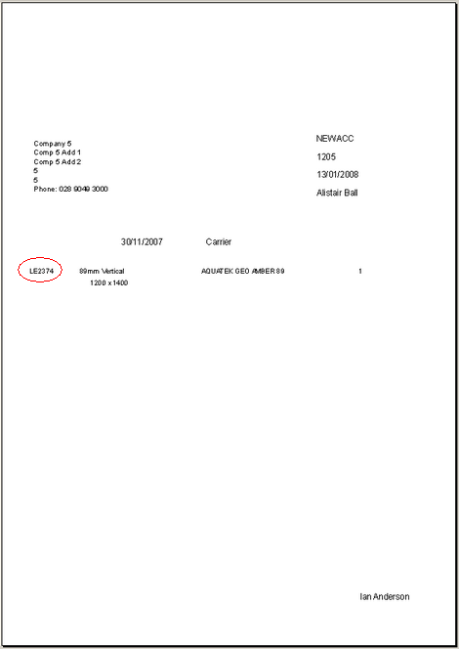

- The auto stock code also appears on ‘Despatch Label 4 x 2’, if it has been used.

893. Sales Files > Customers

There is a new field in the customer record called ‘Delivery Company Name’. This is displayed on the ‘Order Defaults’ tab. If it is null, the order entry program behaves as it currently does ie the company name is put into the ‘Delivery Company Name’ in the order entry form. If the ‘Delivery Company Name’ is not null in the customer record, then it is put into the ‘Delivery Company Name’ in the order entry form.

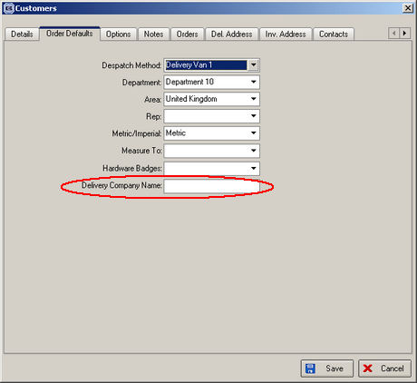

896. Works Order – Label 1

The return size now prints on this report if ‘Enter Valance Size’ = true in the blind type record.

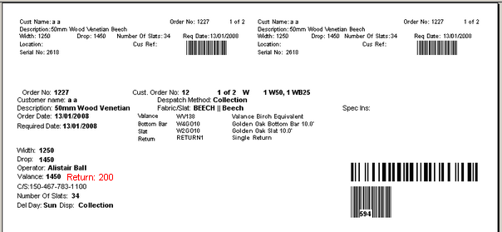

909. Quotation – Bespoke 16

We have added the following fields to the bottom of this quotation.

- Company Details > Logos > Logo2
- Company Details > Logos > Logo3
- Company Details > Company Name, Address
- Company Details > Telephone Number
- Company Details > Fax Number
- Company Details > Url
- Company Details > Registered Office > Registered office
- Company Details > Directors > Directors (Job Title)
- Company Details > Registered Office > Address

