Blindata Release Note 3.7.8 

16 November 2007

Bug Fixes and Enhancements

2019. Delivery Docket - Laser Print (Letterhead Logo)

The logo is now printing in proportion.

2020. Financials > Post Invoices to Sage > Update Ledgers Report

- The date column is now headed ‘Invoice Date’, not ‘Date’.
- The date column shows the invoice date, not the order date.

2021. Financials > Invoice Print and Post

The Create EDI Invoices button was including zero value invoices. This has been changed to exclude zero value invoices.

2023. Order Processing > Archive Enquiry

The Net Total was showing as zero for all the records. Fixed.

2024. Order Processing > Order Entry

This bug only occurred if the Customer Order No is set to mandatory in Administration > Parameters. If you added a new order and selected a customer, went to the Blind Details tab and tried to add a new blind and a warning message appears stating the Customer Order No is mandatory. Eventually the following error message appeared. Fixed.

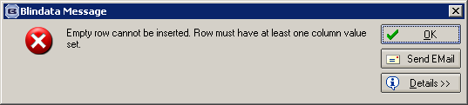

2026. Order Processing > Quotations

If a quotation was entered for a proforma customer and the quotation is then paid and converted to an order, if you then amended the order and saved it could possibly be put on Credit Hold. This no longer happens as it has been paid already.

2027. Order Processing > Orders

There is now an option to select the original order for a remake or a repair so they are linked and can be reported on. The drop down list did not include invoiced orders for that customer. This has been corrected.

2028. EDI Import

An error message appeared if you imported a record with a ‘DelFirstName’ of > 30 characters into the ‘first_name’ field in the Address table. We have split this field ‘DelFirstName’ over the ‘first_name’ and ‘last_name’ in the Address record.

2029. Hardware Cutting Sheet

- The ‘Item No’ column number is now left justified.
- If the bottom rail calculation = 0, then it is blank. Also, the measure to deduction is now done (as it was for width).
- If the bead chain calculation = 0, then it is blank.
- If ‘Inner Chann’ or ‘Outer Chann’ = 0, then the field (including 2 x) is now blank.

2030. Film Cutting Sheet

- The item number column is now left justified.
- The detail lines are now printed in fabric description order.

2031. Item Listing

- The item number column is now left justified.
- The ‘Blind Shape’ column has been moved to the left a bit.

2032. Invoice For Customs

- If this is printed from the ‘Print Order’ button, it now say ‘CUSTOMS’ instead of ‘PAYMENT’.
- This delivery address has been moved slightly to the right to allow more room for the address. Also, instead of ‘Contact Name’, it now says ‘Contact’ beside both contact names and this now leaves more space for addresses.

2033. Weights and Box Dimensions

The detail lines now print in decreasing size of cassette size.

New Work and Customer Requests

813. Administration > Export Data > Key Performance Indicators

We can now export sales lead and sales analysis to a spreadsheet. There is a new option in Administration > Export Data with a start date and an end date.

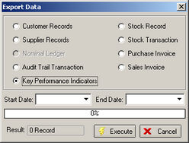

The following information is exported.

Sales Leads
Sales Analysis by Blind Type
Sales Analysis by Customer
Sales Analysis by Rep

821. Works Order – Bespoke 15

We have amended the heading on this report. The blind type setup free type field is now displayed on the works order header and we have removed the logo.

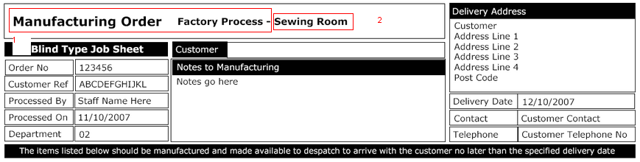

The above replaces the previous layout. ‘Manufacturing Order Factory process –‘ is hardcoded. ‘Sewing Room’ is taken from ‘Blind Type > Free Type’ in the Blind type Setup tab. We have a new system table to maintain these records in Administration > system Tables > Free Type..

We have put a bar code for the blind on right hand side of detail line (if parameter for bar code is on).

824. Component Discount % by Category

It is now possible to calculate component discount % by category when entering a component detail line. There is also a start date and end date for when these discounts apply.

We have created a new discount table by category code for component sales. The table contain id, category code id, discount %, start date and end date. This table will be accessed in Component Detail Entry and will use the discount %, if found, for the category code that is held against the stock item that has been selected. The new form for this is in Pricing below ‘Component Price Table’.

828. Blind Details > Blind Types > Cutting Options

We are now able to enter a width or drop add on and a width (or drop) multiplier together on a line and then the program will calculate the cutting size by (width + width add on default) * width multiplier.

