Blindata Release Note 3.7.7 

13 November 2007

Bug Fixes and Enhancements

2004. Pricing > Option Price Enquiry

The option Selected Price Uplift was uplifting all records that are visible on this form regardless of which one was highlighted. It now only uplifts the prices in the record you are pointing at.

2005. Standard Fitters Worksheet

We have altered this report to allow up to 6 detail lines to print on it.

2006. Order Processing > Orders > Vanes Only Entry

If you entered a blind type with blind identifier = vanes only (and ‘Calc Width from Vanes’ = true) the number of vanes was saved properly after you have entered it and the rest of the detail line. However if you went back into the detail line and amended the fabric, the number of vanes reverted to zero. Fixed.

2007. Quotation – Laser Print (Letterhead)

If ‘Display Text Details Only’ is set to true in a quotation, the detail line column header text no longer prints.

2008. Bill of Materials

The stock in hand figure now only display to 2 decimal places.

2009. Order Processing > Orders

If the roll width of a fabric exceeded by the width of a blind and the calculator = Width, it should be possible to make this blind with a join, but a message appeared to stop this. This has been fixed and a warning message appears, but the blind can be made.

2010. Film Cutting Sheet

If a bottom width is entered in a blind detail line and Measure To = Recess and there is a width add On of -6 set up, this is now applied to the bottom width on the report (ie 6mm deducted from bottom width).

If the bottom width is not entered in the order detail entry, then the bottom width on the film cutting sheet is now blank. LH Offset and RH Offset are also be blank in this case.

2011. Email Quotation

When you emailed quotes the system stored ‘Quotation Printed’ in the history record. This has been changed so it says ‘Quotation Emailed’.

2012. Film Cutting Sheet

Previously the ‘bottom width’ on the report is what is entered in the order detail line in the bottom width field. We have changed this column to say ‘Fabric Bottom Width’, and the report will then pick up a cutting size called ‘Fabric Bottom Width’.

2013. Packing List

This now says ‘LOCAL’, not ‘LICAL’.

2014. Fitters Sheet / Sales Lead

The number of blinds figure in the appointment for fitting was being calculated incorrectly. It was only counting the number of detail lines, when it should have been counting the sum of the quantity in the detail lines.

2015. Order Processing > Orders > Add Order

An error occurred if you did not enter a customer or account code in order entry, but entered something in the address. It is no longer possible to do this.

2016. Order Processing > Order Enquiry

In the ‘Deliver Scan’ routine, the message now says ‘This order does not exist!’.

2017. Order Processing > Order Enquiry > Despatch Order Scan

We made a change (screenshot below) to the despatch functionality because of a problem that existed when printing delivery dockets then labels. (The problem was that the delivery docket was printing to the label page size sometimes). We now use the same functionality as was previously used for the standard ‘Deliver’.

New Work and Customer Requests

625. Reports > Sales Analysis

We now have two new reports:

Sales Analysis by Customer Class by Customer
Sales Analysis by Order Source by Customer
These have the same layouts as ‘Sales Analysis by Area by Customer’.

718. Order Processing > Orders

We are now able to colour code fields on the order amend enquiry form. In the screenshot below, you can see how this might look.

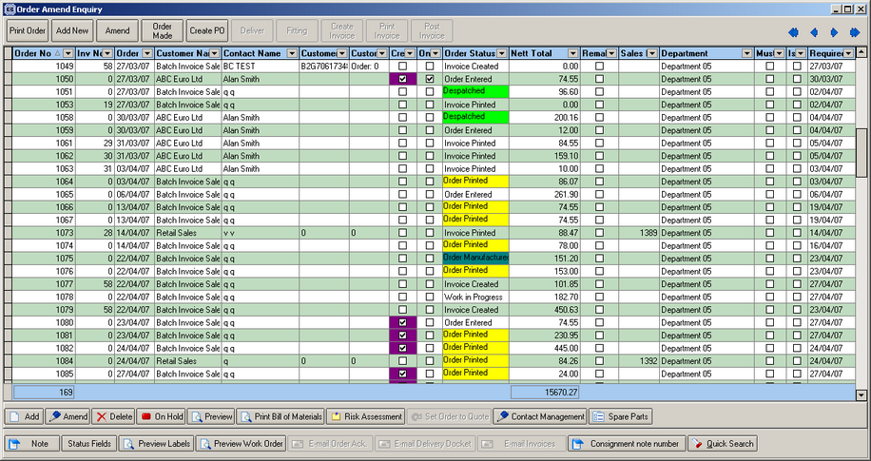

This is done by altering new parameters in Administration > Parameters under a new tab called ‘Forms’. There is a colour choices for all status fields, for orders on credit hold, on customer hold, must go, quality control and remake.

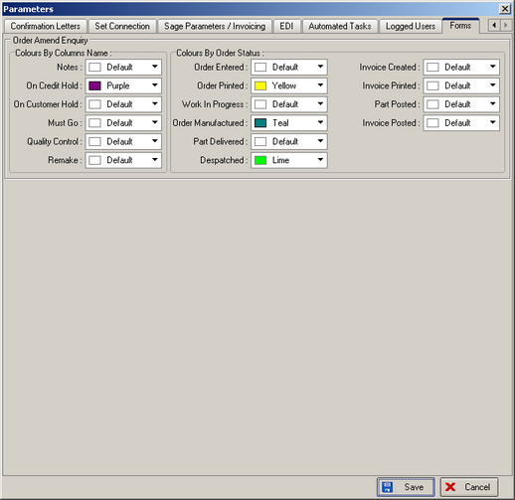

817. Credit Note – Bespoke 20

A new credit note has been created called ‘Credit Note – Bespoke 20’. It has the same layout as ‘Invoice – Bespoke 20’, but is a credit note.

820. Order Processing > Orders

There is now an option for ‘Hide Detail Line Discount’ on order entry totals tab (it had already been done for quotations).

