Blindata Release Note 3.6.8 

10 September 2007

Bug Fixes and Enhancements

1910. Financials > Invoice Print and Post > EDI Invoice Create

The text now says ‘This file already exists. Do you want to recreate it?’

1911. Invoice – Bespoke 8

The address has been moved slightly so it will appear in a window envelope properly. It has been moved 15mm to the right and 10mm up.

1912. Invoice – Laser Print (Letterhead Logo)

The unit price was including the option price. The top line now shows the base price and the bottom line the option price.

1913. Invoice – Laser Print (Letterhead Logo)

If ‘Hide Detail Line totals’ is true, the option prices no longer print.

1914. Quotation Prints

If the new parameter ‘Hide Detail Line Discount’ is true, then the base price and option price (see 1 in screenshot) figures now also do not print.

1915. Quotation – Bespoke 17

The company address is now taken from the department record. The same rule applies to ‘Delivery Docket – Bespoke 17’ and ‘Invoice – Bespoke 17’.

New Work and Customer Requests

714. Sage Companies by Department

It is now possible to update different Sage companies according to the department that is set up for a customer. Therefore we now hold the Sage data location against the department record. If this is left blank, then the Sage data location in Administration > Parameters is used as normal.

There is also a new field in this table to store a logo.

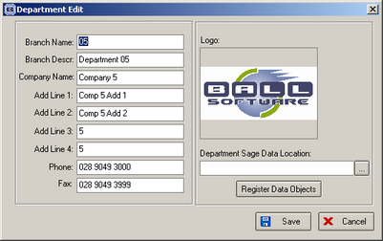

719. New Works Order

This is called ‘Works Order – Bespoke 17’.

720. New Quotation

This is called ‘Quotation – Bespoke 17’.

This uses the company name, address and logo from Administration > System Tables > Departments.

721. New Delivery Docket

This is called ‘Delivery Docket – Bespoke 17’ and prints onto A4.

722. New Invoice

This is called ‘Invoice – Bespoke 17’.

Logo and company details are from Administration > System Tables > Departments.

723. Quotation Entry

In the totals tab we now have another field to indicate whether discount % and discount amount should print or not. It is called ‘Hide Detail Line Discount’.

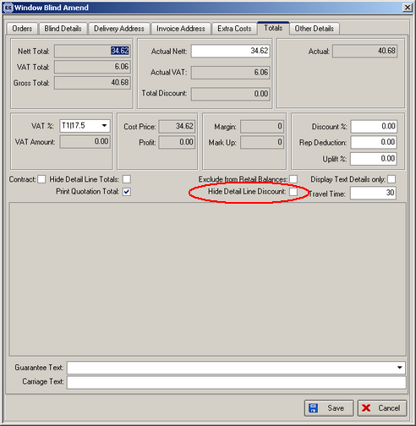

There is now a choice for estimate as well as ‘Quotation’. The only difference is in the name – and what gets printed on the Quotation (or Estimate).
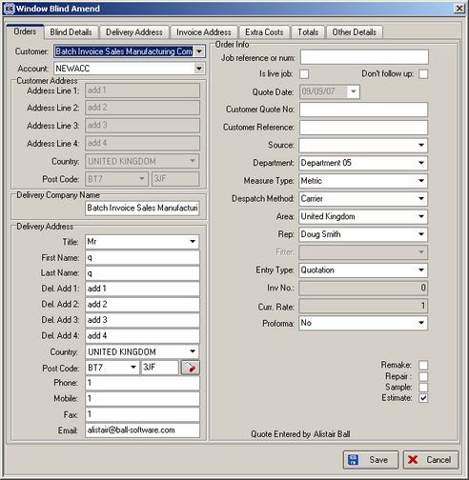

725. Roller Fabric Calculation Change

There is a new parameter in the blind type record if blind identifier = Roller. It is called ‘Allow Vertical Join’. If it is set to true, then it should be possible to have a vertical join in a roller blind. This affects blinds where the fabric calculator = Drop and the width of the blind > roll width of the fabric. If the blind width > roll width and ‘Allow Vertical Join’ = true, then the quantity of fabric used = (blind width / roll width) rounded up * blind drop. A message precedes this and says ‘The width of this blind is greater than the roll width. The blind cannot be made without a join. Please check with the customer.’ If ‘Allow Vertical Join’ = false, then the functionality remains as it is, with the following message appearing:

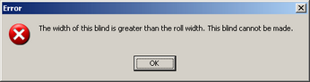

728. Order Processing > Orders

In the ‘Extra Costs’ form, we now have the following extra fields:

- Quantity
- Entered Date
- Due Date
- Hours

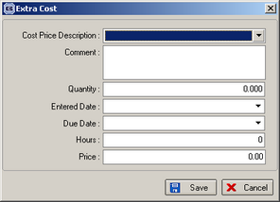

729. Sales Files > Customers > Product Discount

In this tab there is a new field called ‘Category’. This holds the category id. If the category is filled in, then the product field will be blank and vice versa.

When a component detail line is entered, the program checks to see if there is a discount amount by customer and category as well as checking for discount by customer and product. The discount for customer and category will always be a percentage.

