Blindata Release Note 3.6.4 

10 August 2007

Bug Fixes and Enhancements

1877. EDI Enquiry > Automatic Import

If EDI orders are being imported automatically and the system tries to import a purchase order from a customer that has been imported before, this PO is ignored and a message is put into the ‘Import Report’. Previously it brought up a message to say that the record had already been imported, and then stopped the import.

1878. Administration > Users > Advanced permission

A bit of messy screen work has been tidied up.

1880. Stock Setup > Purchase Order Enquiry

The purchase order reference field now appears in the purchase order enquiry form as well as the amend form.

1881. Stock Setup > Purchase Order Enquiry > Display Order

It is no longer possible to cancel a bought in purchase order detail line after the blind has been delivered. A message appears saying ‘This blind has already been received and, therefore, cannot be cancelled’.

New Work and Customer Requests

568. Stock Setup > Purchase Order Enquiry

The reference now appears on Purchase Order Enquiry form for bought in purchase orders. It was also decided it would be useful to see in the purchase order enquiry what sales orders make up the purchase order. If you right click on a purchase order enquiry record, it displays the sales orders that make up the purchase order.

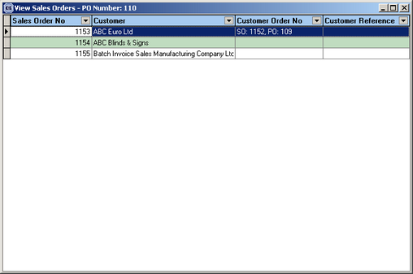

619. Stock Setup > Purchase Order Enquiry

It is now possible to display the columns you want on this form. It is also then possible to copy the data selected to the clipboard and then be pasted to a spreadsheet (for example). This can be done by right clicking anywhere on the form.

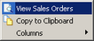

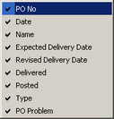

655. Despatch Docket Layout

A new despatch docket layout has been created, called ‘Delivery Docket – A4 Preprinted’.

662. Stock Setup > Purchase Order Enquiry

Previously, when you saved a bought in purchase order, the ‘Create EDI Transaction’ message appears regardless of whether it has already been created or not. This has been changed – if the transaction has already been created, the message does not appear. Instead, if you want to recreate the transaction, there is a button called ‘Recreate EDI Transaction’ at the bottom of the form.

667. Roman Blinds

A new function is now available for blind identifier = Austrian/Roman. It is now possible to print the horizontal measurements where creases are made in the fabric. We are now able to define first crease line and then have a set figure for each further crease. This then leaves a remainder. For example, if the drop of a blind is 1600, the creases might be at 400, 340, 340, 340, 180 gaps. To do this, we now hold a field for the first crease line, then a field for the gap, for each Roman blind type. In the example I have used, the first crease line would be = 400 and the gap would be 340. This is similar to the cord spacing calculation for Venetian and pleated, except the figures apply to the drop measurements, not the widths.

Therefore we have used the cord spacing form to hold the figures. First crease is held in the first cord field and gap is held in the max spacing field.

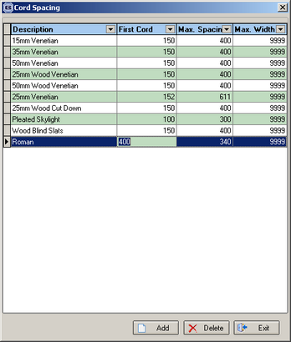

A field is also required in the blind type record (if blind identifier = Austrian/Roman) called ‘Print Crease Lines’. If this is set to true, then the crease lines should print on the Works Order Label Blind Size report in the same place as cord spacing is printed.

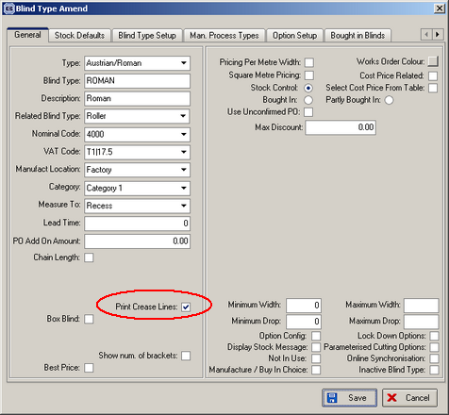

680. Email To Despatch

We have added more information to the email that is sent to despatch when a manufactured order is released from credit hold. This now includes the order detail lines in the email, but only shows the blind type description and the fabric description for each line.

681. Order Processing > Orders / Order Enquiry

It is now possible to select columns to appear on these forms by right clicking on these forms and selecting Columns. Records can also be filtered and the copied to the clipboard by selecting ‘Copy to Clipboard’. They can then be pasted into a spreadsheet.

682. Stock Setup > Purchase Order Enquiry

We have introduced a new function to flag an individual line from a bought in purchase order as being ‘Cancelled’. This is required because, if a blind cannot be supplied by the supplier, that means it cannot be delivered and so the sales order cannot be turned into an invoice. Therefore there is now a ‘Cancelled’ button on this form. If two detail lines are delivered and the third is flagged as ‘Cancelled’, then the detail line in the sales order can be deleted and so the sales order can be delivered and invoiced.

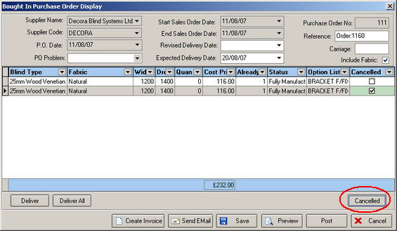

683. EDI Enquiry > Sending Data

To guard against EDI files being sent twice by a customer, we now store a record in a table that says when the file was sent (date and time), who sent it (operator) and what was sent (number). If someone tries to send the file again, the following message appears saying ‘This file has already been transmitted by ‘operator’ on ‘date and time’. Are you sure you want to send the file again?

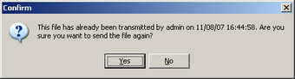

684. Fitters Sheet

In Adninistration > Parameters > Reports, there is a new parameter for selecting fitter reports. A new fitters sheet is available, called ‘Fitters Report (Shutters)’.

685. EDI Enquiry > Receiving Data

We will soon have a situation where more than one company will be sending EDI files to a customer. It will be likely that they will send purchase order numbers that have already been used by another company. Therefore when the import is done, when the PO duplicate check is done, it now to take into account the account number as well.

687. EDI Enquiry > Receiving Data

We have now got another company transmitting EDI orders. The retail part of the business sends orders to the manufacturing part. When the orders are imported, the required date is recalculated by the import routine. This client wants to use the required date in the sent order, deduct two days (working days) from it, and use the result as the required date in the imported order.

We have created a new parameter to control this. It is held against the customer record in the receiving database. The parameter is called ‘Use Receiving Required Date -2’. If this is set to true, the EDI import uses the above to calculate the required date and not the usual lead time calculation. This does not apply to the ‘JL EDI Import’.

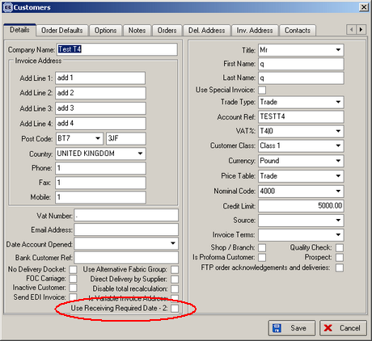

689. EDI Enquiry > Receiving Data > EDI Import Wizard

We have concatenated the stock code to the end of description in Inner Description. This has also been done in ‘Import Options’ as well as ‘Import Fabric’.

