Blindata Release Note 3.6.0 

13 July 2007

Bug Fixes and Enhancements

1853. Order Processing > Orders

The options are now appearing in the option text in the same order as they appear in the detail entry form.

1854. Works Order - Bespoke 15

We have changed th text ‘Branch:’ to ‘Branch/Dept. No:’

1855. Quotation - Bespoke 15

The detail section of this report now displays exactly the same way as it does in ‘Quotation – Laser Print’. The only difference is that the ‘location’ appears on the same line (but before) as ‘Measurement’ and ‘Spec Ins’. The parameter to switch on/off sizes of blinds is also applied.

1856. Label = Label Print - 4 x 1 1/2

- Reduced font size of Customer, Works No (to be called Order No), Cust Ref, Location, Cust Order No to same size as Type but leave in bold.
- Order number and blind numbers do not overlap.
- Date is in format dd/mm/yy
- ‘Works no’ now says ‘Order No’

1857. Order Acknowledgment - Laser Print (Letterhead Logo)

We have reduced the font size of order/customer details etc to match 2nd line which says "Customer Copy", then made text "Customer Copy " font bold and same size font as text "Order Acknowledgement".

1858. Order Processing > Quotations

If Administration > Parameters > Use Quotation Revision = true, then a new revision is created every time you go into amend a quotation, even if you don’t change anything. A message now appears saying ‘Do you want to create a new revision for this quotation?’.

1859. Administration > Parameters > Reports

This report is spelt ‘Quotation – Bespoke 12’.

1860. Quotation – Bespoke 10

If Administration > Parameters > Show Width/Drop on Quotations = false, then width and drop measurements do not appear on this report.

New Work and Customer Requests

658. Auto Create Invoice

Previously the ‘Auto Invoice Create’ function used the current date for the invoice date when the invoice is created. However, if the auto invoice create is run on June 1 (for example), we may want the invoice date to be 31 May. We therefore now have a date field in Administration > Parameters > Sage Parameters / Invoicing, so it can be accessed by the ‘Auto Invoice Create’ function. If the date is null, then the current date is used as the invoice date.

663. Automatic EDI Import

We have now automated the EDI import completely. If an imported order has all of its criteria matched, then the order can be imported without a user action.

We need to set this parameter to determine if the EDI records are to be imported automatically – this is already used to receive the EDI file, but is also now used to do the full import.

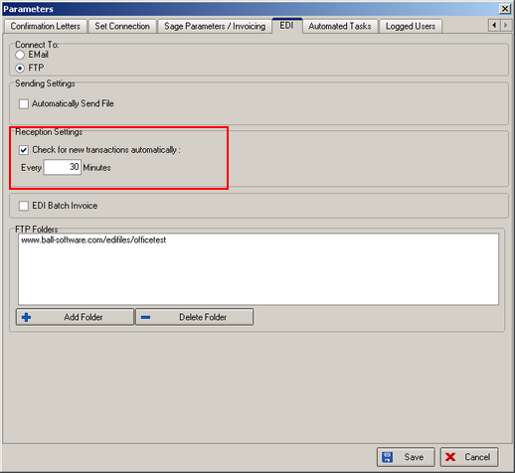

The results of the EDI creation are now written to a table. This includes order IDs created, stock warnings etc and any not imported due to mapping issues. The report can be viewed in EDI Enquiry > Receiving Data > Import Report.

668. PDF Invoices

We have a new report parameter option for choosing the correct pdf invoice layout, which currently has a couple of invoice layouts, including ‘Invoice - Laser Print (Letterhead)’.

669. Order Processing > Quotations

We have introduced a method of holding multiple quotations for one job. Quotes for contracts can work in the following way. Let us say that there is a building that has to be refurbished. There may be 4 building contractors bidding for the job. Each one of these contractors will want a quotation for the job. The blind manufacturer may then have to give a quotation to each contractor. This means creating the same quote 4 times. We can do this by copying quotations and then changing the customer. We also now have a new field that holds the job reference or number. This is held against the quotation record and is displayed on the quotation enquiry form.

We should also be able to create revisions of quotations. The following parameter must be set before this will work.

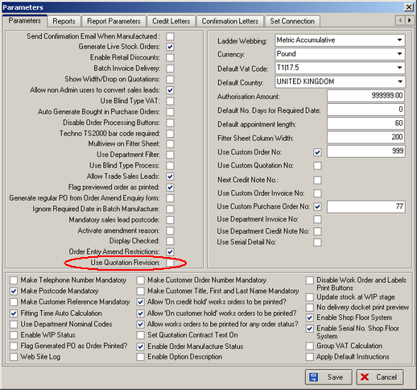

We also need to distinguish between a non live job and a live job.

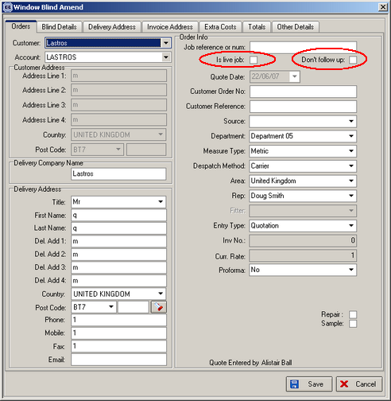

1 – non live – more than 1 main contractor bidding (multi client, same quote). The user then needs to be able to identify contractor who got job and then flag the job as live .

There is also a flag for ‘don’t follow up’.

676. Sales Files > Customers

A ‘No Delivery Docket’ flag is now available in the customer record. If this is set to true, then a delivery docket is not be printed when an order for the customer is despatched.

