Blindata Release Note 3.5.8 

27 June 2007

Bug Fixes and Enhancements

1846. Works Order – Bespoke 15

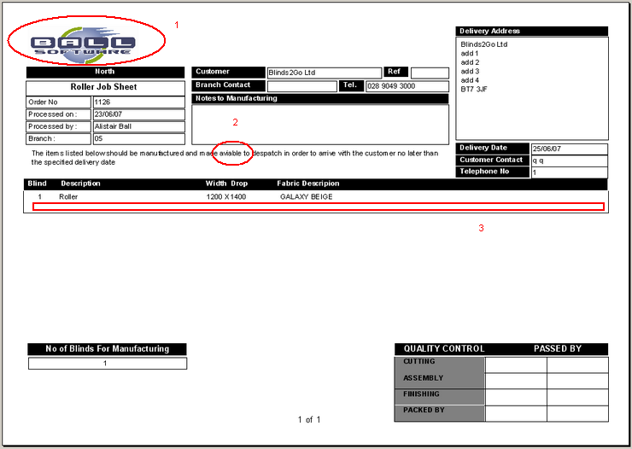

- The logo is now in proportion.
- ‘available’ is spelt correctly.
- There is now room for the options to print across the whole width of the page.

1848. Order Processing > Orders > Posting a Credit Type Receipt

If we post a receipt which is a credit, and the order status = ‘Part Posted’ and balance = 0, the order status is changed to ‘Invoice Posted’.

New Work and Customer Requests

630. Receipts

It is now possible to enter receipt credit amounts against orders. The reason for doing this is as follows – an order might have been entered, processed and the blinds installed. This means the deposit has been updated to Sage and the invoice has been updated to Sage. But the customer may not be happy and a small credit amount may have to be given.

We can set up a new receipt description called ‘Credit’, but we do not want this to get updated to Sage. Therefore we have a new flag in the receipt description field called ‘Credit’. If this is flagged, it will not be possible to post a receipt of this receipt description to Sage. However, it will update the balance amount in the order and change the order to archived if the other normal rules apply (balance = 0, invoice hold = false, order = despatched (if post Retail Invoices = false).

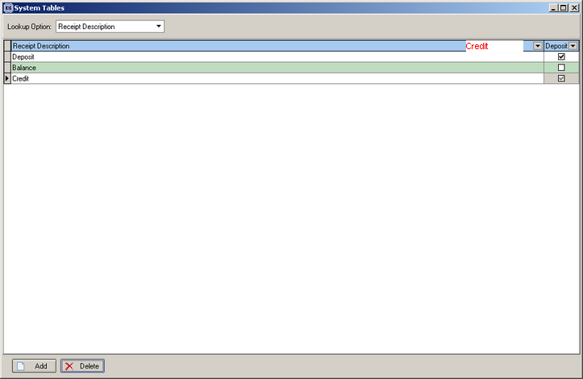

As a result of doing this, we have made changes to ‘Receipts Report by Receipt Description’. This now gives sub totals for receipts where receipt description <> credit and receipt description = credit.

