Blindata Release Note 3.5.2 

24 May 2007

Bug Fixes and Enhancements

1762. Order Processing > Order Enquiry > Blind Made Scan

It is now possible to scan a blind as being ‘Blind made’, even though another blind on the same order has not yet been scanned as ‘Work in Progress’.

1791. Order Processing > EDI Enquiry > Import

If a customer default option is set up in Administration > System Tables > Customer Default Options, this is now picked up when the EDI import is done.

1793. Order Processing > EDI Enquiry > Import

We now import Delivery Title as well as Delivery First Name and Delivery Last Name.

1796. Rep Commission / Discount Report

The nett total was calculating incorrectly. Fixed.

1803. Order Processing > Production Documentation > Works Order A4 Individual

If the system is set up to not print ‘On Customer hold’ records, ‘Works Order A4 Individual’ no longer prints the works order.

1806. Order Processing > Orders

If you enter an order for a box blind, it is now deducting the width difference before working out which box blind to select. It is working out the box blind from the man width, not the entered width.

1807. Works Order Label Blind Size

If ‘Vertical Details in Bold’ is set to true, then only the right hand vertical text in prints in bold.

1808. Works Order Two Labels

We have put ‘Location’ back onto the top two labels.

1809. Administration > Maintenance > Repricing

If a blind type was set to ‘Select Cost Price from Table’, the cost price did not get recalculated when the repricing is done. Fixed.

1810. Label Print – 88mm x 35mm

Customer was overwriting cust ord no. Fixed.

1811. Order Processing > Orders

If parameters are set up like this, then it was not possible to print works orders from the order amend enquiry form if they are past the ‘Order Manufactured’ status. If you set ‘Allow On customer hold works orders to be printed’ to true, then the works order could be printed. This has been fixed.

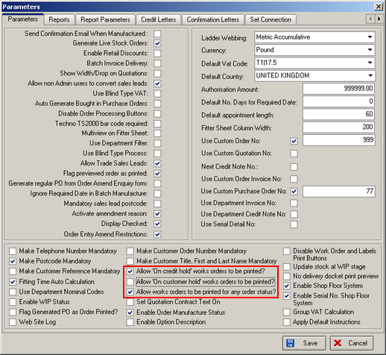

1813. Financials > Post Invoices To Sage

When creating a line 50 export file, the data in the fields “Transaction (Invoice) Reference“ and “Transaction Details” were not holding the correct data in the CSV export file.
The field that the Invoice Number is now put into is “Transaction (Invoice) Reference” and not “Transaction Details”. The “Transaction Details” field now holds the data that was previously in the “Transaction (Invoice) Reference” field. Basically the data in the two fields has been swapped around.
1814. Invoice – Bespoke 2

This report now to show the delivery company name and delivery address when the invoice is a contract invoice.

1815. Shop Floor System

We can now identify tickets printed previously with the Detail Line ID, so they will work on the Shop Floor scans when this is switched on.

1816. Order Processing > Orders

We made a change in 3.5.2 to restrict what can be changed in an order after the ‘Order Entered’ stage. This applied to width, drop, fabric and options. It should also apply to blind type, measurement, measure to, location and special instructions.

1817. Order Enquiry > Out of Stock Blind/Order

The Out Of Stock Blind/Order Scan buttons now re-set the status of the order to ‘Works Order Printed’ if the current status is ‘Work in Progress’.

1818. Credit Limit Message

If Administration > Parameters > Sage Parameters / Invoicing > Sage Version = Not Installed, the old credit limit message now appears, otherwise it will be the new one (below).

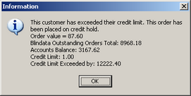

1819. Works Order - Label 1

If a remake or repair has been entered and the serial no. shop floor system is switched on, the barcode was still printing the order detail id, when it should be printing the serial id. Fixed.

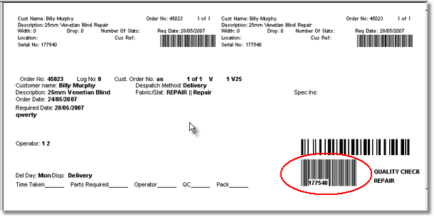

New Work and Customer Requests

599. Works Order Label Blind Size

We have created new parameter for the works order label to define if we print blind identifier codes or blind type codes on the works order label. The parameter should be called ‘Print Blind Type Code’. This would then determine whether ‘L, R, V etc’ printed or ‘L89, R, V25 etc’ printed.

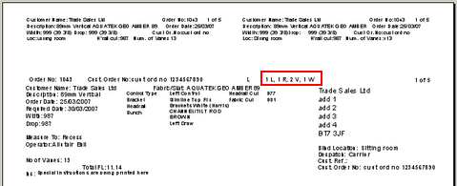

616. Order Processing > Archive Enquiry

Customer reference now appears in the archive enquiry form.

632. Order Enquiry > Consignment Note No

There is a new button for the Consignment Note No on the Order Enquiry form. It has the same functionality and permissions as the one on the Orders form.

634. Order Enquiry > All Barcode Scans

On ‘Works Order Label 1’, there are two barcodes, one for blinds and one for the packing machine. If someone accidently scans the packing machine barcode instead of the other barcode, an error occurs. There is now a message saying ‘Please scan the correct barcode’ and then the program clears the scan field so it is ready to accept the correct scan.

635. Order Processing > Orders > Out of Stock Flag

There is now an ‘out of stock’ flag against the order. This is displayed on the ‘Order Amend Enquiry’ form, but is controlled by the switching on or off of the ‘out of stock’ flags against the order detail lines. The rule is simple: the order ‘out of stock’ flag will be true if any of the order detail line ‘out of stock’ flags are true, otherwise it will be false. Every time an ‘out of stock’ flag is updated in a detail line, this rule is applied.

636. Order Processing > Orders > Restricting Amendments

There is now functionality to stop operators changing the size of a blind, fabric and options as soon as the order has a status of ‘order printed’. However not all users will like this modification, therefore we have parameterised this and also allowed for amendments to be made if a mistake has been made in entering orders.

The following changes have been made:

- There is a new flag in the Parameters table called ‘Order Entry Amend Restrictions’.
- If ‘Order Entry Amend Restrictions’ = true, then a user can only amend the width, drop, measure to, fabric and options if the order status = ‘Order Entered’.
- There is a new button on the ‘Order Amend Enquiry’ form called ‘Allow Amendments’. This is only visible if ‘Order Entry Amend Restrictions’ = true. There is also an advanced permission for the ‘Allow Amendments’ button.

637. Works Order Label Blind Size

We have made a few changes to this.

- It is now possible to print a barcode on this report, in the bottom right hand of the large label. This is controlled by a new parameter in Administration > Parameters > Report Parameters, called ‘print Barcode’.
- On the right hand small label, the headrail cut and number of vanes can be in bold. This is also controlled by a new parameter in Administration > Parameters > Report Parameters, called ‘Vertical details in bold’.

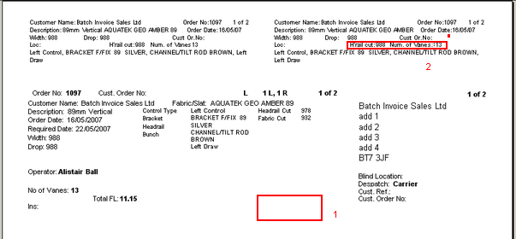

Also, we made a change to ‘Works Order Portrait’ so the font colour for the blind type description and fabric description could be altered. This now also applies to ’Works Order Label Blind Size’. If no colour is set up, then it should default to black.

638. Administration > Maintenance > Repricing

We have added options to recalculate by

- Selling price
- Cost price
- Both.

645. Order Processing > Order Enquiry

There is a new button on the ‘Order Enquiry’ screen called ‘Enquiry Scan’. This resets the status of the order to ‘Order Entered’ and also removes the ‘Checked’ tick box. It only works for orders at ‘Work In Progress’ or ‘Works Order Printed’ status. If it has been manufactured, it cannot be changed.

