Blindata Release Note 3.5.1 

08 May 2007

Bug Fixes and Enhancements

1788. Order Processing > Order Enquiry > Order Made Scan

If there were two blinds on an order, and the first one was scanned as ‘Blind Made’, the date and time the blind is made was updated in the serial detail lines. But if you the did ‘Order Made Scan’ to make the second blind, the date and time the first blind was made was overwritten with the date and time the second blind was made. Fixed.

1789. Order Processing > Order Enquiry > WIP Order Scan

If there are two blinds on an order, and the first one was scanned as ‘WIP’, the date and time the blind was WIPed was updated in the serial detail lines. But if you the did ‘WIP Order Scan’ to WIP the second blind, the date and time the first blind was WIPed was overwritten with the date and time the second blind was WIPed. Fixed.

1790. Order Processing > Order Enquiry > All Scans

The date/time for all scans in the serial detail lines is now updated to the nearest second. Previously the date stamp was only done to the nearest minute.

1794. Works Order Two Labels

The lower small labels have been moved down by 5mm.

1795. Rep Commission / Discount Report

Extra totals for the columns have been added to this report.

1797. Rep Commission/Discount Report

We have replaced Reference with Cust ord No in the report. This was an error in the specification.

1799. Works Order Label Blind Size

If the delivery address had a very long line in it, it wrapped round and displaced the postcode from the bottom of the address. The address lines now do not wrap round.

1800. All Delivery Docket Reports

The delivery address lines no longer wrap round as the postcode was then removed from the delivery address. It was exactly the same problem as 1799.

1801. Financials > Invoice Batch Print

Using the Batch Report: Invoice – Batched By Cust. The report is showing batched invoices, which should be on the same page, on separate pages.

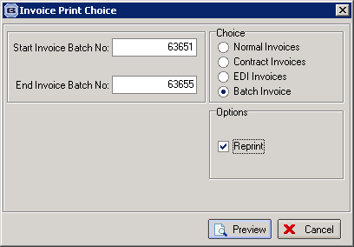

When using the details above with the data attached you get the following report:

Page 1

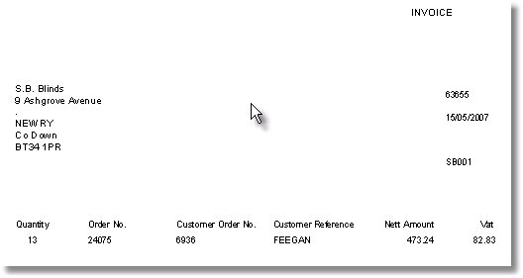

Page 3

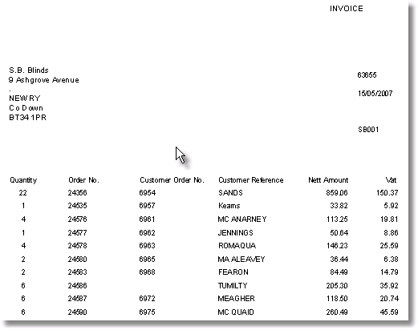

Page 1 & 3 should be on the same page as this is the same invoice no and the same customer. The title of the report also shows: Invoice – Sage Laser Batch Print when it should say: Invoice – Batched By Cust.

Valerij

1802. Works Order Two Labels (Urgent)

if blind identifier = Verticals or blind identifier = Vanes Only, the number of vanes should print on the report.

New Work and Customer Requests

633. Blind Details > Blind Types

The blind type description and fabric description colour can now be defined in the blind type record. This will then print out the relevant colour on the ‘Works Order Portrait’ report.

