Blindata Release Note 3.4.3 

19 March 2007

Bug Fixes and Enhancements

1678. Invoice – Sage Laser Print

- The address has been moved right by 10mm.
- The title and first name now have a space between them.

1680. Invoice – Batched by Cust (Invoice – Sage Laser Batch Print)

We have made some changes to this report.

- The page length is now 11in (279.4mm)
- Nett price has been move up 25mm, and the text ‘Nett price:’ moved 10mm left. VAT has been moved up 20mm and the text ‘VAT:’ moved 10mm left. Total has been moved up 15mm and the text ‘Total:’ moved 10mm left.
- The currency sign is now showing as £ or € instead of ?.
- ‘INVOICE’ has been moved 40mm to the right.
- The customer address has been moved up 5mm.
- The first part and second part of the postcode were the wrong way round.

1681. Invoice – Sage Tractor Feed Letterhead

- ‘INVOICE’ has been moved down 8mm and 20mm to the right.
- If ‘Currency Type’ = Euro, the customer VAT number now appears here (from customer record).
- Removed all horizontal lines.
- Removed the boxes. Moved Nett price down 6mm and moved ‘nett Price:’ text left by 12mm. Moved VAT down by 8mm and moved ‘VAT:’ text left by 12mm. Moved Total down by 12mm and moved ‘Total:’ text left by 12mm.
- The page length is now 11in.

1682. Delivery Docket – Sage TF Letterhead

- ‘DELIVERY DOCKET’ has been moved 40mm right and 2mm down.
- The customer address has been moved 10mm up.
- If ‘Batch Invoice’ in Sales Files > Customers = false, then the totals in the bottom right do not print at all, regardless of the ‘Hide Totals’ parameter in Administration > Parameters > Reports.
- The page length is now 11in.

1684. Order Processing > Fitters Sheet / Sales Leads

It was possible to drag an appointment to the calendar on the right and move it to a different day. If you move it to a day that has an appointment at the same time for the same fitter then a conflicting error occurs. We have disabled this.
1685. Delivery Docket – Sage TF Letterhead

The totals were in the wrong place. They are now in the same position as in ‘Invoice – Sage Tractor Feed Letterhead’.

1686. Woodslat Calculation

If the number of slats (from the Venetian slat table) works out as an odd number and you are cutting the slat in two, you can get a quantity with 0.5 in it. This is now rounded up to the next whole number.

1687. Order Processing > Orders > Delete

If you clicked to delete (cancel) an order, it was possible to cancel it without giving a reason if you click the x in the top right of the form. Fixed.

1688. Order Processing > Orders > Order Acknowledgement Print

When you clicked the ‘print order’ button and looked at an order acknowledgement, it put an entry ‘acknowledgement printed’ into the history of the order, but the user could then close the print preview without printing. This has been changed so it will not record the acknowledgement as being sent until the user actually prints the order acknowledgement.

1689. Invoice – Sage Tractor Feed Letterhead

The text in the detail line (which is from Administration > Company Details > Invoice Text) is now printed at the bottom of the invoice.

1690. Invoice – Sage Laser Batch Invoice

- The contact name no longer prints. The address lines have been up a line.
- The totals now print in the same place as they do in ‘Invoice – Sage Tractor Feed Letterhead’.

1691. Delivery Docket – Sage TF Letterhead

The delivery date has been moved down 3mm.

New Work and Customer Requests

544. Label Print 4 x 1 ½

A new label print has been created. This is the same as ‘Label Print 5 x 1 1/2 ‘, but is only 101.6mm wide instead of 127mm wide.

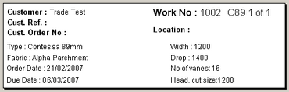

555. Stock Warning Messages

We have made a couple of changes to the stock warning message (which is activated if ‘Display Stock Message is set to true in Blind Types and Stock Items.

- If the stock in hand figure falls below the ‘re-order level’, a message now appears saying ‘Stock in hand is below the re-order level for this item’. The message does not appear if the original stock message appears.

- We have created a new field in the Fabrics table called ‘To Be Discontinued’. If this fabric is chosen and ‘To Be Discontinued’ = true, then a message appears saying ‘This fabric has been discontinued and will not be reordered’.

556. Wood Slat Bill Of Materials

We have changed the way that the calculation of the number of slats used in making a wood blind is done. We can now use different lengths for slats, valances and bottom bar. In the example below, we have defined that if you need to make a blind up to 914mm wide, then you can cut 2 slats from a 6’ wide slat. You can continue to use the 3’ foot wide valances and bottom bars.

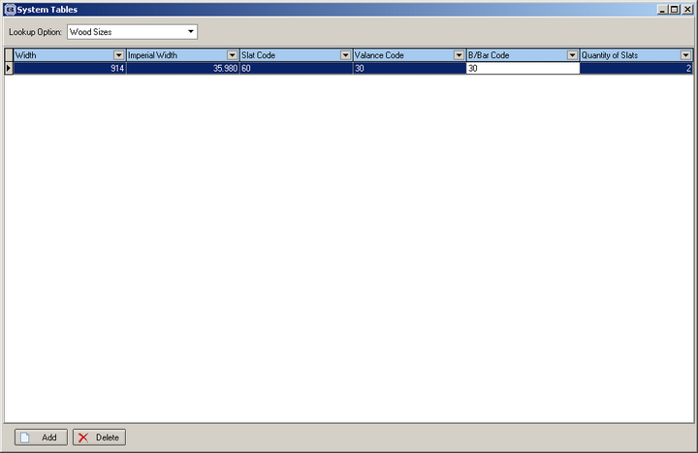

576. Diary

We can now see the sales diary in a in a monthly format (similar to Outlook). The weekly format will be available shortly.

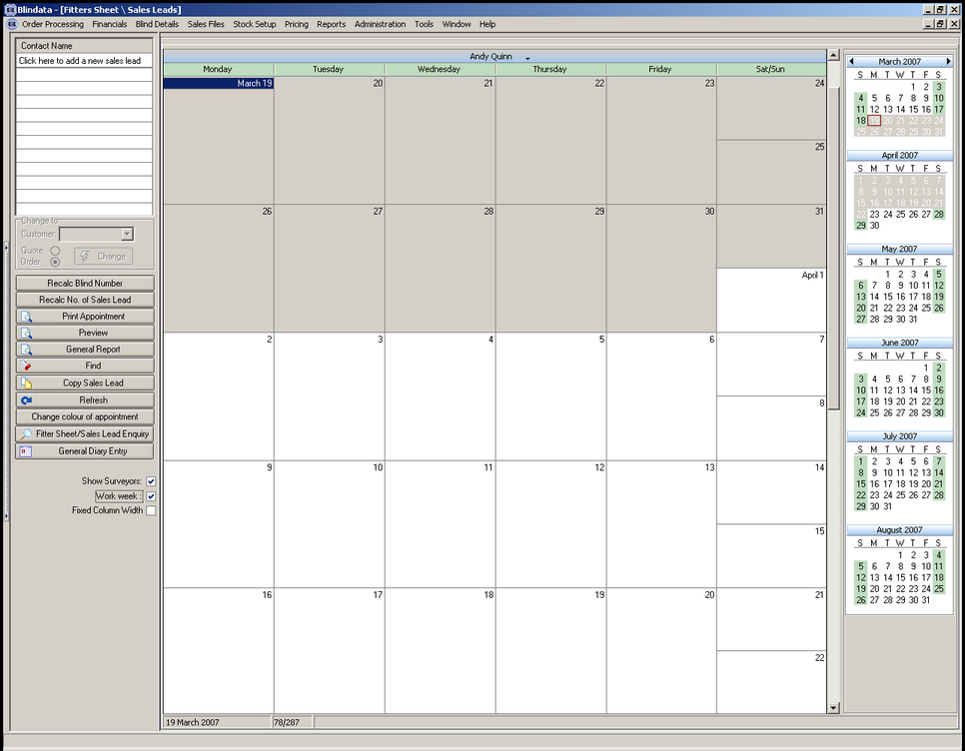

579. Invoice – Sage Tractor Feed Letterhead

A new invoice layout has been created, called ‘Invoice – Sage Tractor Feed Letterhead. This is available on both the regular and batched print.

The layout is similar to ‘Invoice – Sage Tractor Feed’.

581. Works Order Label Blind Size

We have created some more parameters for printing ‘Works Order Label Blind Size’. These are available in Administration > Parameters > Report Parameters. We created this new tab because there was no longer any room in the ‘Reports’ tab.

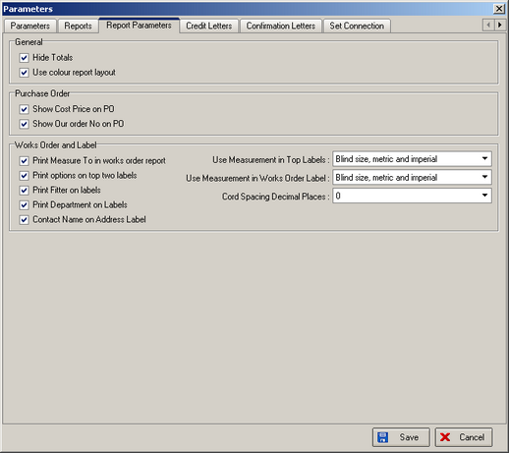

583. Invoice – Bespoke 14

We have made some more changes to this invoice layout (both individual and batch).

- The despatch method is now in the second from bottom box.
- The ‘Cust Ref’ is also in this box
- The ‘Measure To’ is printed for each blind. It is concatenated to the end of the options, in the same font size.

