Blindata Release Note 3.3.8 

12 February 2007

Bug Fixes and Enhancements

1584. Order Processing > Orders

If you set up the following ‘Option Calculation’ for headrail depth, it now affects the calculation of fabric usage for a vertical blind. The calculation worked properly on the ‘works order label blind size’ report, but did not previously work on the stock transaction calculation. Fixed.

1587. Order Processing > Orders

If a user is set up with an Advanced Permissions to use the ‘Status Fields’ button in ‘Order Amend Enquiry’, the button was not enabled unless they had permission for ‘Users’ in Administration > Users > Permission tab > Users. This is no longer necessary.

1588. Fitters Sheet / Sales Lead > Sales Lead Entry

When you used the postcodeanywhere lookup, the address lines were not updating the records to the correct fields. Fixed.

1589. Order Processing > Delivery Docket Batch Print

The lookup for despatch employee was finding ‘is service’ employees instead of ‘despatch’ employees. Fixed.

1591. Reports > Financial Reports > Outstanding Retail Debtors

This report was not taking into account orders with status ‘Part Posted’, and so was missing a lot of records on the report. Fixed.

1592. Sales Files > Customers

If ‘Check Sage customers’ = true (in Administration > Parameters > Sage Parameters / Invoicing), the customer record is updated in Sage. But it got updated even if you answer ‘No’ to the question. Fixed.

1593. Sales Files > Customers

If ‘Check Sage customers’ = true (in Administration > Parameters > Sage Parameters / Invoicing) and Prospects = true (in customers) a customer record no longer gets created/updated in Sage.

New Work and Customer Requests

512. Quotation Print and Order Acknowledgement PDF Emails

We have changed the way in which emails are sent for various documents, starting with quotations and order acknowledgements. When these are sent using the email buttons, they are now sent as attached pdf files, and not using text or html formats.

The reports the PDFs are based on are ‘Quotation – Laser Print’ and ‘Acknowledgement – Laser Print’.

This means that we no longer need the ‘Use Ack. Text Format’ field in Sales Files > Customers.

521. Request Interface

We have written an interface to an accounting system called Request (written in Omnis). There is a facility to export new customer records to csv file so they can be imported to Request. This can be set up in the following way:

There is a new flag in Administration > Parameters, called ‘Omnis CSV Export. This must be switched on.

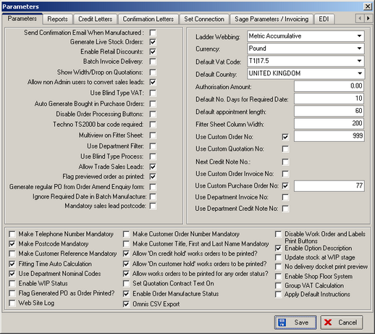

In Administration > Export Data, there is an option to export customer records. This will export all customer records that have not previously been exported.

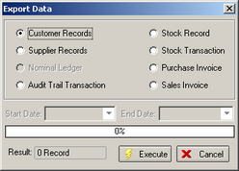

The export file is a csv file called CUS_blindata. The following fields are included:

Code, 8chrs (Sage account reference in Blindata)
Name, 45 chrs (company name)
Address 1, 45 chrs (address 1)
Address 2, 45 chrs (address 2)
Address 3, 45 chrs (address 3)
Town, 25 chrs (address 4)
County, 25 chrs (leave blank)
Post Code, 10 chrs (post code)
Phone, 15 chrs (phone number)
Fax, 15 chrs (fax number)
Contact Name, 25 chrs (contact name)

533. PVC Lengths

For PVC lengths, it is now possible to not hold remainders ie do not calculate left over amount and create sub stock records.

This is required to calculate the amount of stock that will be used in making a vertical blind that uses PVC vanes instead of fabric. Normally the fabric calculation would be ‘Fabric x Fabric Length’, but PVC vanes are solid and are bought in 5m lengths. However we will still use the same calculator.

The stock item will be set up as ‘cut length’ = true and the user will enter the number of 5m (5000mm) lengths they have in stock.

The program now takes into account the number of vanes (found from the relevant vanes table), the vane length calculated (man drop – headrail depth) and then works out how many cut lengths are required.

Example:

A blind requires 17 vanes and each vane has a vane length of 1500mm. There are 100 5m cut lengths in stock.

The system should work out that you can cut 3 x 1500mm vanes from a 5m length. This means we can get 15 vanes from 5 x 5m lengths and 2 vanes from 1 x 5m length. If ‘Scrap Below’ = 0, then the stock usage will be as follows:

Starting stock: 100 5000mm lengths

End stock: 94 x 5000mm lengths, 1 x 2000mm length, 5 x 500mm lengths.

If ‘Scrap Below’ = 2500, then the end stock would be: 94 x 5000mm lengths. If we set the ‘Scrap Below’ figure high enough, it will not calculate any left over stock.

539. Sales Files > Customers

We can now hold bank account payment details against customer records. Because some invoices may be factored (ie a factoring company collects the money) we have introduced a method to print different payment details on the invoice (see dev 540). These bank payment details are held in a new table, in Administration > System Tables. The new table is called ‘Bank Payment Details’, and has the following fields: Id, Description, Sort Code, Account Code, Bank, Bank Address 1-4, Postcode, Payment Terms, Text 1, Text 2, Payment Company Name, Payment Address 1-4, Payment Postcode.

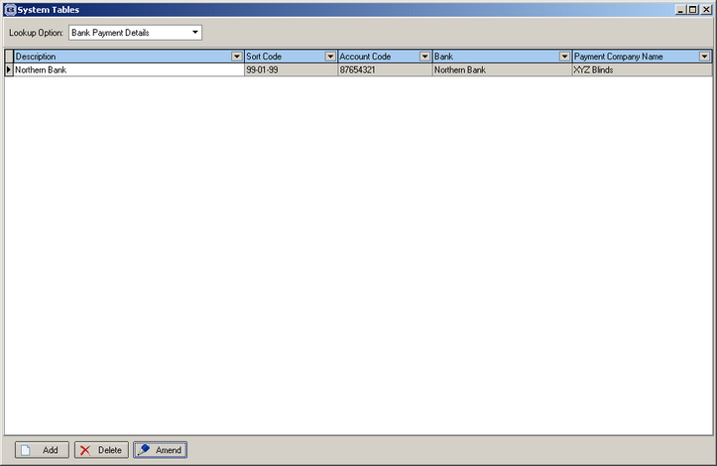

There should be a field in the customer record called Payment Id to identify which payment detail record should be used for the customer.

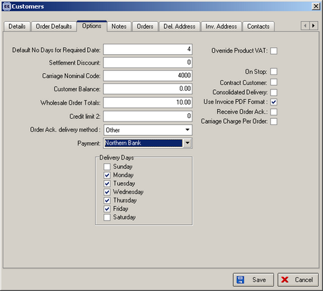

540. Invoice – Bespoke 15

A new invoice layout has been created.

541. Delivery Docket – Bespoke 15

A new delivery docket layout has been created.

547. Sales Files > Customers

It is now possible to create a new account in Sage from Blindata, on an individual basis. There is a new parameter in Administration > Parameters > Sage Parameters / Invoicing, called ‘Check Sage Customers’. If this is set to true, then the following functionality is implemented when a new customer is added or amended in Sales Files > Customers.

If a customer record has been added, a message appears saying ‘There is no customer account in Sage for this record. Do you want to add this customer in Sage?’ If yes, then the record is added in Sage according to the fields that are set to be updated in Administration > Sage Utilities > Create / Update Customer Details into Sage.

If the customer record has been amended, a message appears saying ‘This customer record has been amended. Do you want to update the record in Sage?’. If yes, then the customer record is amended in Sage according to the fields that are set to be updated in Administration > Sage Utilities > Create / Update Customer Details into Sage.

