Blindata Release Note 3.3.0 

15 December 2006

Bug Fixes and Enhancements

1465. Fitters Sheet / Sales Leads

On this form, ‘Fitter’ now says ‘Employee’.

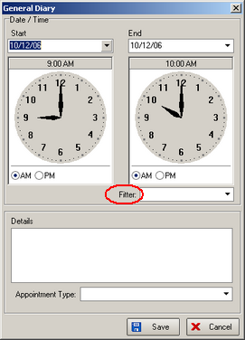

1466. Archive Enquiry

Previously, If you went into ‘Status Fields’ and out, the filter resets to initial setting. Fixed.

1467. Quotation – Laser Print

The detail lines now print correctly if the line is a ‘Text Entry’.

1468. Order Processing > Order Enquiry

Some of the dates were displayed as dd/mm/yyyy, and some dd/mm/yy. They are now all displayed as dd/mm/yy.

1470. Order Processing > Orders

The contact name was not being validated properly for first and last name. Fixed.

1471. Order Processing > Orders

An error message appeared if you added a new order (but did not save the header record). Fixed.

1473. Acknowledgement – Laser Print

- The postcode has been moved up so there are no empty lines (if address line 3 or address line 4 are null).

This also applies to ‘Invoice – Laser Print 11 Detail Lines’, ‘Acknowledgement – Lead Time Text’, ‘Delivery Docket – Laser Print’

1478. Order Processing > Credit Notes

An error occurred when trying to enter a detail line for a credit note and also in a quotation detail line entry. Fixed.

New Work and Customer Requests

We have made a significant change to the way that addresses are held in the system. The reason for the change is to improve the processing speed for all forms and reports that accessed addresses.

