Blindata Release Note 3.2.9 

8 December 2006

Bug Fixes and Enhancements

1462. Works Order Label Blind Size

- These fields no longer print if blind identifier = miscellaneous.
- Misc blind type now prints ‘Invoice Comment’ text in this area.

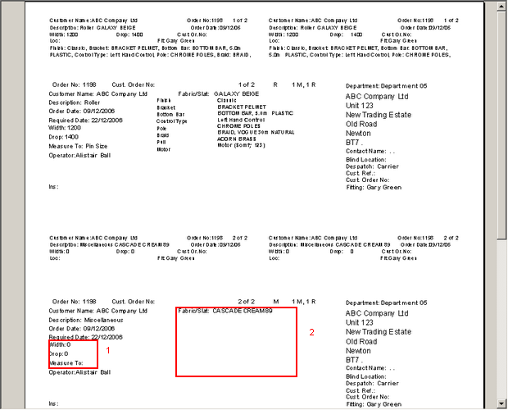

1463. Purchase Order Bought In (all reports – Standard, Blind Size, Department)

If a velux blind has been entered, the velux code now appears on the report, not the width and drop.

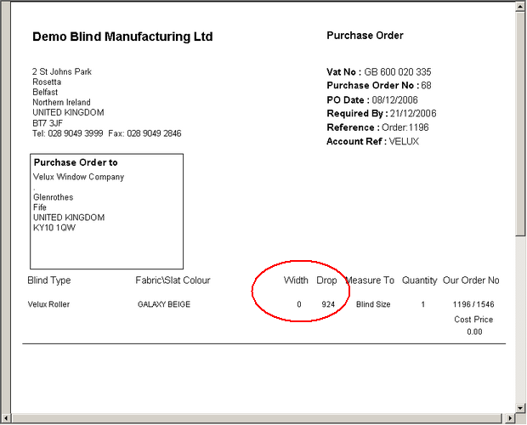

New Work and Customer Requests

444. Cost Prices

There is a new facility to enter a cost price detail line. This is required because there may be an additional cost to an order that has not been picked up by the bill of materials. There is now a new tab in order detail entry called ‘Extra Costs’, which is controlled by an advanced permission. The following form is displayed. The ‘Cost Price Description’ field can be maintained in Administration > Parameters.

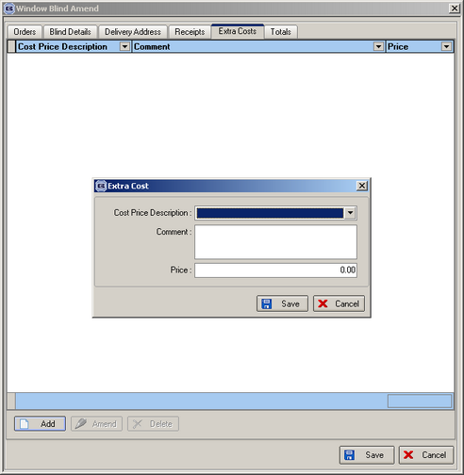

When an extra cost is added here, it is then added to the total cost of the blind.

447. Inactive Blind Type

There is a new true/false flag called ‘Inactive Blind Type’ in Blind Details > Blind Types. This defaults to false. If set to true, a user will not be able to see a blind type when entering a new detail line.

448. Inactive Customer

There is a new true/false flag called ‘Inactive Customer’ in Sales Files > Customers. This defaults to false. If set to true, a user will not be able to see a customer when entering a new order.

465. Pricing > Option Price Enquiry

There is a new button on this form that will allow you to copy an existing option price record and all its associated prices. A form appears that asks the user what blind type, fabric description and fabric group they want to copy the selected record to. It is possible to leave the fabric group blank.

472. Order Processing > Orders

There is now a way of being able to record text against an individual option in a detail line entry. This may be required because we need to enter a size or a number of brackets or just some free text.

To set this up, a new field must be ticked in Blind Details > Blind Types > Option Setup.

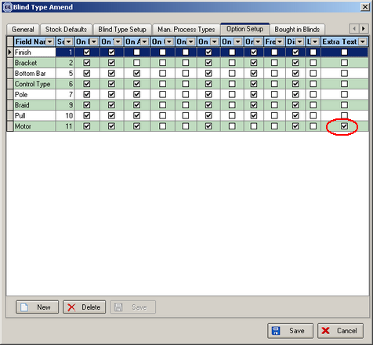

When you enter a detail line, it is now possible to enter text against a specific option.

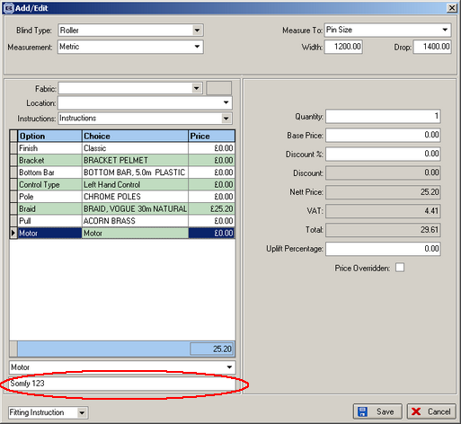

This now prints on the works order label blind size. The text appears in brackets after the option choice.

473. Invoicing

It is now possible to email individual invoices as pdf files. To do this, the customer must be set up with the following flag switched on:

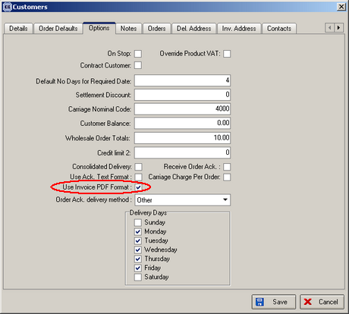

474. Administration > Maintenance

There is a new option to disable stock records by choosing the blind type, supplier and option name, and then flagging all records that meet the criteria as ‘Fabric Not In Use’ = true. It is also possible to flag as ’Fabric Not in Use’ = false as well.

475. Reports > System Reports > Contact Management Reports

We now have the following reports:

Contact Management by Employee

This is grouped by employee and shows: order no, date, customer, action date, type, action type, status.

Contact Management by Customer

This is grouped by customer and shows: order no, date, employee, action date, type, action type, status.

481. Despatch Label 4 x 3

We have added the width of the blind as a barcode on the despatch label. The barcode font is code 128.

482. Option Pricing

It is now possible to price options by square metre pricing. There is a new ‘Type’ set up in ‘Option Price Enquiry’ called ‘Square Metre’. If this is chosen, and prices are entered against this, when the option price is calculated, it will be (Price * Width * Drop) / 1000000, the width and drop being in millimetres and from the width and drop in the order detail line.

485. Blindata Synchro Work

We have altered the design of the Office -> Site synchronization. There is now a mechanism in the application which record all changes in the static data required for the synchronization and stores records in a separate table. All operations with the necessary tables (insert, delete, update) are recorded, and it also records the tables and IDs of the records that have been changed.

The synchronization application then reviews this table and according to the log access only the updated records are synchronized. After a log record has been processed (synchronized), it will be deleted from the office database.

