Blindata Release Note 3.2.2 

20 October 2006

Bug Fixes and Enhancements

1332. Invoice – Bespoke 8

The following changes have been made to the EDI version of the invoice:

- The postcode is printing properly.
- The address was showing the delivery address – is now the invoice address.
- We now show the ‘Delivery Company Name’, not the order contact name.

1337. Pricing > Price Table Enquiry

The reports did not work if you print out more than ‘Selected’. Fixed.

1341. Price Table Enquiry

Reports were coming up with an error message. Fixed.

1351. Label Print – 5 x 1 ½

If ‘Only One WO Label’ is set for this item in Stock Items, now only one label should print out.

1352. Order Processing > Orders > Component Detail Entry

The special pricing was not being picked up properly. Fixed.

1353. Order Processing > EDI Import

When an order is imported via EDI, the delivery company name was not being filled in properly if ‘Direct Delivery by Supplier’ is filled in the original order. Fixed.

1354. Works Order – CB

If the report goes over a page, the header information is now printed on the second page.

1355. Works Order – CB

- If blind identifier = miscellaneous, we no longer the blind type.
- Postcode is now moved up if line above is empty (address lines should be moved up if address line above is empty)
- Order contact has been moved to the right of delivery postcode.
- Order number and customer reference have been swapped around. Customer reference moved 20mm to left.

1356. Works Order – CB

The following changes have been made:

- ‘No of Vanes’ is only printed for blind identifier = vertical.
- Cord spacing is not needed for any blind identifier (on this report)
- ‘Vane Length’ is only required for blind identifier = vertical.

1357. Financials > Create Invoices

When you create invoices in the system (Batch Manufacture switched on, no ‘Order Manufacture’ status), a message appeared saying that no invoices have been created, but invoices have been created. Fixed.

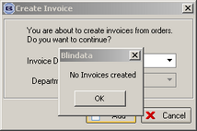

1359. Works Order – CB

The printer setting in ‘Administration > Parameters > Reports > Works Order’ was not being picked up. The report went to the default printer and then had to be changed. Fixed.

The rule about ‘Only One WO Label’ now only applies to blind identifier = Miscellaneous.

1360. Label 5 x 1 ½ - CB

All the production labels now print out in order id order, first with production labels, then all the customer labels.

On the customer label, ‘Order No’ was printing too far to the right. Moved 10mm left.

The printer setting in ‘Administration > Parameters > Reports > Label’ was not being picked up. The report went to the default printer and then had to be changed. Fixed.

The rule about ‘Only One WO Label’ now only applies to blind identifier = Miscellaneous.

1362. Credit Note – Laser Print

The incorrect credit note number was printing. Fixed.

1363. Works Order – CB

Now have ‘Measure To’ on works order, underneath ‘Drop’.

If quantity > 1 for a blind identifier <> miscellaneous, it was printing 2 lines. Now it only prints one.

For miscellaneous items, nett price now appears.

1364. EDI Export/Import (Urgent)

When you are exporting orders and importing an EDI file, there was a problem if there were two orders for the same customer – the detail lines get added together in the same sales order in the receiving database. Fixed.

1365. Label Print – 5 x 1 ½ CB

We now print the ‘Delivery Company Name’, not the ‘Company Name’.

1366. Label Print – 5 x 1 ½ CB

Velux code now prints on label

We are now able to print 8 options on the label.

1367. Works Order – CB

Fabric description now print on works order for blind identifier = Velux

New Work and Customer Requests

353. Order Processing > Orders

It is now possible to double click on an order to amend that order.

359. Order Processing > Orders

There is now a facility to change an order back to a quotation. This is required because people are accidently changing sales leads to orders instead of to quotations. There is a new button on the order amend enquiry screen called ‘Set Order to Quote’, which requires an advanced permission (see Administration > Users > Advanced Permission > Set Order to Quote.

414. Administration > Import from Excel > Blind Type Dataset

We have introduced another spreadsheet import to speed up the setting up of blind types in the system. The spreadsheet contain information on ‘Measure To’, ‘Works Order Control’, ‘Label Control’, ‘Option Setup’ and ‘Stock Items’. We are going to create different spreadsheets with datasets that customers can import quickly and start processing orders immediately.

We have prepared a sample spreadsheet (Louvolite Roller Dataset Example.xls). It is based on the fabrics import spreadsheet, but at the start there are extra records that will get imported to tables other than fabrics. The product type column (F) has been used to determine the type of record that is being imported.

In all types, blind type (column E) = blind type. If a record already exists with the same information, it should remain.

Type 1: if fabric code = null and product type = Measure To, then the record is to be imported to the BlindType Measure table. Fabric description (column C) = Measure, Supp Part No (column K) = width add on and Roll Width (column L) = drop add on.

Type 2: if fabric code = null and product type = WO Control, then the record is to be imported to the WO Control table. Supp Part No (column K) = type and fabric description (column C) = free type.

Type 3: if fabric code = null and product type = Label Control, then the record is to be imported to the Label Control table. Supp Part No (column K) = free type and fabric description (column C) = type.

Type 4: if fabric code = null and product type = Option Setup, then the record is to be imported to the Field Setup table. Fabric description (column C) = option name. All yes/no fields should default to true, the next sequence number should be used.

Type 5: if fabric code <> null, then records are imported in the same way as in fabric import.

421. Order Processing > Orders > Batch Manufacture

There is a new option so that the batch manufacture function will ignore the required date, and change all orders that are ‘Order Printed’ to ‘Order Manufactured’ or ‘Despatched’. This is a parameter in Administration > Parameters, and is called ‘Ignore Required Date in Batch Manufacture’.

424. Order Processing > Production Documentation

We have a situation with one client who prints out works orders and labels for one department on one set of printers and another department prints out on different printers. We wanted to make it easy for the client to print the reports and to not keep having to choose printers.

In Administration > Parameters > Reports, we have parameters for labels and works orders.

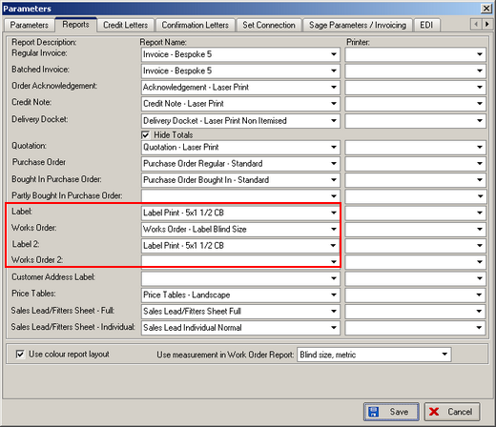

In Production Documentation we can define which print to choose and which department. There is a new table in Administration > System Tables that holds the department and label / works order 1 or 2.

For example, we want all labels and works orders for department = 1 to print to label printer A and works order printer B. For department = 2, we want labels to print to label printer C and works orders to works order printer D.

Department Print Choice
1 Label
1 Works Order
2 Label 2
2 Works Order 2

425. Order Processing > Orders > Component Detail Entry

When you are entering a component line, you might enter a quantity of 100, but not want 100 labels to be printed out. That is why we introduced a field in the fabrics table called ‘Only One WO Label’. We also need a field in the component detail line called ‘Number of Labels’, which will determine the number of labels that get printed. If ‘Only One WO Label’ is true for that stock item, it should default to 1, but if it is false, it should default to the quantity entered. The user is then able to change the figure to what they want and this is what should be printed.

