Blindata Release Note 3.2.1 

13 October 2006

Bug Fixes and Enhancements

1325. Printing Works Order Documentation

The works order labels no longer print if the ‘on customer hold’ field is flagged and parameters are set to stop these orders printing.

1328. Order Processing > Orders > Email Order Ack

This button is only enabled if Outlook is switched on and the order email address is not null.

1329. Order Processing > Order Enquiry > WIP Scan

The 'Not enough stock' message also appears (when relevant) when an order is scanned into WIP using the ‘WIP Scan’ button.

1331. Works Order – CB

- This now prints the customer address, not the address from Administration > Company Details.
- The ‘Delivery Company Address’ now prints in the correct place.
- Customer reference prints where cust. order number was printed, but 20mm to left. Cust Order number has been moved 50mm to right.
- Required date and Notes now print in the bottom left.

1333. Invoice – Bespoke 8

This is the non EDI invoice version.

- The company name is now printed.
- Country is no longer appearing.

1334. Works Order – CB

Move detail down 10mm.

Removed ‘Headrail Cut’ and ‘Vane Length’ for verticals.

1335. Label Print – 5 x 1½ CB

There appear to be margins on the printer, so there is an unprintable area for 10mm on left of label, therefore we have moved everything 10mm to the right, except ‘1 of 1’, which has been moved 10mm to the left.

1336. Order Processing > Orders > Invoice Print

Invoice – Bespoke 8 is now printing properly.

1338. Works Order Label 1

We now show the ‘Number of pleats’ and the ‘Headrail Cut’ size for pleated blinds.

1339. Label Print – 5 x 1

There appear to be margins on the printer, so there is an unprintable area for 10mm on left of label, therefore we have moved everything 10mm to the right.

1340. Works Order Portrait

- This now prints a different page for each blind type.
- We now display ‘Measure To’ on the detail line.
- We now show the total fabric to be used for each fabric in the works order.
- Location field is on detail line.
- We have put rep on the header.
- Width, drop and ‘measure to’ are now bold and blue, and a larger font.
- We have put roller fabric total required on report.
- If a fitting line is included, ‘1 of 5’ says ‘1 of 6’, but there are only five blinds on the order. This has been fixed.

1342. Invoice – Laser Print 11 Detail Lines

‘Deposit’ now says ‘Paid to Date’

1343. Works Order Portrait

- Country has been replaced by Address Line 4.
- Total fabric (m) was 0. Fixed.

1344. Production Documentation

One client print labels and works orders for blinds. If they printed all the labels that hadn’t been printed yet, the detailstatus_id was changed to 2 (printed) in the detail line. This meant that when they went to print all the works orders, it said there were none to print. There are fields in the OrderDetail called is_printed_works and is_printed_labels. These are now updated sepatately.

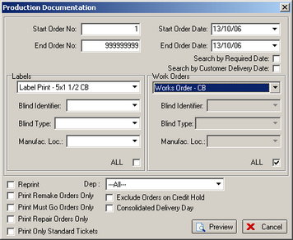

1345. Order Processing > Orders > Component Detail Entry

When you are looking up records by product description, it is now showing the full product description in the lookup box.

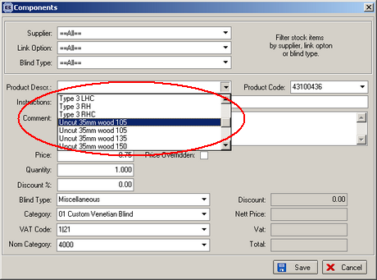

1346. Order Processing > Orders > Component Detail Entry

When you are looking up records by product code, they now display in alphabetical order.

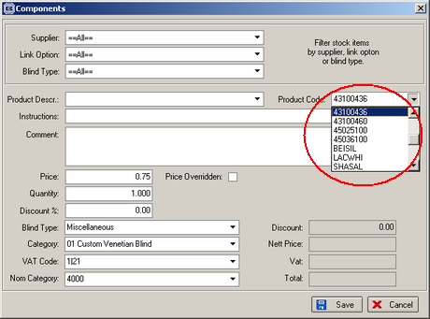

1347. Administration > Import from Excel > Discounts

The following error occured when trying to import discount records. Fixed.

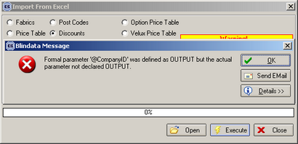

1349. Works Order – CB

- A component line had been entered with a quantity of 500, but the ‘Only One WO Label’ is set to true for the product. It should only have printed one line, but printed 500. Fixed.
- We created a box in the bottom left hand corner of the report. It is not required as the box is already showing on the preprinted stationery.

1350. Order Processing > Orders > Component Detail Entry

This now display the price to 3 decimal places.

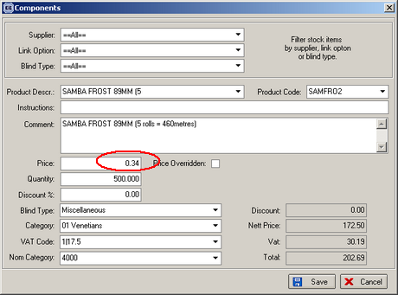

New Work and Customer Requests

200. Reports > Sales Analysis > Sales Analysis by All Blind Types

This new report is identical to ‘Sales Analysis by Blind Type’, except if the number of blinds for a blind type is zero, a line appears with zeros against value, cost, profit and quantity. The report is called ‘Sales Analysis by All Blind Types’. In the existing ‘Sales Analysis by Blind Type’ report, a blind type is not shown if there are no records in the period entered.

350. System Wide Change

When entering the second part of a postcode, the letters now automatically get entered in upper case.

362. Blind Details > Blind Types

Previously we could flag a blind type as requiring a chain length amount. If this field is flagged, then the order detail line chain length defaulted to 75% of the chain length. We have made this more sophisticated, so the default can be applied to each blind type.

There are now two different types of default:

- A percentage of the drop
- A default amount (in mm) to be deducted from the drop.

We now hold one of each against each blind type record that has ‘Chain Length’ = true. Only one of the values can be applicable in the order detail line entry, so we validate the two fields to make sure that one of them is 0.

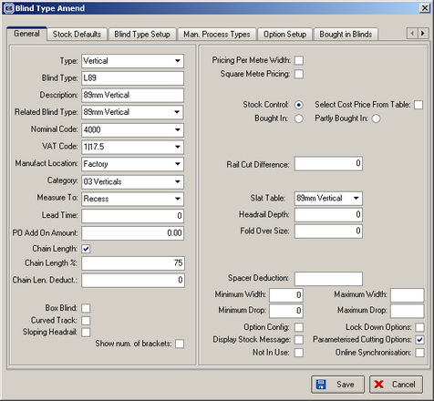

375. Order Processing > Fitters Sheet / Sales Lead

We can now show the number of blinds on each appointment for fitting. Previously it only showed the total at the top of a fitter day.

410. Panel Blinds

Recently we created a new blind identifier, Panel Blind (J). We have now created some extra features for this.

- There are two new forms in Administration > System Tables called Single Bunch Panel Blinds and Split Bunch Panel Blinds. The underlying table holds number of panels, number of channels, single/split (true/false), blind width, panel size.
- When a detail line is entered for a panel blind, we need to know the number of panels. There is a field to enter this (similar to the way the number of vanes is entered for a vanes only blind).
- One of the options set up will be single/split bunch, because we need to know if all the panels will go to one side or be split (just like a vertical blind).
- On the works order, we now display the number of panels, the number of channels and the width of the panels.

413. Financials > Post Credits to Sage

When exporting credit records using the ‘Line 50 Export File’ button, the file exported now has the same format as the ‘Post Invoices to Sage’ file for Line 50. In the file itself, in field 1, “SI” for an invoice has been replaced by “SC” for a credit note.

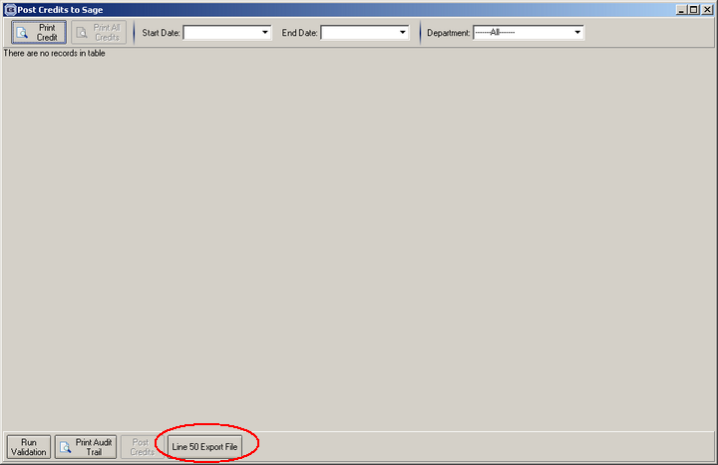

417. Sales Files > Customers

There is a new flag called ‘Direct Delivery by Supplier’ which is true/false. If this is set to true, then the ‘Direct Delivery by Supplier’ flag will be set to true when an order is entered.

418. EDI Transfer / Import

If ‘Direct Delivery to Supplier’ is set to true, we now include the ‘Delivery Company Name’ in the EDI file to be transferred and then imported.

419. Label Print – 5 x 1 ½ CB

- ‘Delivery Company Name’ has replaced the customer name.
- Instead of separating the metric and imperial sizes by a’/’, the imperial sizes are now in brackets, like this ‘(45 3/8)’. The reason for doing this is that you can have fractions and there will be too many of these /, which may confuse someone in the factory.

420. Order Processing > Orders > Component Detail Entry

There is now a lookup by product description as well as product code.

