Blindata Release Note 3.1.9 

29 September 2006

Bug Fixes and Enhancements

1304. Posting Receipt as Invoice to Sage

The following message appeared when trying to post a receipt as an invoice, but is more more specific to tell the user that the nominal code is missing. The message says ‘Nominal code (xxxx) is not set up in Sage. The receipt cannot be posted until this has been rectified.’

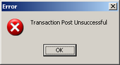

1305. Pricing > Export to Excel

‘Exel’ is now spelt ‘Excel’.

1306. Order Processing > Orders

This message now says ‘Do you want to create an immediate invoice for this order, which will be processed later?’

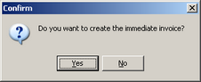

1307. Reports > Sales Analysis > Sales Analysis by Category

The report now prints all values to 2 decimal places.

1308. Reports > Sales Analysis > Sales Analysis by Category

Categories are now selected from the order detail line instead of the blind type. This means the report is now accurate.

1309. Order Processing > Orders

When entering a new sales order, a message now appears if the same customer reference has already been entered in an existing order for the same customer. This was omitted previously.

New Work and Customer Requests

202. Sales Files > Customers > Email Order Acknowledgements
There is now an option to define the format of the order acknowledgement that is sent to a customer. If the recipient of the email cannot receive html formatted emails, then this field should be ticked.

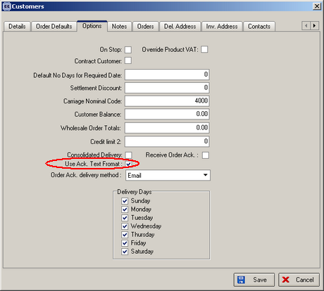

269. Customer Discounts Report

There is a new report in Reports > System Reports that prints out the discounts that are set up in the system. There is an option to select by customer.

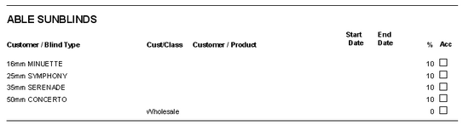

328. Order Enquiry > WIP Scan

The 'Not enough stock' message that can appear when an order is being processed also now appears when an order is scanned into WIP.

345. Cost Price Table Calculation

There is a new menu option in Pricing for ‘Cost Price Table Calculation’.

The purpose of this new feature is to generate cost price tables for blinds by calculating the cost price from the bill of materials for each width and drop and then filling the cost price table for that blind type and fabric group.
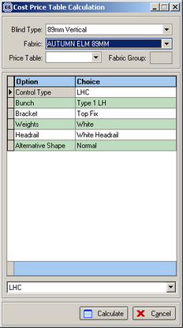

Functionality

The user can enter a blind type (from a lookup), a fabric group (from a lookup) and a price table (from a lookup) to find the widths and drops and a price table (from a lookup). After the blind type is chosen, the options for that blind type will be displayed with the defaults in place. All that needs to be done after that is to click on the ‘Calculate’ button. A cost price table will then be generated for that blind type and fabric group.

365. Order Processing > Orders
When a quote is converted to an order, you can now see the quotes history in the order 'view history'. It also shows who converted the quote to an order and when.

372. Sales Files > Customers

Two new fields have been created in the customer record to determine settings for sending order acknowledgements.

A Yes/No flag field is now held against the customer to distinguish if a customer wishes to receive Order Acknowledgements. When the order acknowledgement is printed it, the program checks the flag. If set to yes, the order acknowledgement is processed; if it is set to no then a message will be displayed stating ‘This customer has requested not to receive order acknowledgements - are you sure you wish to print or email?’

Method of receiving Order Acknowledgement - another field is now held against the customer to distinguish the way in which a customer wishes to receive Order Acknowledgements, whether it be via fax, email, post etc. If it is set to email then a message will be displayed stating that this customer has requested to receive order acknowledgements via email - if you go to print, are you sure you wish to print and vice-versa for email to print.

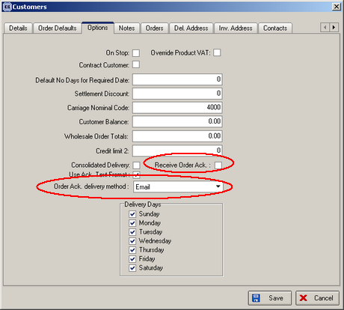

395. Order Processing > Orders

If a customer creates a sales order, but doesn't create any blinds on it and then goes to save the order, a message now says ’You have not entered any detail lines on the order’. It still allow you to save the order, though.

407. Sales Files > Customers

There is a new table being held against the customer record. This holds blind type and category. To access this, there is a new tab on the Customers form called ‘Categories’.

When a detail line in an order is entered, the system now checks this new table to see if there is a record that matches the customer and the blind type. If so, it stores the category it finds in the detail record. If there is no record, the category is taken (as it currently is) from the blind type record.

This functionality has also been included in the EDI import.

