Blindata Release Note 3.1.5 

4 September 2006

Bug Fixes and Enhancements

1251. Sales Analysis by Rep by Customer Detailed

This report is now printing the correct information.

1252. Fitters Sheet / Sales Lead

After converting a sales lead to an order or quote (for a sales lead that is in a day other than today), the diary went back to the current date. It now stays on the date selected.

1253. Fitters Sheet / Sales Lead

The rep is now copied from the sales lead to the order when converting from a sales lead to an order (or quotation).

1254. Order Processing > Orders

The operator may not know who the fitter is at the order entry point, so this is no longer mandatory.

1255. Works Order – Label Blind Size

We have fitted the number of vanes onto the two top labels, in between ‘H’rail Cut’ and ‘Fit’.
The space to print special instructions is now bigger. We also changed ‘Instructions:’ to say ‘Ins:’

1256. Orders > Component Detail Line Entry

When inputting a Component, the cursor now starts in Product, then goes to each field in descending order on the form.

1257. Quotation – Bespoke 10

We have some changes to the layout of the quotation.

- The comment line now prints out properly.
- The detail line totals do not appear if flagged to not appear.
- The quotation text now appears properly.

1258. Quotation – Bespoke 9

The same changes need to be made in this report as have to be done in 1257.

1259. Fitters Sheet / Sales Lead > Sales Lead Individual Normal

If the comments field contains too much text, the report slipped onto the next page. Fixed.

1260. Invoice – Bespoke 10

This is now lining up properly.

1263. Order Processing > Fitters Sheet / Sales Lead > Sales Lead Enquiry

The postcodes were being displayed in a strange way. There is now only one space between the first and second part of the postcode. The postcodes can now be found easily.

1266. Blind Details > Blind Type > Blind Type Setup

‘Custumer’ is now spelt ‘Customer’.

1267. Works Order Portrait

The width and drop no longer appear if blind identifier = miscellaneous.

1272. Administration > System Tables > Department

The following error message appeared when you tried to save a record in department in company 2 (if it already exists in company 1). Fixed.

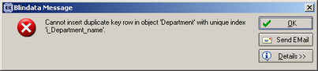

1273. Administration > System Tables > Order Source

The following error message appeared when you tried to save a record in Order Source in company 2 (if it already exists in company 1). Fixed.

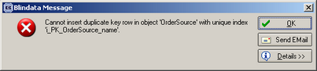

1275. Invoice – Bespoke 10

For a component line, the Comment now prints out instead of the blind type.

New Work and Customer Requests

344. Multi Company Functionality

The system is now completely multi company ie all blind types, fabrics etc will be held in their own company.

If you want to create a new company, go to Administration > Company Details and click on the ‘Add New Company’ button.

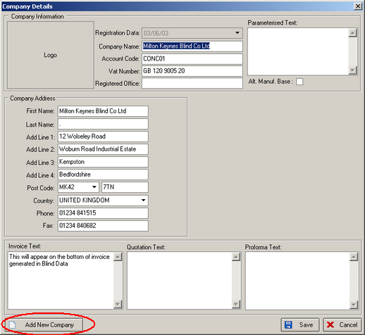

This will prompt you with the following screen. You can then fill in the details. After this you should log out and then back into the new company. A default username and password of admin and admin will have been set up.

