Blindata Release Note 3.1.3 

18 August 2006

Bug Fixes and Enhancements

1239. Order Processing > Order Enquiry > Blind Made Scan

If an order only has two miscellaneous lines on it, and they are scanned individually using the ‘Blind Made Scan’ button, after the second line is scanned, the user is now prompted to say if the order should become ‘Fully Manufactured’.

1244. Reports > Receipts by Type

The contact name (from order entry screen) was missing in this report. Fixed.

1245. Order Processing > Orders / Purchase Orders

A sales order component line has been entered for a quantity of 3.111 now displays and prints everywhere as 3.111.

1246. Invoice – Bespoke 11

- Moved invoice address 4 characters to the right and two lines down.
- Instead of ‘Account Code’, we now print ‘Cust Ord No’.
- Neither discount or quantity now appear if ‘Hide Detail Line Totals’ is true.

New Work and Customer Requests

337. Allocate Payment Update to Sage (Major Enhancement)

We now have a facility to post payments(receipts) to Sage as well as invoices. If a receipt has been entered against an order, we are now able to post this to Sage at the same time as the invoice is posted.

Previously we had the following parameters available in Administration > Parameters > Sage Parameters / Invoicing for retail order posting:

- Post Retail Invoices
- Post Deposits and Balances to Sage
- Manual Batch Post Receipts to Sage

We have added a new parameter:

4. Update and Allocate Receipts to Invoices

It defaults to False. If this is set to true, then the system must post receipts to Sage along with the invoice.
If we post a receipt to Sage at the same time as posting an invoice, the Sage sales ledger looks like this:

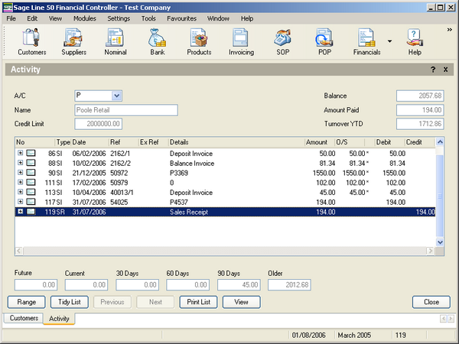

The sales receipt has been posted to the correct sales account and been allocated to the correct invoice.

New field in the receipts table.

To clarify matters, there is an extra field on the receipts form. Previously we had a field (circled) called ‘Posted to Sage’. This has been renamed ‘Inv. Posted to Sage’ and there is a new field called ‘Receipt Posted to Sage’. This field is set to true when the receipt is posted.

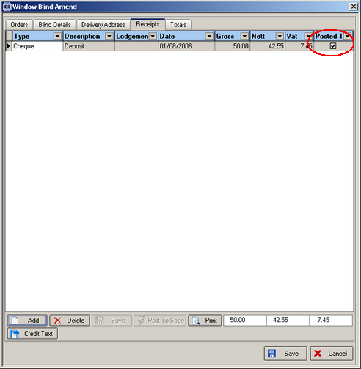

There are now a number of different cases that can be set for the parameters

Case 1: If 1 is set to true, then 2 and 3 must be false, 4 is set to true.
Case 2: If 1 is set to true, then 2 and 3 must be false, 4 is set to false.

Case 3: If 2 is true, then 1 and 3 must be false, 4 may be true.
Case 4: If 2 is true, then 1 and 3 must be false, 4 may be false.

Case 5: If 3 is true, then 1, 2 and 4 must be false.

Functionality

Case 1

There are three ways this could be done:

If 1 is true and 4 is true, the invoice and the receipt must be posted to Sage. This may be a receipt for the full amount of the invoice, or it may only be a deposit. If it is only a deposit (ie the balance > 0), the order status is changed to ‘Part Posted’. This will be done using the ‘Post Invoice’ button in Orders or in Financials, or in ‘Post Invoices to Sage’.

We then need to post the remaining receipt amount to Sage after the receipt is entered against the order. This should be done in the receipts screen.

Case 2

This will do what the system currently does. Invoices get updated to Sage, payments do not.

Case 3

Both invoices and payments get updated to Sage for deposits. Only invoices get updated for balances when deliveries are created. The balance payment gets updated when the receipt is entered in Receipts and the ‘Post to Sage’ button is pressed.

The order status cannot be changed to ‘Invoice Posted’ until the balance = 0.

Case 4

This will do what the system currently does. Invoices get updated to Sage for deposits and for balances when deliveries are created.

Case 5

This will do what the system currently does.

The following specific changes have been made:

1. Added a new flag ‘Update and Allocate Receipts to Invoices’ to Parameters form, this flag can be enabled only if the flag Post Retail Invoices = True.
2. Added a new field ‘Receipt Posted to Sage’, its default value is False, and it is set to True after the payment is posted to Sage.
3. Added a new field Bank Code to the system table Nominal Code. It can be set to True only for one Nominal Code record.
4. Developed the functionality to post Receipts to Sage when the parameter ‘Post Retail Invoices’ and ‘Update and Allocate Receipts to Invoices’ (Case 1) on the form Order Amend > Receipts are enabled (Post To Sage button).
5. During the operation of posting an invoice into Sage we added the functionality to tie the payments by one invoice and the invoice in Sage.
6. Developed the functionality to post an invoice and receipt to Sage for Case 3.

355. Invoice – Bespoke 2

The order contact name now prints on the invoice.

356. Acknowledgement – Laser Print

If Administration > Parameters > Use Department Filter = true, the company address in this report is now taken from the department record instead of from Administration > Company Details.

357. Financials > Complete Posting of Invoices

There is now an option to choose department as well as start and end invoice date.

360. Quotation – Bespoke 9

The following changes are required:

- Moved ‘Qty’ across to the right, just to the left of ‘Nett price’.
- Removed ‘Description’
- Moved ‘Nett Price’ and nett price field 10mm to the left.
- Moved quantity field across to the right, just to the left of the nett price.
- Moved total fields 10mm to the left.
- All text on the quotation is in 10 pitch.
- The invoice address should has moved slightly right to line up with the other text on the page.

361. Acknowledgement – Laser Print

We now show ‘Order Notes’ and ‘Fitting Date’ on this report. Also instead of ‘Order Contact Name / Telephone Number’ on the same line, they should be separated and put on separate lines with ‘Contact Name’ and ‘Telephone No’ shown.

If any of these fields are null, then they are not shown.

Also ‘Location’ is shown (from order detail line), but not if null.

370. Order Processing > Fitters Sheet / Sales Lead

There is a new field in the sales lead entry form called ‘Company Name’. This is a free text field so a user can enter a name for a company as well as a contact name.

