Blindata Release Note 3.1.1 

04 August 2006

Bug Fixes and Enhancements

1218. Financials > Invoice Batch Print - Urgent

An error message ‘Out of memory’ or ‘Unspecified error’ was appearing when you tried to run this report. The stored procedure has been optimised and the problem is fixed.

1221. Order Processing > Orders

The message now says ‘This blind type is not in use’.

1222. Invoice – Bespoke 5

There was a problem when printing an invoice (batch or individual) that contains a component line. The nett price and total did not get displayed in the detail line. Fixed.

1223. Sales Lead Individual Extra

The following changes have been made:

- The name has title, first and last name concatenated.
- The postcode now prints and the telephone number has been moved down slightly.
- If ‘Enquiry Type’ = Shop, it prints. If ‘Phone’, now also prints.
- It always printed the same operator. Now prints the operator who entered the sales lead.
- We have removed ‘Suggested/’, and changed text to ‘Requested Time’ only.

1224. Order Processing > Orders > Receipts

The message now says ‘Are you sure you want to delete this record?’.

1225. Financials > Invoice Batch Post

After the invoices have been printed, the order status changes to ‘Invoice Printed’. It was remaining at ‘Invoice Created’. Temp bug now fixed.

New Work and Customer Requests

238. Sales Files > Customers > Listing

It is now possible to print out the details for a customer. This can be done by selecting a customer on the customer enquiry form and the choosing the ‘Listing’ button.

299. Sales Lead History

We can now record if a sales lead has been moved and who moved it. We can view this information by right clicking on an appointment (similar to the way we can view the history of an order). The following information is displayed.

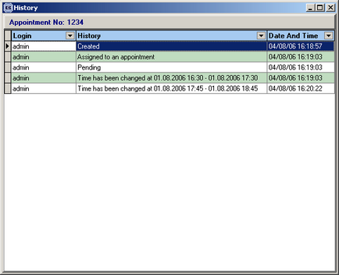

302. Rep Diaries

There is a new button on the Fitters Sheet / Sales Lead screen called ‘General Diary Entry’. This enables you to enter a diary entry for an employee that is not related to a sales lead or to a fitting. For example, it could be used for a holiday or a dental appointment.

If you click on the ‘General Diary Entry’ button, the following form will be displayed:

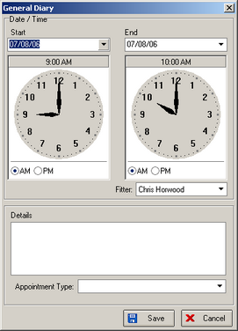

A new table has been created in Administration > System Tables > Appointment Types to hold appointment types.

320. Amendments for Blindata Online

In the very near future, it will be possible to enter orders online for Blindata and synchronise them with the desktop version. As part of this project, we have done some preparatory work on the desktop version. We have included fields to identify which blind types are to be synchronised and which options will be used in the online version. These changes are in the blind type form:

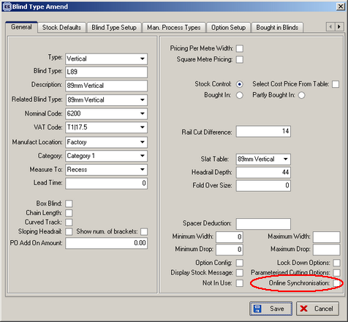

It will also be possible to determine which options are shown on the online version:

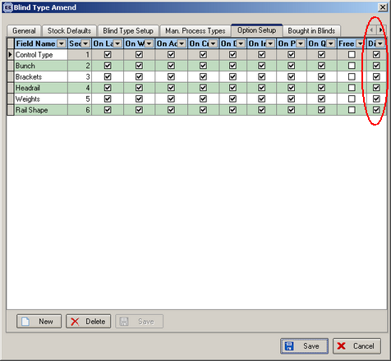

We also have fields in the customer record for login and password.

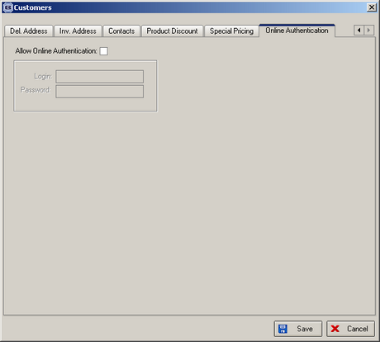

334. Administration > Parameters

There is now an advanced permission to control whether a user can delete a logged user record.

