Blindata Release Note 3.0.9 

28 July 2006

Bug Fixes and Enhancements

1207. Fitters Sheet / Sales Lead

When you do the ‘Postcode Anywhere’ postcode lookup, a box displays the address like this:

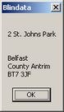

This address has a blank second line. Previously this then filled the sales lead address like this:

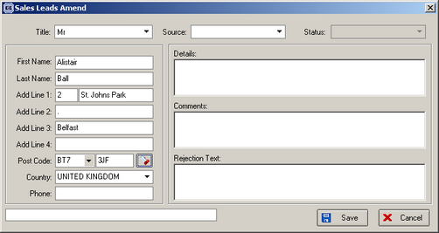

The address is now filled as follows:

Add line 1: 2 St. Johns Park
Add line 2: Belfast
Add line 3: County Antrim
Add line 4: null

In other words, if there is a blank address line, the lines below it get moved up one, instead of a dot (.) being put in.

1208. Administration > Maintenance > Clear Orders

If you tried to clear out all the orders in a very large database, you got a timeout error. Fixed.

1209. Logging In Issues

If a VPN connection is lost, there is the possibility that the user will still be recorded as being logged in, and will therefore not be able to get into the system. We have introduced a ‘Delete’ button in Administration > Parameters > Logged Users to free the user login record and allow the user to log in again.

1210. Order Processing > Orders

If you create an invoice straight from an order & missed out the production documentation, delivery note process etc, the despatch date on the invoice printed out default to a date in 31/12/1899. This now writes the invoice date to the delivery date.

1211. Credit Note (Letterhead)

Country is no longer printed. The postcode has been moved up to print below the last address line.

1212. Credit Letters

We have removed the Country field from all the credit letters and put the postcode beneath the address.

New Work and Customer Requests

16. Stocktaking

A facility has been introduced to allow stock take figures to be entered. The following functionality is required:

A stock take report is now available in Reports > Stock Take Report – there are options to allow the sorting and selecting of records to be printed.

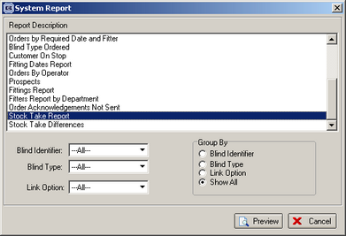

A blank column is available on the actual reportfor writing down actual stock levels. Fields shown are stock code, stock description, location, pack quantity, stock in hand, blank field.

There is a new field in the Fabrics table called ‘Stock Held’. Records are not be included in the stock take report if ‘stock held’ is false.
There is a new screen that will allow the quick entry of actual stock levels against stock items. A stock quantity can be entered (which will be the stock take figure), the difference between the stock quantity and stock take figure will be calculated and a stock transaction adjustment figure will be created which will be the difference between the two figures. This form is on the menu Stock Setup, and is called ‘Stock Take Entry’.

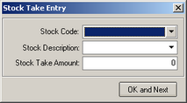

A report is now available that displays stock differences. This lists stock adjustments for the stock take. It is in Reports > System Reports.

275. Part Deliveries

It is now possible to issue part deliveries in the system. The following changes have been made:

- A new detail status called ‘Blind Delivered’ has been created.
- A new detail status called ‘Part Delivered’ has been created.
- A new order status called ‘Part Delivered’ has been created.
- Two new buttons are available on the Order Enquiry form, called ‘Deliver Blind’ and ‘Deliver Blind Scan’.
- If ‘Deliver Blind’ is clicked, the program checks to see if the blind has a status of ‘Blind Manufactured’ or ‘Fully Manufactured’. If so, the user is prompted with the message’ Do you want to deliver this blind?’. If the status of the blind is not ‘Blind Manufactured’ or ‘Fully Manufactured’, a message says ‘This blind has not yet been manufactured. The program also checks that the order is not on credit hold and that quality control is not required. Once the blind has been delivered, the status of that blind changes to ‘Blind Delivered’ and the status of the order to ‘Part Delivered’. If all the blinds in the order have been delivered, the status of the order changes to ‘Delivered’. The delivery docket will then print, but will only show the actual blinds that are to be delivered.
- If ‘Deliver Blind Scan’ is clicked, the user is prompted to scan the works order label to allow delivering of the blind. The blind can only be delivered if it has a status ‘Blind Manufactured’ or ‘Fully Manufactured’, and also the program checks that the order is not on credit hold and that quality control is not required. Once the blind has been delivered, the status of that blind changes to ‘Blind Delivered’ and the status of the order to ‘Part Delivered’. If all the blinds in the order have been delivered, the status of the order changes to ‘Delivered’. The delivery docket then prints, but only shows the actual blinds that are to be delivered.

It is now possible that you could have a situation where some blinds in an order are delivered but others have not yet been manufactured. This means we have had to alter the status rules when the last blind in an order is manufactured. Previously, the status of the order changed to ‘Fully Manufactured’ at this point. But if a blind is already delivered, and the last blind in the order is manufactured, the status of that order will be ‘Part Delivered’. In this case, when the final blind is manufactured, the status of the order remains as ‘Part Delivered’, but the status of the blind will change to ‘Blind Manufactured’.

We could also have a situation where the quantity on a detail line is > 1. If the shop floor system is enabled, then it is also possible to part deliver a detail line.

326. Quotation – Laser Print (Letterhead)

- Rep now appears on the quote.
- The department address prints if the department filter is true.
- Country has been removed and the postcode moved up a line.

331. Archiving Retail Orders

There is a parameter that will stop retail orders that are being archived from getting invoice numbers. This is called ‘Manual Batch Post Receipts to Sage’ and is held in Administration > Parameters > Sage Parameters / Invoicing. It defaults to false. If it is switched to true, then both ‘Post Retail Invoices’ and ‘Post Deposits and Balances to Sage’ get set to false.

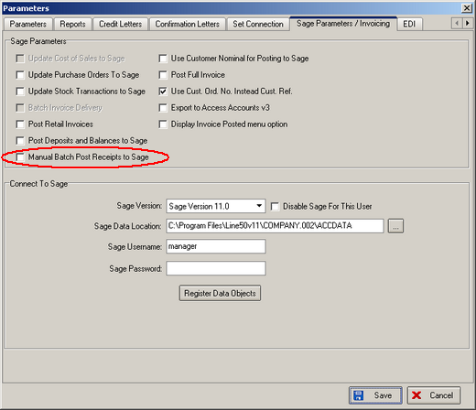

When the archive gets done automatically (after delivery and when the balance = 0), an invoice number is not be allocated to an order.

332. Amending Order Date

We have had requests from customers who wants to be able to amend the order date in an order. This has become an option in Administration > Users > Advanced Permissions > Order.

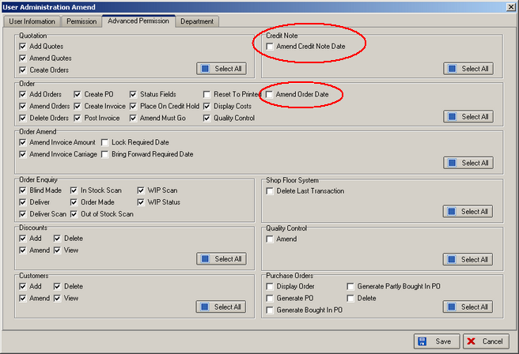

333. Amending Credit Note Date

It is now possible to amend a credit note date at any time prior to the credit note being posted. There is a new advanced permission option for this (see above screenshot).

