Blindata Release Note 3.0.7 

18 July 2006

Bug Fixes and Enhancements

1183. Works Order A4 Individual

This report has been is fully optimised.

1195. Customer Defaults

Customer defaults now take priority over defaults held against fabrics when entering order detail lines.

1198. Works Order Label Print

The drop field was being cut off by the cust. order no. field. Fixed.

1199. Credit Note Problems

The credit letters are now picking up the invoice address instead of the delivery address.

New Work and Customer Requests

236. Reports > Sales Analysis > SA by Delivery Date

Sales analysis by delivery date is now available.

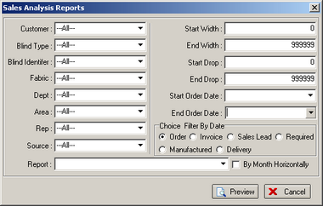

291. Scrap Allowance

We have introduced a scrap allowance percentage field against stock items.

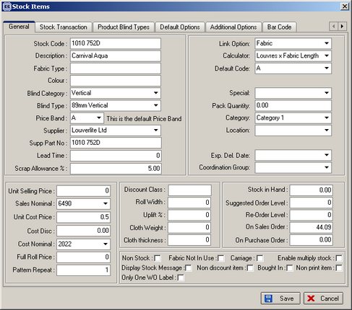

When the bill of materials is now calculated, two cost prices are calculated, one for theoretical cost price and one for a price including the scrap allowance %.

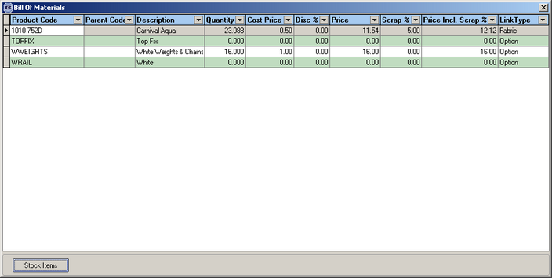

293. Order Processing > Orders > Create PO

Previously this only created purchase orders for bought in blinds. Now it works for regular purchase orders as well. The logic is the same as for ‘Generate PO’ in Purchase order Enquiry, except it will only be generating a purchase order (or orders if more than one supplier) for the one sales order.

298. Velux Code Bill of Materials

We are now able to hold a bill of materials against a Velux Code. The following changes have been made.

- A button has been added to the form Administration > System Tables > Velux Codes so that we can hold data about the bill of materials.

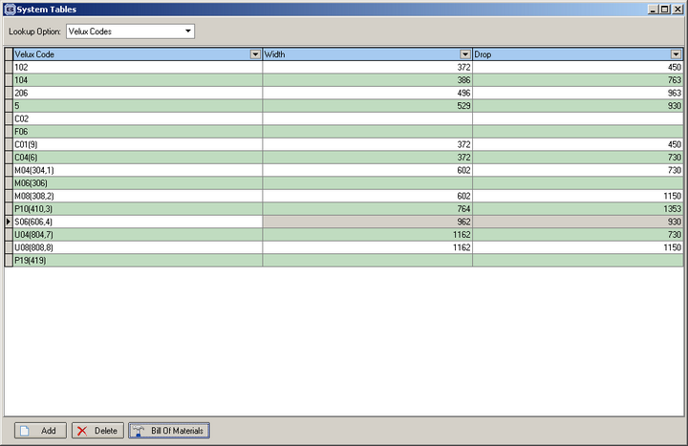

- We have amended the order detail entry so that the bill of materials is picked up from the velux code bill of materials for a velux blind.

314. EDI Development – Phase 2

Phase 2 testing has now been completed. The following items were resolved.

Bugs
- On the email that contained the EDI order, the subject is 'EDI Order', but the content of the mail read 'IDE Order'. Fixed.
- 'Import Customer' stage of the Import Wizard. You could not proceed to the next stage until the down arrow is pressed on the keyboard. Fixed.
- 'Select Import Data' stage of the Import Wizard. If you had 4 orders imported to select from, the system would not let you proceed until I had selected at least 2 of them. It would not let me only select one to continue. Fixed.
- 'Import Blind types' stage. Something strange happened here. One or all of the Blind types did not appear in the list to match up. It let you proceed to the end of the import, but it then failed. If I restarted the import it then worked fine. Fixed.
- The 'Inner Code' field in the Fabric Import and Import Options stages were not in alphabetical order. They are now.
- After the orders were successfully imported, the status of the EDI transaction did not change and remained at 'New EDI Transaction'. Fixed.
- When looking at the orders after the import, the box code has now generated correctly.
- If the customer was over their credit limit, the imported orders now flag as on Credit Hold.
- A blind selected was out of stock and no warning appeared to say so. Fixed.
- 'Move to Special Instructions' was tricky to find as it is in with the list of stock items. It has been moved to the top.
- The maximum and minimum width/drop checks now apply.
- There is now a check for duplicate Customer Refs included as in the standard order entry. It is possible that a customer may email the order and also mistakenly send it by EDI.
- The code and description of the items now appear together in the drop down list to make it quicker to match them up.
- The link option restriction from the Link Options now apply.

Other Issues

- Is the Customer Ref generated from their PO number? Why are the Customer Ref and Customer Order No different? Customer Ref – is the Order Id of the transferred order. Customer Order No – is the PO number of the transferred order.

317. Cord Spacing Calculation

There is now a parameter in the blind type record to determine if the cord spacing calculation should be made from the man width of the blind or from the headrail cut size. The parameter is called ‘Calc cord spacing from headrail cut?’ and defaults to false.

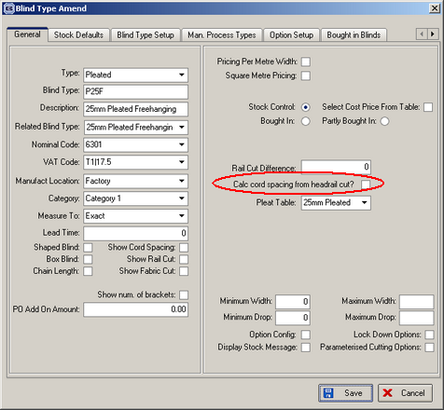

If set to true, the cord spacing should be calculated from (man width – headrail cut difference) instead of just from man width.

319. Stock Total Fix

A maintenance program has been added that will run through all the transactions and then correct the figures for each stock record for stock in hand, on sales order and on purchase order amounts. It does this by checking the stock transactions and then updating the relevant figures in the stock record.

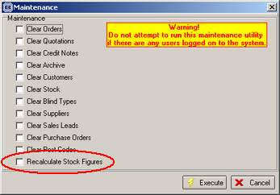

327. Invoice – Sage Laser Print

We have removed the VAT amount from the detail line and inserted a column for Discount %. If there is no discount then the column does not show.

329. Invoice – Bespoke 11

There is a new bespoke invoice layout called ‘Invoice – Bespoke 11’.

