Blindata Release Note 3.0.6 

3 July 2006

Bug Fixes and Enhancements

1156. Invoice – Bespoke 8

The discounts are now displayed to 2 decimal places, ie 43.25 instead of 43.50.

1174. Financials > Daily Sales Report

The dates now appears in the format 23/06/2005, not 23.06.2005.

Some credit notes were being shown as invoice figures. This was incorrect. If a credit note has been archived, it now appears as a credit note in this report, not as an invoice.

1177. Works Order Label Blind Size

If ‘Parameterised Cutting Option’ is set to true in the blind type record, the following fields no longer print on the report.

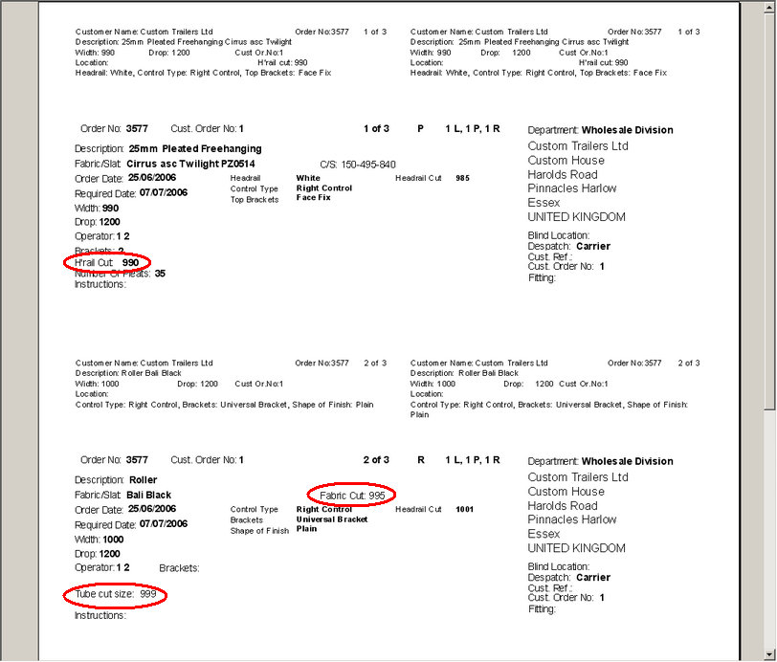

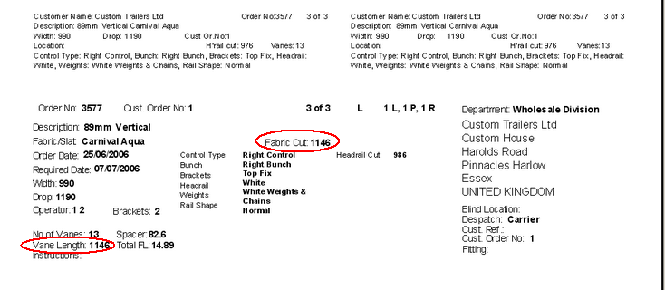

1178. Works Order Label Blind Size

Delivery company name is now appearing properly on address label – it was currently showing customer company name.
Delivery postcode now appears instead of country in address label
Measure to now goes onto large label, above width and drop
Contact name now goes on address label below address.
Top left label – if 1 of >9 is displayed, the last character was falling off the label. Moved slightly to left.
On small top labels, we now show number of slats (if Venetian) and number of pleats (if pleated).
We now show order date on small top two labels, to right of fabric description.

1179. Acknowledgement – Laser Print

Customer company name was wrapping round – fixed.

We have removed country from both addresses and move postcode up a line.

1180. Sales Files > Customers

If the customer name is very long, it did not display properly. We have made the field wider on the form.

There is now a ‘save’ button in the delivery address tab, to save a new delivery address.

1181. Blind Details > Blind Types

In the ‘Blind Type Setup’ there is now a Save button. Also the width add on and drop add on default to 0 when you enter a new record.

1182. Reports > Outstanding Orders

Sort by product (blind type) is now working properly. This is now grouping by blind type when you select by product (blind type).

1184. Stock Setup > Purchase Order Enquiry > Generate PO

When you are manually adding a detail line to a purchase order, the cost price is now being pulled in from the stock record.

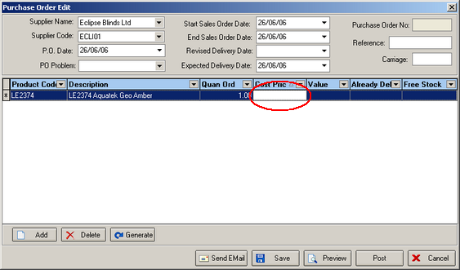

1185. Purchase Order Regular – Standard

- Country is no longer printed – moved address line and postcode up a line.
- Postcode now prints first and second part.
- It printing the id instead of the product code (from the stock record). Fixed.

1186. Stock Items > Calculator Default

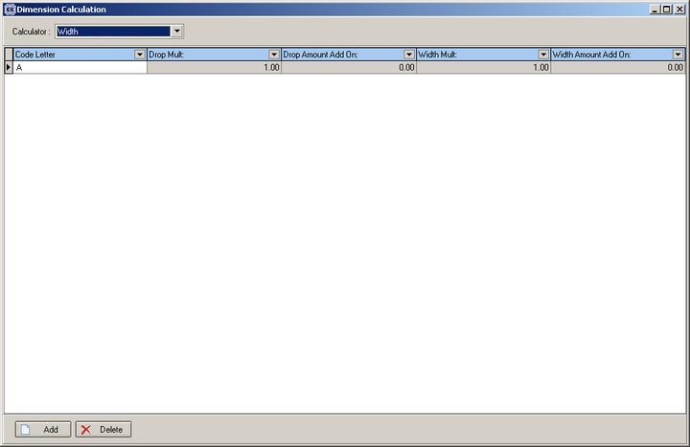

There was no letter showing in the lookup. Fixed.

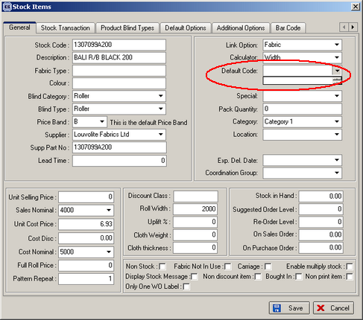

1187. Order Processing > Orders

The selection of default options was not working when entering an order. This has been fixed.

1188. Order Processing > Orders

If you enter an order for a blind, the options list will now appear correctly, when adding numerous detail lines and also whilst amending them.

1190. Sales Files > Customers

There was a bug with the 'view only' customer permissions. Users with this permission had all of the 'amend' buttons disabled for the customers, however they were still able to double click on a customer record and to change it. Fixed.

1191. Order Processing > Orders > Velux Detail Entry

If you entered two velux blinds in an order, the second one does brings up the price of the blind, but didn’t alter the price if you change the Velux code. Fixed.

1192. Works Order Label 1

If you now enter a blind with identifier = ‘Wood Component’, the number of slats print out on the large label.

1193. Blind Details > Blind Types > Field Setup

The option records are now being displayed on this screen.

New Work and Customer Requests

248. Price Table Reports

We want to make some improvements to the price list reports.

- The title should now say ‘Company Name’ Price Tables.
- ‘Print selected’ has been removed.
- The imperial sizes now print to the nearest 1/8 of an inch and are in format 23 5/8 (not 23.625).
- The company logo appears on the price list.

271. Order Acknowledgement Text – New Report

There is a new order acknowledgement report in the system called ‘Acknowledgement – Lead Time Text’. . The lead time text gets printed for each detail line, before the dividing line but after the special instructions.

The following work has been done.

There is a new table called ‘Lead Time Text’ and this has been placed in Blind Details menu. This table contains manufacturing location and lead time text. A new permission is available in Administration > Users > Permissions.

When an order is entered, the lead time text is picked up from the manufacturing location in the blind type that is in the detail line.

A new order acknowledgement report should be created for Decora, called ‘Acknowledgement – Lead Time Text’, and should be based on ‘Acknowledgement – Laser Print’. The lead time text should be printed for each detail line, before the dividing line and after the special instructions.

