Blindata Release Note 3.0.4 

16 June 2006

Bug Fixes and Enhancements

1129. Financials > Create Invoices

Occasionally the status of some orders has reverted back to Order Manufactured even though an Invoice Number is allocated. Fixed.

1131. Quotation Print – Laser Print (Letterhead)

The font size on the quotation stored texts was printing too small is now the same size as the detail line text.

1134. Invoice – Sage Laser Print

- The font has been made slightly bigger for the company name.
- The country has been removed and the postcode moved up a line.
- ‘Tel / Fax:’ has been put in front of the tel number and fax number.
- The font has been reduced to the size used in blind type description in the detail line.

1135. Administration > Parameters > Reports > Batched Invoice

There is now an option for ‘Invoice – Sage Laser Print’.

1136. Label Print – 5 x 1

The headrail cut size is now correct. It is (Man width – rail cut difference (from blind type record)).

We have also included options on this label.

1137. Bespoke Works Order

- The customer company name is now displaying.
- Country has been removed, and replaced by address line 3 and address line 4.
- ‘Pleats’ now only appear for blind identifier = Pleated. If blind identifier = Vertical, Vanes should appear, if blind identifier = Venetian or Wood, Slats should appear. The correct relevant amounts should appear below this.
- The company postcode is now showing properly.

1138. Order Processing > Orders > Receipt Report

- If the department filter is set to true, the address, telephone and fax number on the receipt are now taken from the branch address and not from Administration > Company Details.
- If the title has been filled in, it is now concatenated with the name.

1139. Credit Note Numbers

We made a change for a customer so that separate invoice numbers would be used if the following parameter was set. This now also work for credit notes if this parameter is set.

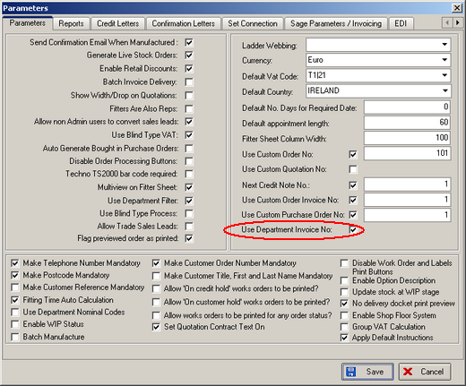

1140. Invoice – Bespoke 2

If a component line is entered, the invoice comment line now prints out instead of the product description.

1141. Financials > Complete Posting of Invoices

When setting the Invoices to ' Invoice Posted' it seemed to affect other users. A warning notice 'Transaction (process D51) was deadlocked on lock resources with another process and has been chosen as the deadlock victim. Fixed.

1142. Financials > Line 50 Export File

The works order was going to the wrong field.

1145. Reports > Sales Analysis by Customer by Nett

This report is supposed to appear in descending order of nett value by customer. It worked properly if you choose by order date, but if you chose by invoice date, it prints in alphabetical order. Fixed.

1148. Financials > Daily Sales Report

- This report now displays the start and end date entered.
- There is more room for the customer name. We have made the font smaller on the line and make more space for the customer description.
- The records now appear in credit note number order, then invoice number order.

1152. Order Processing > Order Enquiry > Deliver

A timeout error was occurring printing a delivery docket. Fixed.

1153. Order Processing > Orders > Detail Line Entry

If you entered special instructions, and then click back on the circled arrow, the special instructions did not get saved. In fact, special instructions only get saved if you go to an options field next. Fixed.

The same problem was happening with fitting instructions.

1157. Quotation – Bespoke 9

If the quotation goes onto a second page or more, the totals are now only displayed on the last page. Also, page numbers (eg 1 of 3) are now displayed to the left of the totals.

1158. Order Processing > Orders

The location was not being saved properly in the detail line. Fixed.

New Work and Customer Requests

