Blindata Release Note 3.0.2 

5 June 2006

Bug Fixes and Enhancements

1075. Works Order – Label 1

If ‘Enable Shop Floor System’ = true in Administration > Parameters, all bar codes should show the serial number and the process.

1096. Works Order Portrait

The parameterised cutting sizes are now appearing on this report.

1097. Order Processing > Orders > Detail Line Entry

The co-ordination code functionality is now working in the order entry program.

1099. All Quotation Prints

Quotation text lines are now printing out on the quotation prints.

1100. Order Processing > Quotations

If you enter a quotation text line as the first detail line in a quotation, and then add a second line as a blind, an error occurred. This has been fixed.

1101. Financials > Create Invoices

If Post Retail Invoices = false in Administration > Parameters, it is now not possible to create an invoice for a retail customer order in Financials > Create Invoices.

1102. Setting Order Status to Invoice Posted

The parameter description ‘Use Sage Line 100’ in Administration > Parameters has been changed to say ‘Disable Order Processing Buttons’

There is a new parameter in Administration > Parameters > Sage Parameters / Invoicing called ‘Display Invoice Posted menu option’. If this is set to true, then the last menu option on the Financials screen is displayed and is called ‘Complete Posting of Invoices’ instead of previously ‘Complete Posting to Sage Line 100’.

1104. Invoice – Bespoke 9

Extra descriptions have been added to this report.

1105. Financials > Post Invoice to Sage > Line 50 Export File

It is now possible to export records by department.

1106. Financials > Post Invoice to Sage > Line 50 Export File

The header record (with field names) is no longer included in the export file.

1107. Financials > Post Invoice to Sage > Line 50 Export File

The export file waincluding records that hadstatus = invoice posted. It nowly include records that have status = invoice printed.

1108. Financials > Post Invoices to Sage > Export Line 50 File

Only the date/Invoice No/Customer reference was transferring to Sage. Now Customer Order No and Works order No to transfer as well. Customer Order no goes into the field ‘Transaction Details’ and order id into field ‘Extra Reference’.

1109. Works Order Label 1

The calculated 'Deduct Each End' total on the tickets was incorrect. It now calculates with the following formula: (Box Code Width - Actual Width)/2.

1110. Order Processing > Orders > Detail Line Entry > Valance Calc

There was a refresh problem on the order entry form when using this functionality. If you changed an option which should affect the size of the valance, the valance option did not update automatically. Fixed.

1113. Order Enquiry > Deliver Order Scan

On the order enquiry screen, if you click 'Deliver Order Scan' for a quality check order, it will despatch it without flagging that the order requires a quality check. However if you click 'Deliver' it works fine.

1114. Administration > Sage Utilities

The following items have been fixed when update Sage customers to Blindata.

1. Town and County in the address was the wrong way round
2. The postcode wasn't converting even when ticked.
3. No Phone or Fax numbers were converting even when ticked.
4. Country was defaulting to Abu Dhabi.

1115. Administration > System Tables

When you removed a postcode that is attached to a supplier it removed the suppliers address record (if the warning was ignored). This meant that the supplier was deleted from the enquiry form. This has been disabled so the postcode cannot be deleted if there are related records.

1116. Stock Setup > Purchase Order Enquiry > Generate PO

If the cost price in a detail line was amended, the whole screen froze and then closed. This has been fixed.

1124. Order Processing > Orders > Detail Entry

If you enter a detail line and change the default measure to from Recess to Blind size, it saves ok. But when you amended the line, it changed back to Recess size. Fixed.

1125. Variable Width and Drop Calculator

The calculated amount is now being divided by 1000.

1126. Order Processing > Orders

Special pricing is now working for retail customers. The last line was calculating the wrong amount. Fixed.

1128. Order Processing > Orders > Component Detail Entry

If you enter a component line, it is now picking up the correct blind type from the stock item record. The problem seemed to happen if there are several blind types where blind identifier = Miscellaneous.

1132. Financials > Post Invoices to Sage > Line 50 Export File

If there was only one record to export, the export did not work. Fixed.

New Work and Customer Requests

115. Special Pricing

There is a new option for special pricing by customer. It is possible to override standard price tables with special prices that can be determined by customer, blind type and specific fabric or fabric group. It is also possible to limit the size of the blinds that the special prices will relate to.
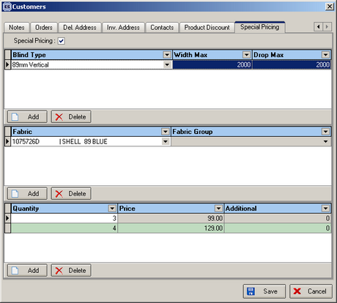

When an order is entered, the program now checks to see if the ‘Special Pricing’ box is checked against the customer. If it is, the program checks the special pricing tables to see if any prices are applicable. It only checks this after all blinds have been entered on the order. For an order to qualify for special pricing discount, the blind type and fabric must be held in this table and the quantity of blinds must be applicable.

219. Customer Duplicate

There is now an option to copy a customer record.

273. Pricing > Option Price Enquiry

There are some option prices that get applied to all blind types. Therefore it is now possible to hold a null in the blind type record, so in the order detail entry, the price is found based purely on the option chosen.

276. Order History

It is now possible to see who took orders off credit hold and when. This is displayed by right clicking on a record and selecting ‘History’.

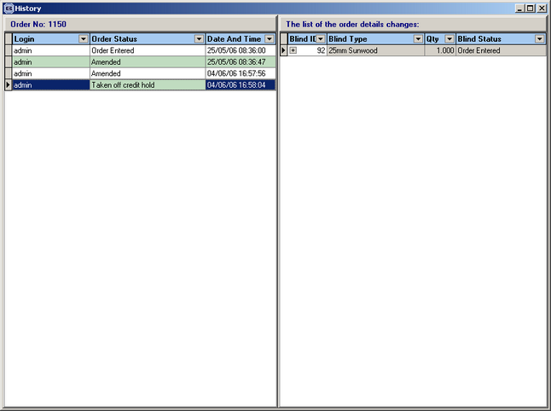

278. Production List > Order Control Report

There is now an option to print the order control report by department.

282. Pricing > Option Price Enquiry

It is now possible to uplift option prices by a percentage. The user can filter records in the enquiry and then uplift all prices for the chosen records by the percentage entered.

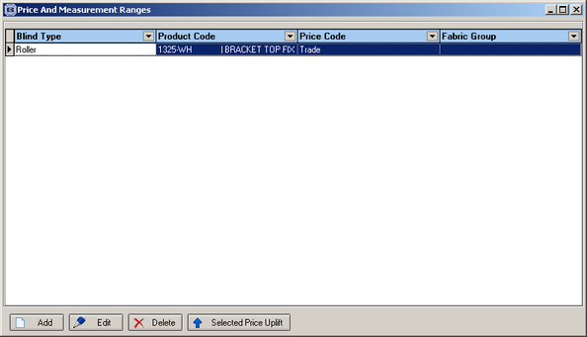

283. Quality Control

There is now an option to lock down the 'Quality Check Required' option on the order entry form. There is a new advanced permission for this in Advanced Permission > Order, called ‘Quality Control’.

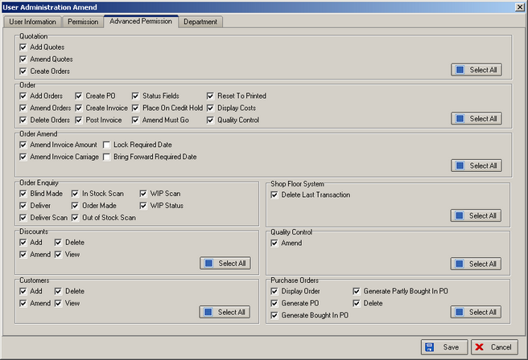

284. Cord length on Works Order Label 1

If the chain length is calculated for a roller blind, it now appears on the works order label.

285. New Calculator

A method was required of calculating the amount of cord used on venetian blinds. The amount of cord used is dependent on the number of ladder webs. Here is an example:

2 Ladders - (3.5 x Drop) + Width
3 Ladders - (6 x Drop) + (1.5 x Width)
4 Ladders - (7 x Drop) + (2 x Width)
5 Ladders - (6 x Drop) + (1.5 x Width)

There is a new calculator that works out the usage dependent on the width variable selected. In this example the number of ladders will be calculated by looking at the width variable. To calculate the amount of cord used, we then need to multiply by width and drop related amounts. This new calculator is a combination of width (or drop) variable, width and drop, and is called ‘Variable Width and Drop’.

In the example above, Width Variable would be used to find out the number of ladders to use. The ‘Values for Width Variable Calculator’ table may look like this:

Code Size Count
A 1000 2
A 1500 3
A 2000 4
A 2500 5

There is now a new field to this table called ‘Width Code’. If the stock item calculator is set to ‘Variable Width and Drop’, it will look for the ‘Width Code’ in the above table. Once this code is found, it will then look in the ‘Dimension Calculations’ table to get the multipliers, where Code Letter = Width Code.

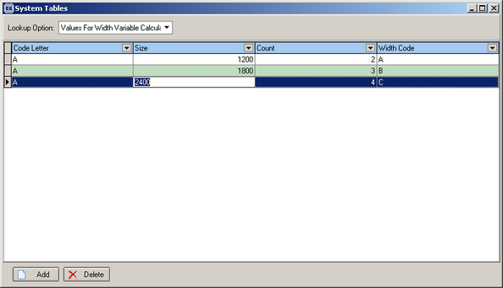

288. Box Blind & Wood Slat Substitution

There is now a true/false button to switch off the substitution – this is held against the blind type and only applies to blind identifiers = wood. If it is switched off, substitution will apply for neither box blinds nor wood slats, valances and bottom bars. The default is True.

