Blindata Release Note 2.9.9 

12 May 2006

Bug Fixes and Enhancements

1028. Optimization of Order Entry Form

We have carried out a review of how to optimize the speed of the Order Detail Amend form. We have separated certain logical sections into separate program functions to get a general picture of this form functionality. Here is the work that has been carried out so far:
- Optimization of ‘Blind Type’ selection.
- Optimization of ‘Fabric’ selection.
- Optimization of inputting ‘Width”.
- Optimization of inputting ‘Drop’.
- Optimization of calling and displaying the ‘Order Detail Amend’ form.

We will continue to improve the speed of the order entry program by carrying out the following in the next week:

- Optimization of the selection of default options for Blind Type and Customer.
- Optimization of prices search for Base price field, Price field and for all options.
- Searching and setting related options (Link Options).
- Optimizing the setting of options for blind types– Wood and Box Blind.

1048. Invoice – Bespoke 4

The following has been changed:

- Moved the fabric description to the left by 20mm.
- The first price in the first line is only be the base price less discount, not (base price + option price less discount).
- Removed Country.
- Move the detail line total amounts down one line so they are level with the option price.

1052. Order Processing > Orders > Delete Detail Line

When a detail line was being deleted in an order, timeouts were sometimes occurring. This process has been optimised.

1053. Sales Analysis by Blind Type by Fabric

The quantities and values were incorrect for this report. Fixed.

1054. Order Processing > Orders

When you enter a detail line for a bought in blind, it was not calculating the cost price properly if the cost price > 1. It left the cost price as if the quantity is 1. Fixed.

1055. Blind Details > Blind Types > Cutting Options

The following message now says ‘You must enter ONLY Width Add On or ONLY Drop Add On.

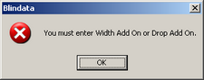

1056. Order Processing > Credit Notes > Status Fields

There is now an option to be able to change the credit note date in here.

1057. Reports > Receipt by Receipt Description Report

The totals were running into each other. Fixed.

1058. Reports > Financial Reports > Deposits for Incomplete Orders

This report now has the same layout as the ‘Deposits by Nominal Report’, but the criteria are as follows:

Instead of asking for a start and end order date, it asks for a cut off date.

Records appear in the report if the (order date <= cut off date) and if the (despatch date = null or despatch date > cut off date) and if order status <> cancelled.

The department criteria are also applied.

1059. Orders > Order Processing

The link options were active for Blind Types whether the link options check box was ticked or not. If the check box is not ticked, they should be inactive in the order entry program. Fixed.

1060. Orders > Order Processing

If you enter an order with a reference that is already in use, you got the warning message, which is fine. However once you click ok to the warning, you could not edit the next field down which is order source. Fixed.

1061. Financials > Post Invoices to Sage

This message appeared when you tred to open ‘Post Invoices to Sage’. The same message appeared when you open ‘Post Credits to Sage’. Fixed.

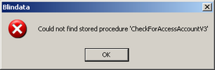

1062. Financial Reports > Outstanding Retail Debtors

This now compares the invoice date to the debtor date (instead of comparing delivery date to debtor date).

Also, it now display the invoice date in the report.

1063. Financial Reports > Balance Invoice report

This report no longer includes invoices that are ‘on hold’.

1069. Invoice – Bespoke 2

There were problems with this invoice print, which have been fixed.
- The detail now prints the comment line for a component detail entry (regular was working, batch was not).
- The box in the bottom left was not showing the VAT properly. If the detail lines had different VAT rates (21% and 13.5%), there should be two lines – not one. The lines are now grouped by the VAT rate.

1070. Order Processing > Orders > Component Detail Entry

When you entered a component line, after entering price and then changing the quantity, the price got zeroised. Fixed.

1071. Reports> Receipt by Type

This report is now in Receipt Number order instead of works order number within receipt type.

New Work and Customer Requests

206. Changing Status from Order Entered to Order Printed

It is now possible print preview works orders (from the order amend enquiry form) but not have the status of the order changed from ‘Order Entered’ to ‘Order Printed’. The status of the order only changes to ‘Order Printed’ if the works order is actually printed. This can be set with a new parameter in Administration > Parameters, called ‘Flag previewed order as printed’.

254. Order Processing > Fitters Sheet / Sales Leads

We can now display the appointments in a tabular format. There is a new button on the form called ‘Fitters Sheet / Sales lead Enquiry’.

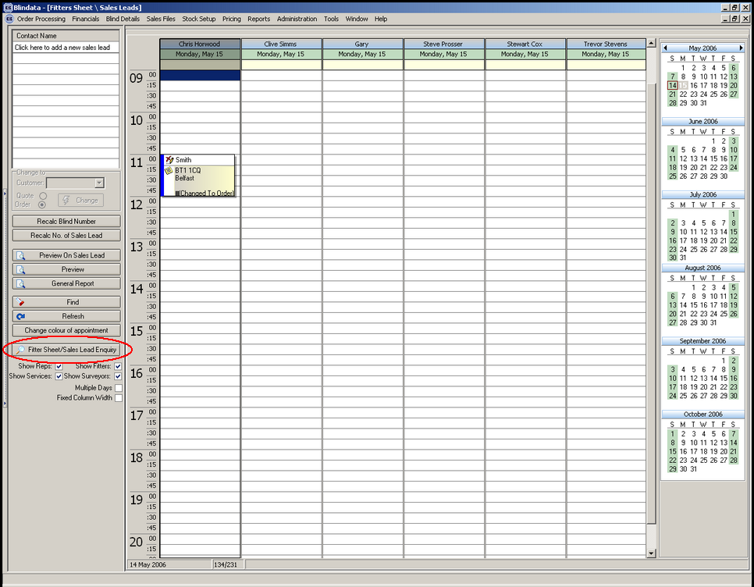

261. New Calculator – Width/Drop Variable

There is a new calculator called Width/Drop Variable. This will calculate the quantity of stock to be used depending on the width and drop of a blind. There is a new table in System Tables called Width and Drop Variables which holds the following:

Code Letter
Width
Drop
Quantity

It will behave in the same way as calculators ‘Width Variable’ or ‘Drop Variable’, except that it is checking width and drop before finding the quantity to be used.

263. Invoice – Bespoke 10

There is a new invoice layout. The invoice details contain blind type description, fabric description, quantity on first line, then options on second line.

266. Archive Enquiry

We are now able to view details and history in the archive in the same way it is done in order amend enquiry.

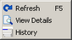

267. Advanced Permissions

We now have another new advanced permission for orders called ‘Display Costs’. If this is set to true, then the following fields and buttons are visible:

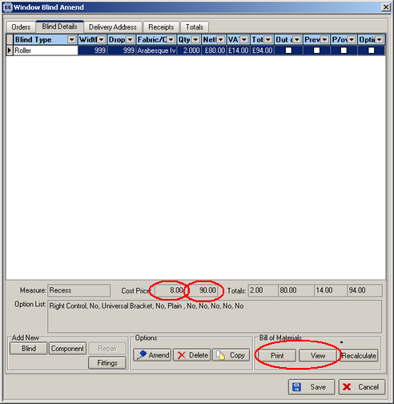

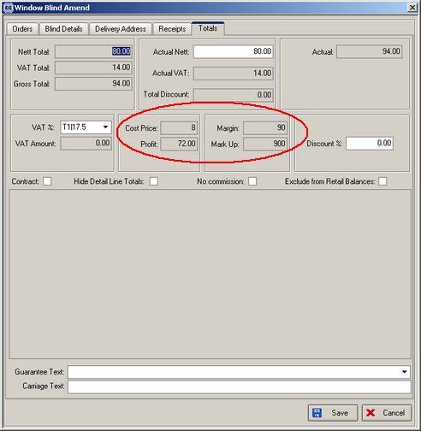

268. Required Date Locking

There is a new advanced permission called ‘Bring Forward Required Date’. It is now possible to stop certain users bringing the required date forward (ie changing it to a date < the calculated required date), but still be able to amend it to later than this date.

