Blindata Release Note 2.9.8 

9 May 2006

Bug Fixes and Enhancements

1042. Administration > Parameters > Automated Tasks

The automated invoice creation routine no longer takes place at weekends or on holidays. Please make sure the correct information is entered in Administration > Holidays/Weekend.

1043. Administration > System Tables > Values for Drop Variable Calculator

When you add a record to this form, it then appeared in the ‘Values for Width Variable Calculator’ form instead of the ‘Values for Drop Variable Calculator’ form. Fixed.

1044. Sales Files > Customers > Print Label

This now only prints a label with the customer address on it – nothing else. The circled information no longer prints.

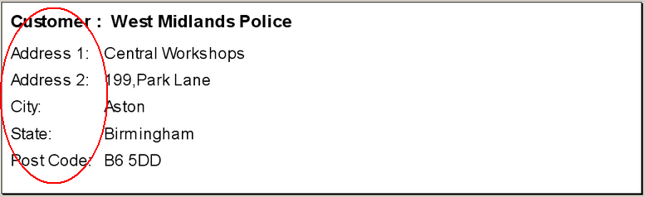

1045. Invoice – Bespoke 3

The following changes have been made to the invoice for a RETAIL sale.

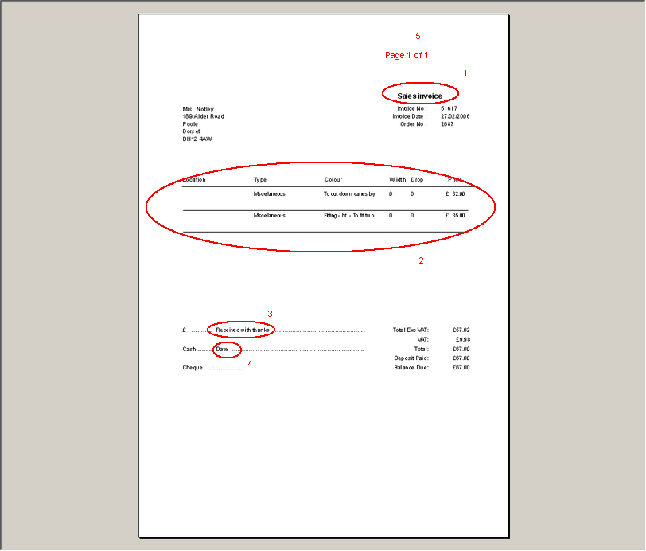

- ‘Sales invoice’ now says ‘Sales Invoice’.
- The detail lines have been moved up a bit so you can fit more onto the page.
- ‘Received with thanks’ has been moved 10mm to the right to allow more space for writing in an amount.
- ‘Date’ has also been moved 10mm to the right.
- ‘Page 1 of n’ appears here.

1046. Invoice – Bespoke 3

The following changes have been made to the invoice for a TRADE sale.

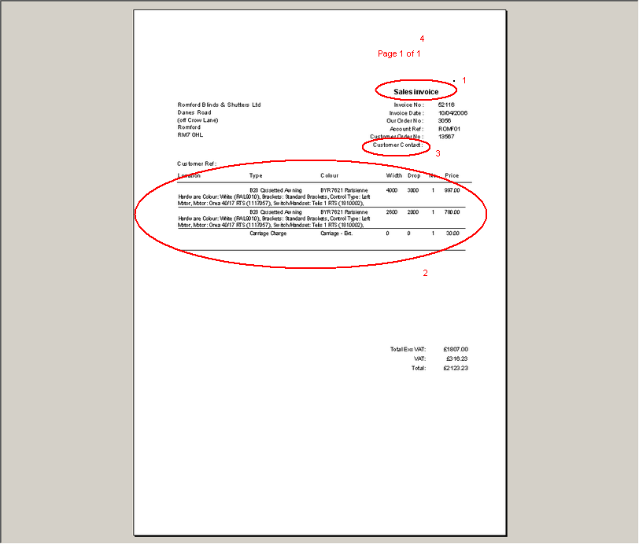

- ‘Sales invoice’ now says ‘Sales Invoice’.
- The detail lines have been moved up a bit so you can fit more onto the page.
- ‘Customer Contact’ now say ‘Contact’ and the contact name starts 20mm to the left so more room is available.
- ‘Page 1 of n’ appears here.

1047. Archive Enquiry > Reset to Printed

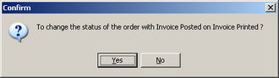

This message now says ‘Do you want to change the status of this order from Invoice Posted to Invoice Printed?’

1049. Archive > Reset to Printed

When you reset a credit note backed to printed, it can now be seen in Order Processing > Credit Notes.

1050. Order Processing > Credit Notes

The ‘Status Fields’ button is now on this screen.

New Work and Customer Requests

229. Cutting Options / Cassette Production Documentation

We have made a significant change to the system to make the calculation of cutting sizes more flexible. Previously this was handled by specific fields in blind type (eg Headtail Cut Diff) or by settings in Administration > System Tables > Option Calculations. These forms and fields are used to calculate additions and deductions to widths and drops of blinds.

These settings will be replaced by a new facility called ‘Cutting Options’. It is now possible to calculate both width and drop cutting sizes by blind type for any combination of options chosen when entering a blind. The user can define the number of cutting sizes they want to appear on the works order documentation.

Please note that for the time being this is only available for ‘Works Order Portrait. In the next two weeks it will be integrated into all other works order prints.

Implementation

There is a new table called ‘Cutting Options’ in Administration > System Tables. This is where cutting option descriptions can be defined.

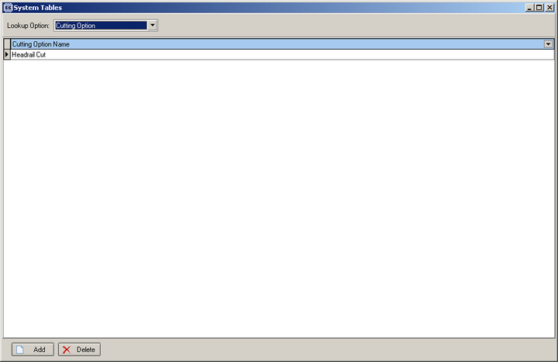

There is a new flag in Blind Details > Blind Types called ‘Parameterised Cutting Options’.

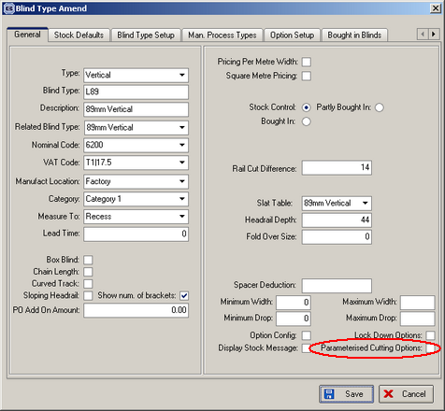

There is a new tab in Blind Details > Blind Types called ‘Cutting Options’. This is where the specific information can be filled in. There are three tables to be filled in, and all are related.

The first subform contains the cutting option (that was set up in System Tables > Cutting Options).

The second subform allows you to enter a ‘Combination Name’. This is a name that the user can decide, but should be meaningful and relate to the options that will be applied to it. It will only be related to the cutting option that is being pointed to in the first subform. We can also define the order in which the cutting options are printed out on the works order by filling in the sequence number.

The third subform allows you to enter options that must have been chosen before the relevant combination name and additions / deductions can be applied. You can enter as many options as you like here. Again, these options will be related to the combination name you are pointing at in the second subform.

Once this has been set up, the new cutting options will be displayed in the works order. Please note, only on ‘Works Order Portrait’ until further notice.

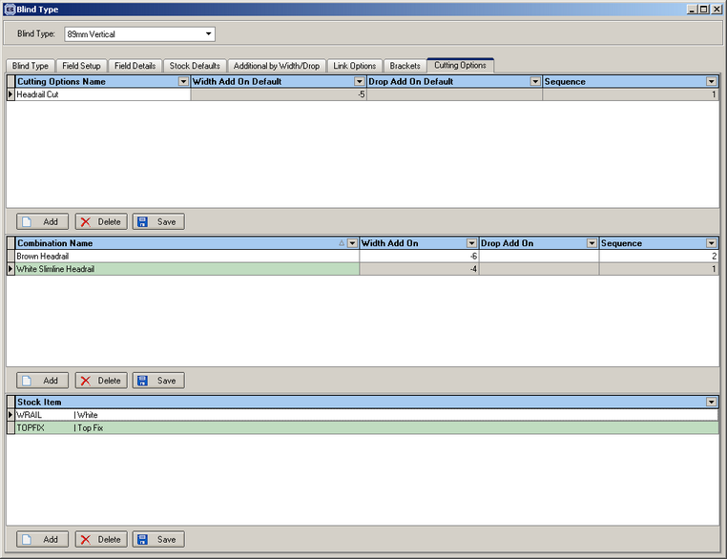

255. Post Invoices to Access Accounts v3

It is now possible to generate a different csv file if a customer uses Access Accounts v3 accounting software. There is a new parameter in Administration > Parameters > Sage Parameters / Invoicing, called ‘Export to Access Accounts v3’. If this is set to true, then the button in Financials > Post Invoices to Sage > Line 50 Export File says ‘Access v3 Export File’ instead and the export file is in the format:

"INV","PITT01",,0,0,"93912",11/03/06 00:00:00,,,,0,,0,0,0,0,,116.36,,20.36,136.72,136.72,"SALES",,,,,0,
"INV","ACOR02",,0,0,"93911",17/02/06 00:00:00,,,,0,,0,0,0,0,,86.88,,15.21,102.09,102.09,"SALES",,,,,0,

To take the first line as an example:

INV indicates an invoice (CRN would indicate a credit note)
PITT01 = account code
93912 = invoice number
11/03/06 = invoice date
116.36 = nett total
20.36 = VAT total
136.72 = total
SALES = analysis code (always SALES)

