Blindata Release Note 2.9.6/7 

03 May 2006

Bug Fixes and Enhancements

1030. Production Documentation Deadlock Message
A deadlock message has appeared occasionally when running works orders at the same time as entering orders. We have further optimized the stored procedure that is used to run the production documentation logic, and this should stop this message from appearing.
1035. Invoice Bespoke 8 (EDI Invoice selected)

The page numbering was wrong. The total is now the total of pages in each invoice, not the overall total.

1036. Work Order Label Blind Size

The fitter now appears on the address label.

1038. Label Print – 5 x 1 ½ CB

The option choice name eg Headrail, Bunch etc now print out properly.

1039. Label Print – 5 x 1 ½ CB

Country no longer appears on the address label.

1040. Works Order Label Blind Size

This was not printing anything if you entered a new order. Fixed.

1041. Works Order Label Blind Size

The following layout changes have been made.

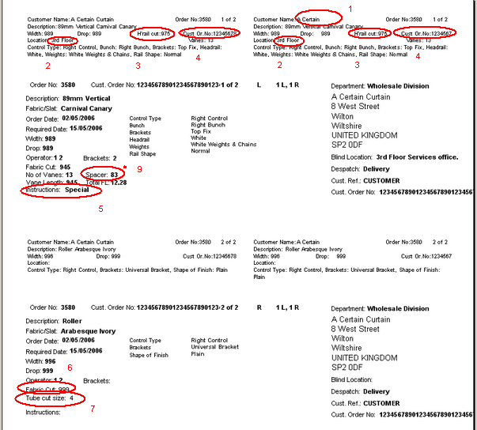

- There is more space for the company name – it was being cut off.
- There is more space for the location – it was being cut off.
- Moved ‘H’rail cut’ down a line (to same line as Vanes.
- ‘Cust Ord No’ has been moved to the left so it can print more text.
- Special instructions text was being cut off.
- Fabric cut is now calculating properly.
- Tube cut is now calculating properly.
- Spacer = ((Man width – spacer deduction) / (number of vanes – 1) + 0.05) rounded to 1 dp.

New Work and Customer Requests

187. Order Acknowledgement Sent Report

There is a new report showing the customer, order number, order date, order status and user who entered the order. This lists any orders which have not yet had an order acknowledgement generated (ie printed or emailed). The generation of the order acknowledgement is also recorded in the history.

247. New Invoice Layout

There is a new invoice report called ‘Invoice – Bespoke 9’.

251. Status Field in Archive Enquiry

It is now possible to bring back an order from the archive to orders. This can only be done by users who have the relevant permissions set up.

In Administration > Users > Advanced Permissions, there is a new button called ‘Reset to Printed’ in the Order section. If this is switched on, then it will be possible to return a record from the archive by going to Order Processing > Archive Enquiry > Reset to Printed.

252. New Label Print: Label Print 5 x 1 ½ CB

There is a new label layout called ‘Label Print 5 x 1 ½ CB’.

253. Sales Files > Customers > Print Customer Label

It is now possible to print an address label from the customer record in Sales Files > Customers.

256. Order Processing > Paid Proformas.

We have added an option to convert proforma quotes to orders within the Paid Proforma screen. This will only allow quotes which have been marked as paid to be converted, thus reducing a step in the current process.

257. Sales Files > Customers > Quality Check

There is now an option for Quality Check on the Customer form. If this option is selected then all orders for that particular customer will have the Quality Required option selected automatically.

