Blindata Release Note 2.8.9 

31 March 2006

Bug Fixes and Enhancements

998. Reports > Sales Analysis > Sales Analysis by Area by Customer

This report now shows the company name, not contact name.

999. Quotation – Laser Print

If you entered a proforma invoice and added a carriage line, the totals and the carriage line did not print. Fixed.

1004. Works Order Label 5

We have altered the formula for the amount that appears in the circled area, but ONLY on this works order. It is (Man Drop – Headrail Depth (from blind type record), not (Man Drop – Headrail Depth + Fold Over Size).

1006. Financials > Create Invoices

If ‘Use Department Invoice No’ is switched on in Administration > Parameters, we now ask for department number when creating invoices in Financials > Create Invoices.

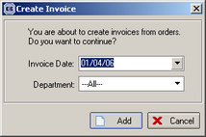
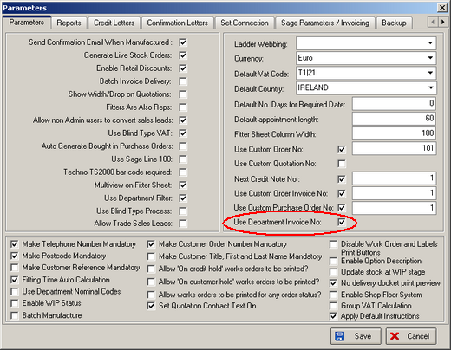

1008. Invoice Bespoke 2

If you tick ‘Contract’ in the Totals tab of an order, the invoice now only prints out the contract text and totals.

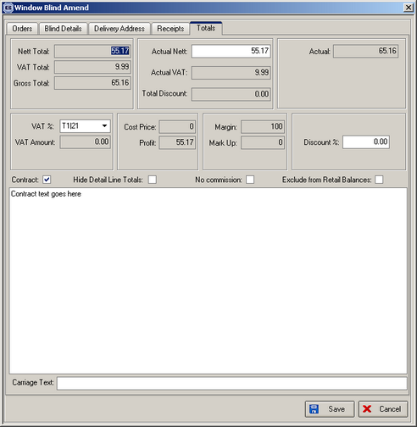

1010. Invoice - Bespoke 6

Vat number is now printing on the top right of the invoice.

1011. Works Order Label Blind Size

There is now a parameter to show cord spacing on Venetians or pleated blinds. This can be set up in Blind Details > Blind Types.

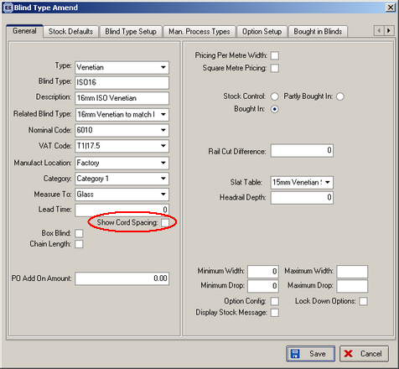

1012. Order Processing > Order Enquiry > Delivery Docket – Laser Print (Special)

For orders with more than 12 detail lines, these detail lines were encroaching on the footer part of the document. Fixed.

1014. Order Enquiry > Blind Made Scan

There was a problem when you use ‘Blind Made Scan’. After a blind has been scanned and changed to Manufactured, the order detail id number was left in the scan field. It is now cleared so the next blind can be scanned. Also the blind status now changes to ‘Blind Manufactured’ as soon as the scan is done.

Also if you scanned a blind that has already been manufactured, and did this a couple of times you could block the order. We have tightened this up so that if you scan a blind that has already been manufactured, a message appears saying ‘This blind has already been manufactured’. Also in ‘Order Made Scan’ it is not be possible to scan a blind that has already been delivered.

New Work and Customer Requests

220. Order Processing > Production Documentation

We have added the following new options on the Production Documentation form:

1. Print repairs only.

2. Print orders for delivery day customer only.

3. Print only standard tickets. This will exclude remakes, must go, repairs.

4. Consolidated delivery day option on production documentation to print tickets only for customers who have specific delivery days. This means we check the customer delivery days – if delivery day is flagged for all days, then the customer is not a specific delivery day.

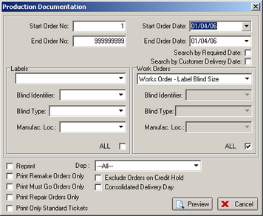

221. Order Processing > Order History

We are now able to access the history of an order. It is possible to view the date and time the order was entered, who entered it and the time the detail lines were entered and also amended.

To access this form select “History” item in the context menu (right click) on the Order Amend Enquiry form:

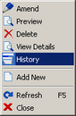

As well as order status or order details status changes, the History form will also display the history of order and order details editing.

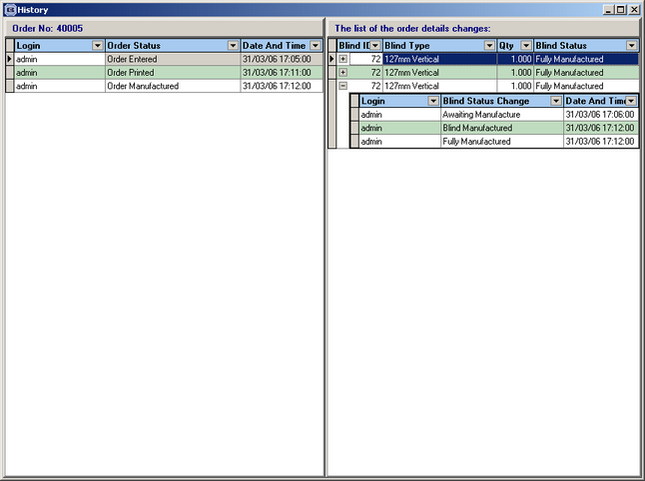

222. Sales Files > Customers

There is a new date field in the customer record to hold the date an account was opened. The label description says ‘Date Account Opened’.

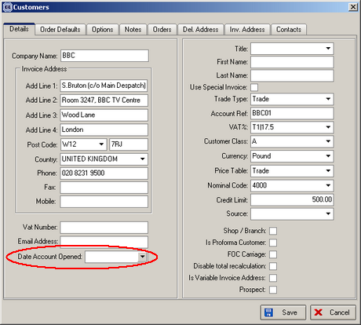

223. Sales Files > Customers

We can now hold multiple contacts against customers. There is a new tab on the customer forms for holding extra contact names, job title, telephone number, fax number and email address.

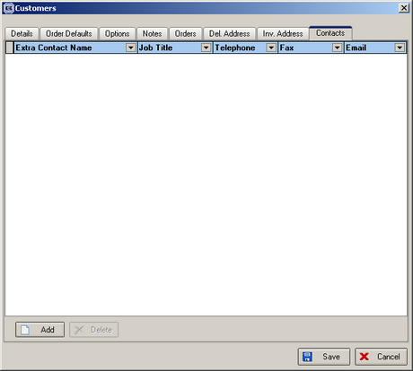

224. Administration > Sage Utilities

It is now possible to update the memo field for customers in Sage with the notes field in customers in Blindata.

225. Order Processing > Orders

There is a new advanced permission to lock required date so only specific users can alter it.

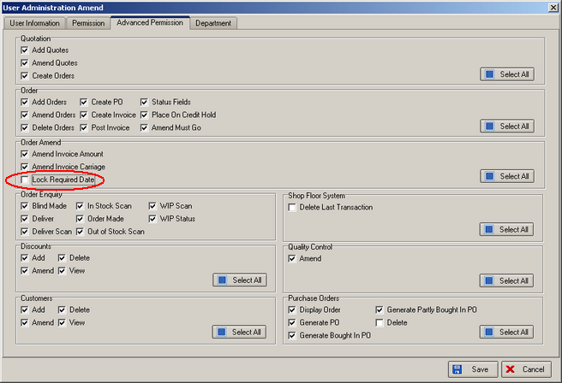

226. Order Processing > Orders on Hold

There is now an additional field on the 'Orders on Hold' screen that the user can tick to prevent tickets being printed for the order. If ‘Print Hold’ = true, it is not be possible to print a works order or label for that order.

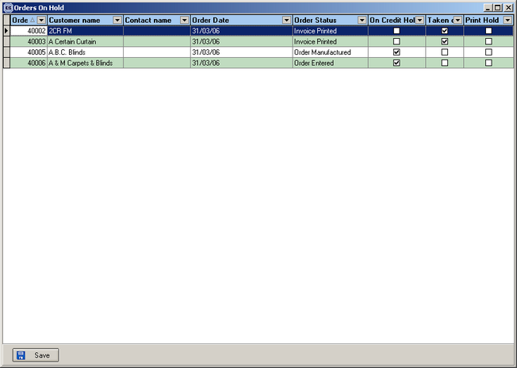

227. Order Processing > Orders

There is a new function to lock the options when entering a detail line, so they cannot be changed. This can be applied by blind types.

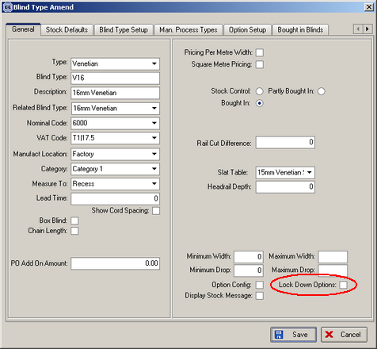

228. Administration > Parameters > Automated Tasks

There is a new tab on the Parameters form to set automated tasks. This includes backups and the creation of invoices.

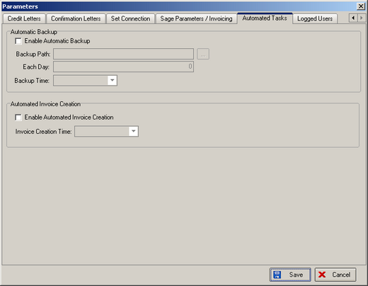

235. Sales Files > Customers

We can now hold source against a customer record. This looks up the ‘Order Source’ table in Administration > System Tables.

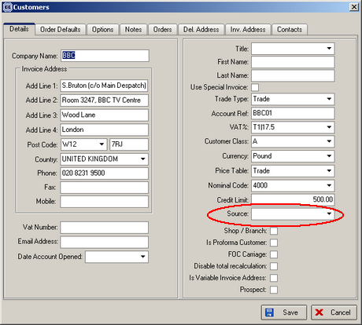

240. Order Processing > Orders > Detail Line Entry

There is now space for 16 options to be displayed on the detail line entry screen, without the vertical scroll bar appearing.

242. Sales Files > Customers

We now have a default measurement type against a customer. It is possible to leave this blank, but if it is not blank, it will be used as the default in ‘Measure To’ in detail line entry instead of the default held against the blind type record.

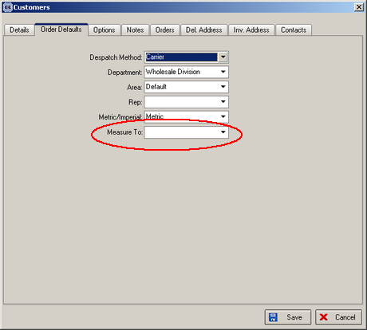

243. Invoice – Bespoke 3

1. If customer trade type = trade, the following now displays

Invoice No.
Invoice Date
Our Order No: [Order id]
Account Ref
Customer Order No
Customer Ref
Customer Contact: [Order Contact Name]

2. The existing headings have been replaced with: Location, Type [Blind Type], Colour [Fabric Description], Width, Drop, Price.

3. If customer trade type = Trade, price now excludes VAT. If customer trade type = Retail, price includes VAT.

3. There is a new table called ‘Guarantee’ (Administration > System Tables). This holds id and ‘Guarantee Text’. It is now possible to store the id against the order and then display it on this invoice here.
4. Instead of ‘Cash’, ‘Cheque’ and ‘Date’, this now says ‘Cash’, ‘Cheque’, ‘Card’ and ‘Date’.
5. ‘Deposit paid’ and ‘Balance Paid’ only appear if the customer trade type = Retail. If customer trade type = Trade, the ‘invoice text’ from Administration > Company Details appears instead.

