Blindata Release Note 2.8.1/2 

6 March 2006

Bug Fixes and Enhancements

956. Invoice Bespoke 5

The customer (company) name was missing in the addresses.

‘0 x 0’ no longer prints out if there is a carriage charge line.

957. Invoice Bespoke 5 (Batch Print)

The same problems existed as in 956, but also the totals were not printing out correctly.

958. Sales Lead Individual Extra

Customer name (contact eg Mrs Anderson) was missing from report.

Also ‘Encuiry Type’ now says ‘Enquiry Type’.

959. Reps/Fitters Sheet 10

- Customer name (contact eg Mrs Anderson) was missing
- Address are now in order: address line 1, address line 2, address line 3, address line 4, postcode.

960. Order Processing > Orders > Order Entry

If the user screen was set to screen resolution 800 x 600, it was not possible to enter an order because the buttons could not be seen properly. We have put a vertical scroll bar in, but only if the screen cannot be seen properly.

961. Administration > System Tables > Option Calculations

We added a new column Option Code to the Option Calculations system table. This column displays the option code for the selected “Stock Description” and is read only. The user is not allowed to edit the fields which are not related to the selected Option Code. For example for Option Code = Valance Calc, the user will be able to edit only Valance Size field.

963. Order Processing > Production Documentation

If there is a mixed order, say 25mm venetians and rollers, and you print all 25mm Venetian works orders, if you then print the whole order, previously the 25mm venetian works orders will be printed again. They now don’t print and only the rollers should print on the second run.

964. Fabric Drop Calc

The amount of roller fabric usage is no being calculated properly for ‘fabric drop calc’ options.

New Work and Customer Requests

169. Cost of Option Prices for Bought In Blinds

Cost prices are picked up for options for bought in blinds. The following rule applies: if a selling price can get picked up a blind for the base price and also for an option price, it is also possible to pick up the cost price using the same method.

194. Order Processing – Drilldown

We have added a new item to the context menu on the Order Amend Enquiry form, called View Details. When you select it, you’ll see the order details information in the same format as on the order editing form, Blind Details tab. The user is only able to view this information. To access the context menu, right click on the relevant order line.

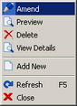

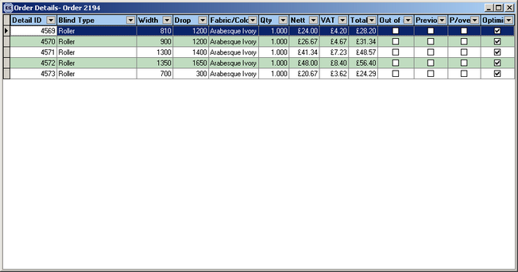

195. Stock Setup > Stock Items

A new field called ‘Cross Reference’ has been put in the fabrics table, on the Stock Items form in the ‘Bar Code’ tab. It is a text field with 10 characters.

196. Special Instructions

One client did not like the change we have made to default the special instructions to the instructions entered in the previous detail line of an order. We have a new parameter called ‘Apply Default Instructions’ in Administration > Parameters. It should default to true. If set to false, the instructions will not be copied to the next detail line.

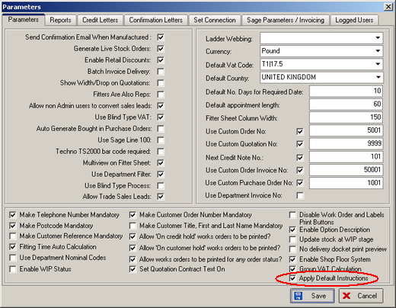

207. Reports > Receipts by Type

The customer reference field now prints on this report, between company name and receipt no.

208. Fitters Report by Department

A new report is available that shows orders for fitting. The user can choose by department. It only shows orders with status = order entered, order printed, work in progress, order manufactured. The report is in Reports > System Reports.

209. Balances Invoice Report

There is a new report that gives the invoice value of each order balance (Gross less deposit paid) that occurs within the specified date range/department. This has no relation to the balance outstanding i.e. whether it has been paid or not. The report shows total invoice value of all items delivered/created/printed/posted with the invoice date in the specified range. This is analysed by nominal code, similar to the Deposits by Nominal. This gives a total value (balance element only) of goods invoiced in the period and, when combined with the Deposits by Nominal report, will give the total Sales value for the period and the figure on which Vat is payable for the period.

