Blindata Release Note 2.7.3/4 

6 February 2006

Bug Fixes and Enhancements

883. Post Deposit and Balance Invoices to Sage

When the deposit and balance invoice transactions are posted to Sage, they were using the customer nominal code when it should use the nominal codes from the blind types in the detail lines. This complicates things, because you have to make sure that the individual apportioned amounts add up to the deposit and balance amounts. The customer nominal is only be used if Administration > Parameters > Sage Parameters > Use customer nominal to post to Sage = true.

Example: an order is entered and has two detail lines, a vertical blind sold for 65.00 retail and a roller blind sold for 55.00 retail. The nominal code for vertical is 4001 and for roller is 4002. The lines therefore look like this.

Vertical (4001) nett = 55.32, VAT = 9.68, total = 65.00
Roller (4002) nett = 46.81, VAT = 8.19, total = 55.00

A deposit of 40.00 is paid. Because we need to look at nominal codes in detail lines when posting to Sage (if Use customer nominal to post to Sage = false), then the amounts need to be calculated as follows.

Vertical (4001) deposit nett = (65.00 / ( 65.00 + 55.00)) * 40.00 * 100 / (100 + 17.5) = 18.44
Vertical (4001) total = (65.00 / ( 65.00 + 55.00)) * 40.00 = 21.67
Vertical (4001) VAT = 21.67 – 18.44 = 3.23

Roller (4002) deposit nett = (55.00 / ( 65.00 + 55.00)) * 40.00 * 100 / (100 + 17.5) = 15.60
Roller (4002) total = (55.00 / ( 65.00 + 55.00)) * 40.00 = 18.33
Roller (4002) VAT = 18.33 – 15.60 = 2.73

This all works properly, because the totals add up to 40.00. But if the vertical blind total price was 66.00 instead of 65.00, the totals would be 21.82 and 18.81, which adds up to 39.99. We therefore have to take into account rounding errors when we make this deposit posting to Sage. We have made sure that the overall amount that gets posted is equal to the deposit amount.

888. Order Processing > Order Enquiry

The wrong address field was showing on this screen. It is now the address line from the order record, not the customer record.

892. Purchase Order Enquiry > Generate PO

When we generate a regular PO, the calculations to add cost prices and cut length charges are now correct. The PO add on amount is also working properly.

896. Box Blind Substitution

This is now working properly. As an example, I have set up the following box blind minimum width table.

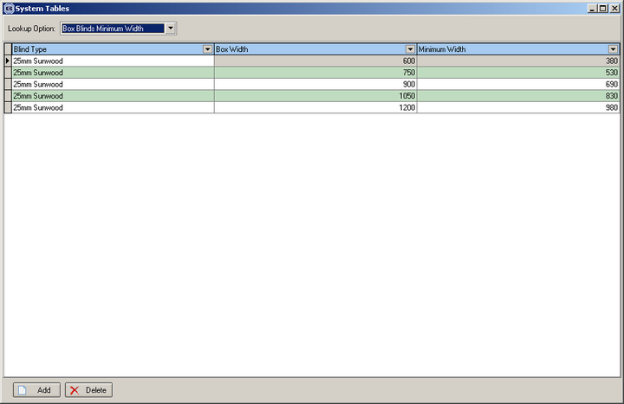

I have made sure that the stock in hand figure is < 0.

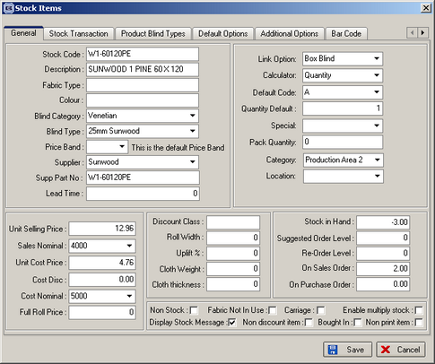

I have set up alternative box blinds for this stock item.

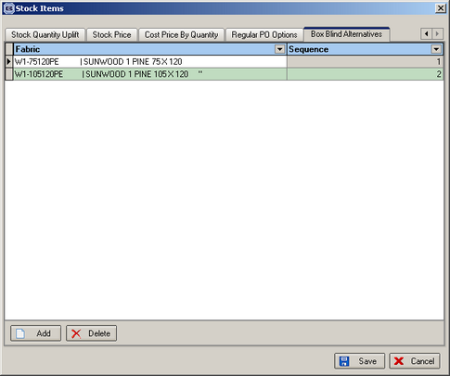

The following happens when I enter a blind - the program goes and check to see if there is a substitute box blind held against this box blind (which there is). The program then checks to see if the width is ok (ie man. width is not below the minimum width in the box blind minimum width table). If that is ok, it then checks to see if there is enough stock in hand. If that is ok, it should then replace the option with the substitute option.

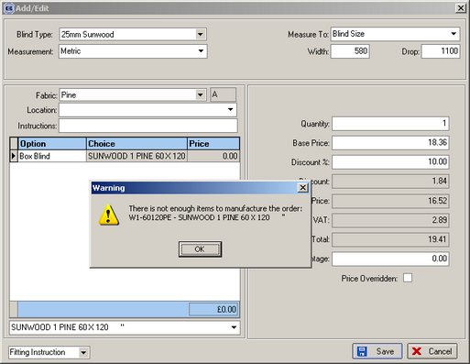

898. Order Processing > Fitters Sheet / Diary Screen

The diary now goes up to 9pm. We have added a scroll bar to the diary screen, but it still defaults to start at 9am.

899. Works Order Label Blind Size

We have changed the number of characters (Cust.Order No.) that appear on the tickets. Currently only 8 characters appear but up to 29 characters can be input within the order entry screen.

900. Delivery Docket Print

When printing a 'Delivery Docket' the name and address details were duplicated within the same box. This did not show on the print preview screen, only when printed. Fixed.

901. Financials > Post Invoice to Sage > Post Invoices

This is the file layout that is exported when invoices are sent to a Sage Line 50 export file.

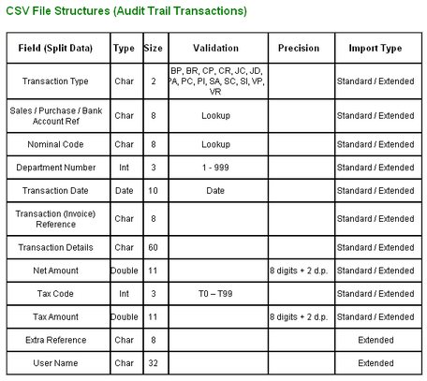

902. Order Processing > Production Documentation > Works Order Label 1

Concatenating contact names that are too long gave an error in works order label 1. Fixed.

903. Financials > Post Invoices to Sage

The ‘Print All Invoices’ button is now working.

905. Order Acknowledgement / Invoice (Letterhead) reports

The discount percentage and discount amounts no longer prints if it is a retail order.

906. Order Processing > Orders

This message was bringing up the figure for the minimum width instead of drop. Fixed.

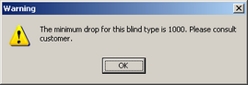

907. Order Processing > Quotations

Quotes were going into retail balances even if the tick box "exclude from retail balances" was ticked. The program has been changed so that the records don’t go into retail balances at all until an order is created.

912. Reports > Deposits by Nominal

This report was incorrect. The criteria for status code is everything except ‘Order Cancelled’. We can now also filter this report by department.

915. Administration > System Tables > Option Names

There is now a code for Fullness Ratio.

916. Administration > System Tables > Option Calculation

An error appeared when you open this form. Fixed.

New Work and Customer Requests

142. Spacer Calculation

There is a new field displayed in the blind type record if blind type = vertical or headrail only, called ‘Spacer Deduction’. The spacer calculation now appears on certain works order labels, and is calculated as follows:

Spacer = ((Man width – spacer deduction) / (number of vanes – 1) + 0.05) rounded to 1 dp.

152. Curtains

We have created a new blind identifier for curtains (U = Curtain). In the blind type form we can now hold the following: heading allowance, hem allowance.

When entering an order, the program requires width and drop measurements (as usual). Options can be set up as normal, but we now hold a ‘curtain fullness ratio’ against a particular option. It is possible to create a new code in Administration > System Tables > Option Names, called ‘Fullness Ratio’.

We can then hold the fullness ratio amount in the ‘Option Calculation’ table.

There is a new field in the fabrics table for ‘Pattern Repeat’. This is an integer, which will hold the distance in millimetres.

There is a new calculator called ‘Curtain Fabric’. This will calculate the fabric usage in the following way:

Width * Fullness ratio = width of fabric required
Width of fabric required / roll width is then rounded up to next whole number to give number of widths required.
The drop of the fabric is calculated as the entered drop size + heading allowance + hem allowance.

The total fabric required is number of widths * total fabric drop.

There is another new calculator called ‘Pattern Fabric’. This will calculate the fabric usage in the following way:

Width * Fullness ratio = width of fabric required
Width of fabric required / roll width is then rounded up to next whole number to give number of widths required.
The drop of the fabric is calculated as the entered drop size + heading allowance + hem allowance.
Then divide this by the pattern repeat. Round the result up to the next whole number and then multiply by the pattern repeat figure to get the total drop required.

The total fabric required is number of widths * total fabric drop.

164. Order Entry > Receipts tab

We are now able to print out a special credit note from the receipts tab form in order entry. There is a button to add the credit text in the receipts form and also to print the credit statement.

166. Lead Times Report

We have added customer promised date, days late and total average days late to this report.

171. Print option for a deposit in receipts

There is now a button to print out a receipt in the order entry receipt screen.

172. Order Processing > Production Documentation

There is now an option to print works orders and labels by department.

180. Diary Screen

It is now possible to fix the width of the diary columns on the diary screen. In Administration > parameters, there is a new field that allows you to define the width.

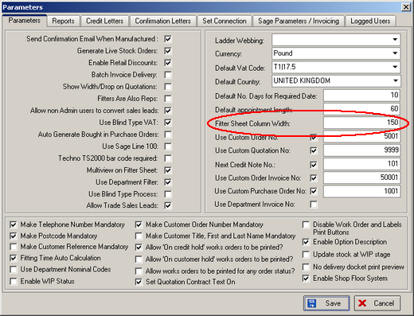

We also added a “Fixed Column Width” tick box to the Fitter Sheet. It controls the width of columns. Please note that this mode will not be working in Multiple Days mode.

