Blindata Release Note 2.6.4 

06 January 2006

Bug Fixes and Enhancements

741. Order Processing > Orders > Detail Line Entry

When calculating discount, we can now exclude certain options from having discounts applied to them. To do this, the option ie the stock item record needs to be flagged as a ‘non discount item’.

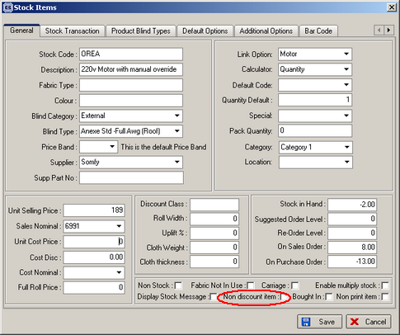

The previous nett price calculation was as follows:

Nett Price = ((Base Price + sum of option prices) * (100 – disc %)/100) * uplift % * quantity.

The new calculation is:

Nett price = (((Base Price + sum of discount option prices) * (100 – disc %)/100) + sum of non discount option prices) * uplift % * quantity.

Also on the order acknowledgement and invoice we now display the two different sum of option prices along with their discount %.

742. Headrail Depth

If an option name is set up as a ‘Rail Calc’ item, it is now possible to hold different headrail cut and headrail depth figures for headrails. These will override the default figures that are held in the blind type record.

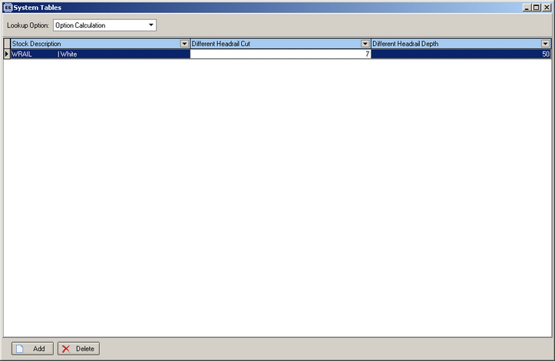

841. Order Processing > Quotes

When converting quotes to orders and when only certain blinds are selected, all the detail lines were left in the quotation. Only those that have not been selected to be converted are now left.

843. Credit Note – Laser Print (Letterhead)

The special instructions field now prints out onto this credit note in the same place as is on invoice.

855. Order Processing > Orders > Detail Line Entry

If an option is selected as a default from Stock Items > Default Options tab after a fabric has been selected, the price for that option is now get picked up.

857. Administration > System Tables > Nominal Codes

Previously an error message could occur when you are adding a new nominal code. If you added a record, but did not update the ‘sales code’ field and then tried to change that field and save the record again, the following error occurs:

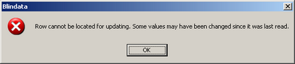

This has been fixed.

859. Administration > Users > Permissions

There were menu permissions missing for Receipts by Receipt Description, Option Price per Metre and Border Option Pricing. Fixed.

861. Invoice – Bespoke 2

The batch invoice version of this now prints in invoice number order, not order number order.

New Work and Customer Requests

21. Order Processing > Orders > Order Detail Entry > Shaped Blind

We can now hold some extra information if a blind type is flagged as being ‘Shaped Blind’. It is possible to enter dimensions for LH Offset Width and Small Height as follows:

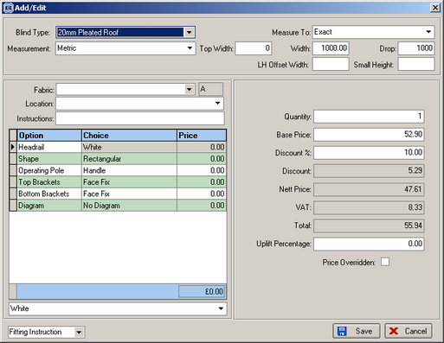

104. Prospects

We have introduced a new field to the customer table called ‘Prospect’. This is a true/false field. The default will be false. The following changes have been made to the program.

Orders and credit notes cannot be entered for customers who are flagged as a prospect.

A quotation can be entered for a prospect customer but cannot be converted to an order.

A sales lead cannot be converted to an order for a prospect customer.

A new report is available in Reports > System Reports, called Prospects. This should contain company name, address and telephone number.

141. Bought In Purchase order

A situation is possible where a detail line is entered for a blind, and part of that blind is manufactured elsewhere, therefore a bought in purchase order needs to be generated for that part.

An example of this is a sophisticated roller blind or blind that requires a special track. The roller or track may be manufactured by another company. We need a method of identifying which part is bought in.

Previously we identified whether a blind is manufactured in house or bought in by flagging either the ‘stock control’ or ‘bought in’ fields in the blind type. There is now a third type: Part Bought In.

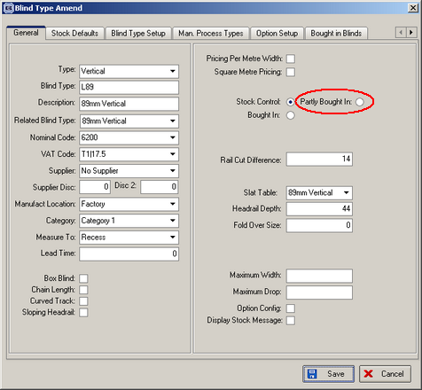

Because the blind is to be part manufactured and part bought in, we need to identify the bought in part by looking at the fabric table. We have created a new field in the fabric table, called ‘Bought In’.

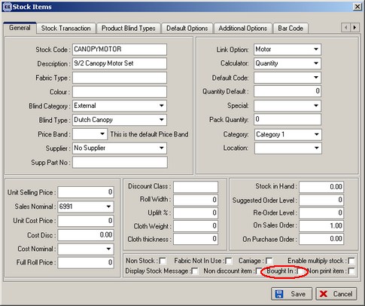

When a bought in purchase order is generated, we first need to check that the blind type is ‘bought in’ or ‘part bought in’. If it is ‘bought in’, then the existing functionality works, but if it is ‘part bought in’, we now examine the options that have been chosen for that blind, and then create a bought in purchase order, by looking for the supplier (which is already held in the fabrics record). The selected option appears on the bought in purchase order in the place of the blind type. The width and drop still appear. Please note it would be possible in theory to have two different options that are supplied by two different suppliers – therefore two purchase orders would be created.

When displaying the bought in purchase order form or printing the bought in purchase order report, we now take into account if it is ‘bought in’ or ‘part bought in’. This will determine what gets displayed or printed i.e. either blind type or option.

