Blindata Release Note 2.6.5/6 

16 January 2006

Bug Fixes and Enhancements

825. Invoice – Bespoke 2

All dimensions now print in millimetres (whole numbers only!)

The unit price now prints the retail –we have added VAT to the unit price. The nett price also includes VAT.

847. Credit Letters

Addresses have been moved down the page to fit letterhead. Retail balances screen is now updated.

Credit Letter 1 now prints out after 21 days from invoice date have elapsed.

849. Reports > Sales Analysis

Sales analysis reports have been optimised and should now run faster.

858. Quotation – Laser Print (Letterhead)

The address has been positioned to fit in a window envelope ie 5cm from the top of the A4 sheet.

There are also some additional changes that have been made to the quotation:

- Removed "Note" from "Quotation Note" at top of page
- Removed totals box from print out or give option to remove on print out.
- Removed lines between text options on print out
- Remove headings Type Colour Quantity
- Added customer telephone number
- Added page numbering

860. Complaints

We have added company name and contact name to the complaints screen.

862. Order Processing > Orders

In detail line entry, we now default special instructions to the previous detail line in that order. If it is the first detail line in an order, special instructions are blank.

863. Administration > Import to Excel > Customers

If you imported customers more than once, the delivery address got added again. The delivery address is now only be added once for a customer, regardless of the number of times the records are imported.

864. Sales Files > Customers

If you tried to delete a delivery address, an error message appeared, although the delivery address record did get deleted. This has been fixed.

866. Stock Setup > Purchase Order Enquiry > Partly Bought In

It is now possible to print a purchase order for a partly bought in purchase order.

867. Fitters Sheet / Sales Lead

Color in ‘Change color of appointment’ is now spelt ‘colour’.

If the screen resolution is set to 1024 x 768 (or lower) you could not see all the options down the left hand side. There is now a scroll bar here.

869. Outstanding Orders Report

Customer was printing the Agent name instead of the Customer reference name – fixed.

Now printing 'Blind Identifier' instead of full description - this was causing an overtype onto Fabric Description.

Orders are now listed in sequence of earliest required (do by) date first.

If you select ‘by customer’, it is now putting all the outstanding detail lines on the same page for the same customer.

870. Order Acknowledgement – Laser Print

The measurement and special instructions fields no longer print if the detail line is not entered via ‘Blind’ button.

876. Works order label 1

The despatch method now appears on the large label, beside customer details.

New Work and Customer Requests

139. Works Order – Label 6

There is a new bespoke works order label layout. This is based on ‘Works Order – Label Blind Size’, with the following differences:

A bar code appears in the top right hand small label (and nothing else).

On the big label there is a lot more room for option descriptions. We have also made a lot more space for special instructions.

‘Measure To’ appears on large label

148. Fittings

it is now possible to fitting details against an order. There is a new fitting button on the blind detail entry screen. This will display the following form:

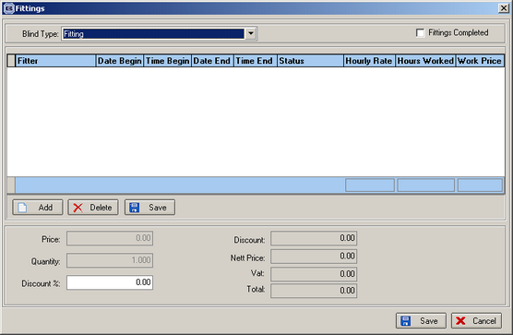

Fitters are set up in Administration > System Tables > Employees. There is also a new field in this table to hold an hourly rate.

The following must also be set up:

- Add a ‘Blind Type’ with ‘Type’ field = ‘Fitting’, all other fields should be filled similar to ‘Miscellaneous’
- Add a ‘Stock Item’ related to the new ‘Blind Type’

On the new form the user can create “Fitter Sheet” records related to the new order detail. The following fields are being used: fitter, fitting start date and time, fitting end date and time, fitter sheet status, hourly rate, hours worked.

When you fill in all fields, the program recalculates the price of the order detail, and also updates the fitter diary.
We have also added a new ‘Fittings Report’ to ‘System Reports’. This will only show records that have status ‘Fittings Completed’ = true.

150. Fitters Sheet / Sales Leads

We added a new table to Administration > System Tables, called Colour Chart. It allows setting the colour sets with corresponding text names.

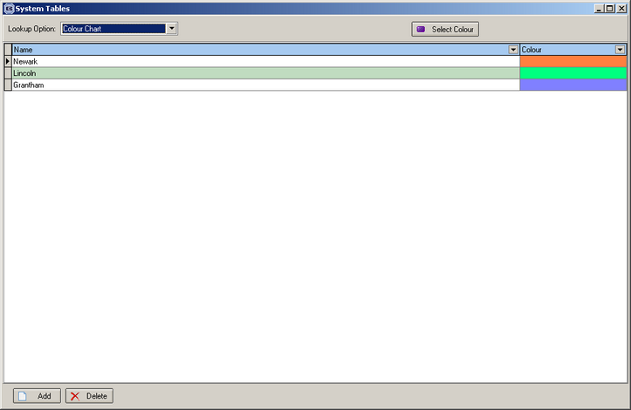

In the fitter sheet / sales lead form, when you click “Change colour of appointment”, you will now see a form, which allows selecting a colour from the preset colors or using a standard colour selection dialogue.

156. Stock Setup > Fabric Group Setup

Previously it was only possible to alter the fabric group for a number of selected records. It is now possible to adjust the calculator field and also the roll width amount in this form.

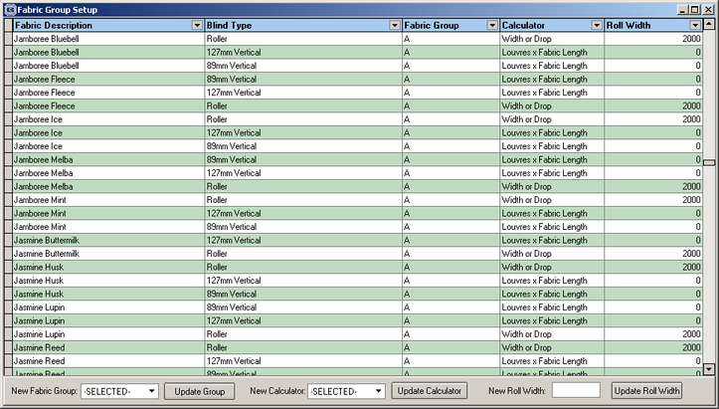

These three update buttons on the form all act independently of one another. We also display two new columns on the form: ‘calculator’ and ‘roll width’.

160. Complaints

We have added a new field in the Complaints table for the status of a complaint. This is called ‘Complaint Status’ and can be maintained in Administration > System Tables.

The field is displayed on the complaint enquiry screen, but only be editable by going into the record.

