Blindata Release Note 2.6.2-3 

29 December 2005

Bug Fixes and Enhancements

663. Reports > Lead Times

There is a new option to print out lead times by status by blind type.

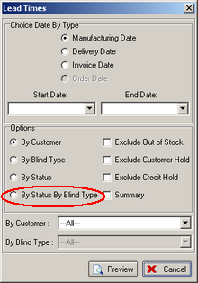

799. Administration > Sage Utilities

When you choose the option Create / Update Customer Details from Sage, the postcode from Sage now gets updated properly to the postcode first and second part fields.

845. Order Processing > Fitters Sheet / Sales Lead

First name is no longer mandatory if Title and Last Name have been entered. Title is no longer mandatory if First Name and Last Name have been filled in.

846. Order Processing > Sales Lead Diary Screen

We have amended what is displayed in sales lead appointments to the following:

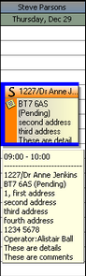

848. Order Processing > Quotations > Create Orders

‘Quo. No.’ now says ‘Quote No.’.

850. Works Orders Portrait

This report has been tidied up.

851. Shop Floor Scan

The scan message now says ‘Is this process complete?’.

852. Order Processing > Order Enquiry > View Process Transactions

The date and time are now properly displayed on this form.

853. Order Processing > Order Enquiry

If the parameter ‘Enable Shop Floor System’ is switched on, the ‘Shop Floor Scan’ button is now enabled all the time in Order Enquiry.

New Work and Customer Requests

96. Pleat Table Lookup

We can now hold a pleat table against pleated fabrics (although this can be null). This is because a different number of pleats can be used for different fabrics for the same drop. The program still looks at the blind type record to find the correct pleat table, but now also looks in the fabric record to see if there is a pleat table there.

110. Surveys

There is a new facility in the system to handle surveys. Sometimes a survey is required when a sales lead has been converted into an order, but a more detailed onsite survey has to be carried out. The order of events is now as follows:

Sales lead entered
Conversion to order
Question asked: survey required (y/n). If yes, the program now allocates a survey appointment against an order for a surveyor. This is done in the same way as a fitting appointment is made. There is a new employee type called ‘Surveyor’.

145. Order Processing > Production Documentation

There is a new option "Print Remake Orders Only". This will print only orders which have the remake flag chosen in order entry.

