Blindata Release Note 2.6.0 

21 December 2005

Bug Fixes and Enhancements

567. Administration > Import from Excel > Discounts (Low Priority)

The discount import routine now imports rows in the spreadsheet where blind type code > 5 characters in length. Previously it did not recognise the blind type.

822. Order Acknowledgement / Invoice (Letterhead)

We have added customer telephone number to works order (A4 individual), order acknowledgement & invoice. This is required because once an invoice is archived the phone number must show on the archive enquiry screen.

823. Production Documentation > Works Order – Label 5

We now print out blind type code on ‘works order label 5’, not blind identifier code.

For retail sales, we now show company name instead of contact name.

- The text is being cut off – we need a bit more space on the right hand side.
- For a retail order, the company name should appear here – in other words, the same rule as for a trade order.

Both these changes are only applicable to ‘works order label 5’.

832. Reports > Financial Reports > Invoice by Nominal Report
There is no longer a page break between nominal code groups on this report.

833. Reports > Financial Reports > Outstanding Retail Debtors

We have made an important change to this report. It now includes a debtor date, so that you can print off the report at any time. The report gives a snapshot of all outstanding retail debtors at a particular date specified by you. This means the debtors amounts is calculated depending on when receipts were paid. Here is an example:

An order total is 200.00
A receipt is taken on 02/12/05 for 50.00
A receipt is also taken on 12/12/05 for 150.00

If the current date is 17/12/05, then the outstanding retail balance = 0, and so the report will not show this order. But if you want to print this report as if it was 07/12/05, then the outstanding balance should be 150.00. The ‘debtor date’ will be entered as 07/12/05 by the operator and the report will then be generated by calculating the outstanding retail balances as at this date.

The other criteria relevant to this report are: order must be for retail customer, balance > 0, order status must be delivered, invoice created, invoice printed or invoice posted.

New Work and Customer Requests

144. Printing Options

At the moment we can define whether we want an option printed on the acknowledgement / label / works order etc by setting fields in Blind Details > Blind Types > Option Setup.

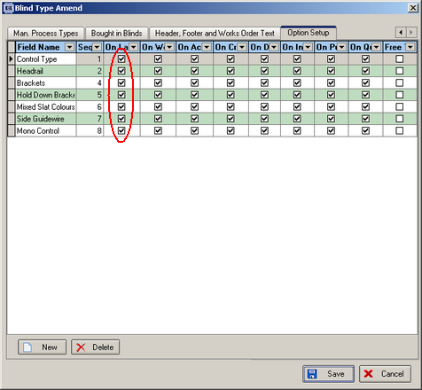

This is a very good feature, but was not flexible enough. Take the following example: you have set up an option called ‘Hold Down Brackets’ and created two new stock items called ‘Standard Hold Down Brackets’ and ‘No Hold Down Brackets’. If the first item is chosen, then the client wants this printed on all options ticked (form above), but if the second item is chosen (No Hold Down Brackets) is chosen, it should not print at all, nor should the description of the option (Hold Down Brackets) be printed.

There is a new field (true/false) in the stock item table to say that an item should not be printed on any documentation. The field is called ‘Non print item’ and should default to false.

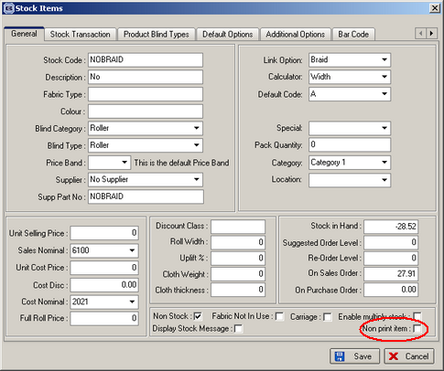

147. Reports > Receipts by Receipt Description

There is a new report on the Reports menu that is similar to ‘Receipts by Date’, but it sub divides the records by ‘Receipt Description’.

