Blindata Release Note 2.5.7/8 

05 December 2005

Bug Fixes and Enhancements

788. Invoice – Bespoke 2

We need a new invoice layout for Sunlite Blinds. See jpeg.

Totals are wrong way round on report. The amounts should be in the same order as the totals on a standard order acknowledgement for a retail customer.

Denis

793. Order Processing > Fitters Sheet / Sales Lead

If you try to make a sales lead appointment for an employee who is not a rep, the following appears.

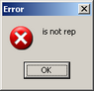

The message should say ‘This employee is not a rep’.

796. Order Processing > Orders

There should be a column for nett price on this form, with a total at the bottom. The contract column can be removed.

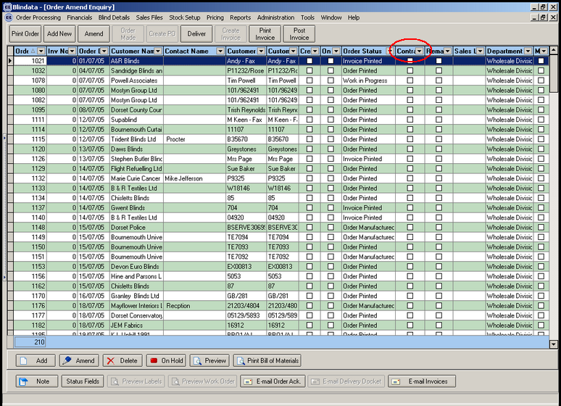

797. Logging Out

Sometimes people accidently click the x in the top right of the screen instead of the x on the form window. This means they are logged out immediately. If the x on the very top right is clicked, a message should appear saying ‘Do you want to log out?’.

798. Administration > Import from Excel > Fabrics

We need a new column in the spreadsheet, called cost price discount %. This field will get updated to cost discount in the fabrics table.

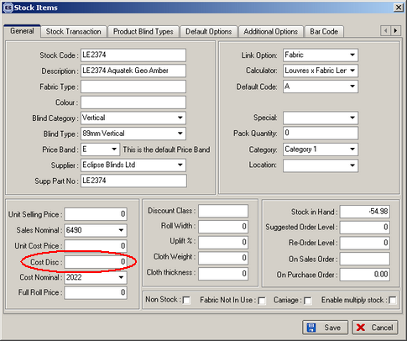

800. Order Processing > Fitters Sheet / Sales Leads

When a sales lead is converted to an order, there are occasions when the fitter and date of the fitting are not known. We need a new field in this form that says ‘Fitting details’. It should be placed in the highlighted area, should be a true/false flag and should default to Yes. If it is changed to No, then the sales lead is updated to an order but the fitter and fitting date is not updated.

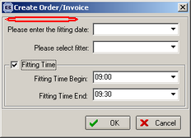

814. Order Processing > Order Enquiry > Order In Stock

When we choose the "Order Out of Stock" Option on this screen it changes the status automatically back from "Work In Progress" to Works Order Printed", what we would like to do is when we choose the option "Order In Stock" it will automatically change the status forward to "Work In Progress", what is happening currently is we have to choose the Option "Order In Stock" and then choose the option "WIP Order Scan", we would like not to have this as a 2 step process to release the Order back into manufacturing but a 1 stage process.

820. Fitters Sheet / Sales Lead

When you add a new appointment on the diary system and hit the refresh button to update the appointments it wipes everything off the diary screen, you have to exit the form, then go back in and the appointments are back on the screen.

There is still a problem with the refresh for fitting appointments. The same problem occurs if you refresh immediately after a fitting appointment has been made when converting a sales lead to an order.

Also, when the sales lead screen is refreshed, it displays from 8am when it should display from 9am.

Pavel

New Work and Customer Requests

136. Option Pricing

We need an extra way of pricing an option. Here is an example of how the customer wants it to work:

Roman blinds – cream or white linings. These are priced like this:

Width = 1500 Drop = 1000

Drop 1000 + 750 (for turnings and pockets) = 1750.
Widths are multiples of 1370, this blind requires 2 widths
Lining = 1750 * 2 = 3500, rounds to 4m. The price per metre is 6.50.
Therefore option price is 4 * 6.50 = 26.00.

We need to hold a width multiple – this means we can work out how many widths are require. In the example above, the blind has a width of 1500, but the lining width used is only 1370, so we need two widths of lining.

We also need to hold an amount that will get added to the drop. The result is (drop + add on). We then multiply this by the number of widths required and this should then be rounded up to the next whole metre.

A new table is required, which should hold blind type, fabric code (option), width multiple, drop add on and price per metre. In the above example, width multiple = 1370, drop add on = 750mm, price per metre = 6.50).

The form for this table should be in Pricing and should be called ‘Option Price Per Metre’.

This option price should be looked for at the same time as other option prices are found in the order entry program. If there is a price for an option in this table, it will supersede all other prices found for this option (but in reality there won’t be any).

