Blindata Release Note 2.5.4 

02 December 2005

Bug Fixes and Enhancements

715. Order Processing > Orders > Option Choice

A major improvement has been made to the order detail line entry. We now have a method of restricting option choices when entering a detail line, depending on what other choices have been made.

For example, in a roller blind detail line, when a turret finish is chosen, the choice of poles should be restricted to only a few options (and not all that would normally be available).

To set this up, the following must be done. In Blind Details > Blind Types, there is a new field called Option Config. This must be ticked if you want the option restrictions to apply to a blind type.

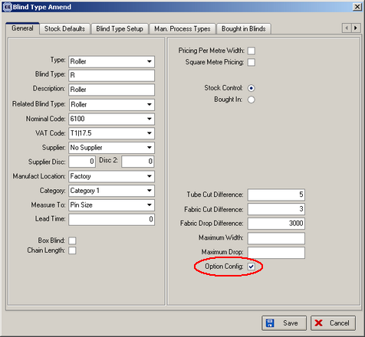

We must now record the options and the restrictions you want to place on these options. This is done in Blind Details > Blind Types Options > Link Options tab.

In here you can set the following fields:

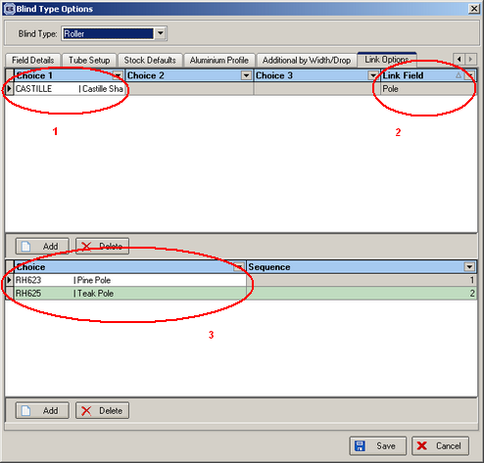

We have selected blind type = roller and the following fields have been set up:

- Choice 1 has been filled in as “Castille”. Up to three choices can be selected.
- The link field has been set to “Pole”. This means that if Castille is chosen as one of the options in the detail entry, the Pole option will be restricted to the choices that are set up in 3.

So when we now enter a detail line for a roller blind, if a Castille shape is selected, the Pole options are restricted to the two that have been set up.

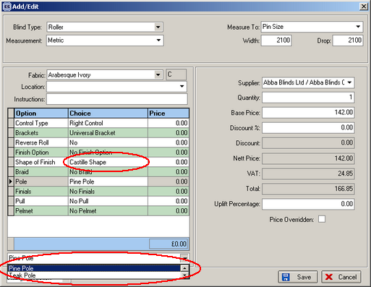

795. Reports > Credit Letters

This routine is now working properly. There are four letters:

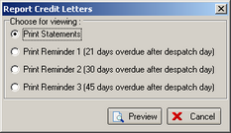

- Print Statements
- Print Reminder 1
- Print Reminder 2
- Print Reminder 3

The purpose of these letters is to get retail customers to pay their outstanding bills. The functionality works as follows.

- Statements are printed. This report prints out a letter for each retail order that has a despatch date, but has not had a previous statement, reminder letter 1, reminder letter 2 or reminder letter 3 printed. The text on the letter is taken from Administration > Parameters > Credit Letters > Statement Text.
- Print reminder 1 is printed. This prints out a letter for each retail order that has a despatch date, has had a statement printed, but not a reminder letter 1, 2 or 3. The despatch date must be at least 21 days ago.
- Print reminder 2 is printed. This prints out a letter for each retail order that has a despatch date, has had a statement printed, a reminder letter 1 printed, but not a reminder letter 2 or 3. The despatch date must be at least 30 days ago.
- Print reminder 3 is printed. This prints out a letter for each retail order that has a despatch date, has had a statement printed, a reminder letter 1 and 2 printed, but not a reminder letter 3. The despatch date must be at least 45 days ago.

802. Administration > Users

When you delete a user, a warning is now given if the user record is related to any orders.

806. Order Processing > Production Documentation

The works order label now shows the details of all blinds on an order even if only certain blinds from that order are included in the production documentation run. This includes both the ‘2 L89, 3 V25’ style text field and also the ‘1 of 5’ type.

809. Works Order Label Blind Size

The total fabric metreage now appears on the big label for vertical and vanes only blinds, to the right of vane length.

810. Invoice – Sage Laser Print

- We now display the customer order no. as well as the order number in the order number box. The fields between the fields and display like this: Order id / Customer Order No.
- We now display the telephone and fax number from Company Details form below the company address.

New Work and Customer Requests

10. Discount report by department

There is a new report, called Discount Report by Department, in Reports > Financial Reports.

74. Order Processing > Orders > Roller Fabric Message

When entering a roller blind detail line in an order, the rules for the messages have been changed to the following:

Turnable fabric (calculator = width or drop): if width and (drop + fabric drop difference) are both greater than the roll width, a message appears saying ‘Both blind width and drop are greater than roll width, therefore a join in the fabric will be required. Please contact the customer to ensure this is acceptable.’.

Non turnable fabric (calculator = width): if (drop + fabric drop difference) is greater than the roll width, a message appears saying ‘Blind drop is greater than roll width, therefore a join in the fabric will be required. Please contact the customer to ensure this is acceptable.’.

Non turnable fabric (calculator = drop): if width is greater than the roll width, a message appears saying ‘Blind width is greater than roll width so this blind cannot be made with this fabric. Please contact the customer.’.

A message will not appear to say that a fabric has to be turned – the software will work this out.

118. Appointment Bonus System

Operators can get a bonus depending on whether an appointment is taken or not and if an appointment is turned into an order. The bonuses are:

For booking an appointment for a new customer £2.00
For an order (new or existing customer) £2.00

The customer needn’t have paid, but the appointment must have taken place.

The report is in Reports > Financial Reports > Appointment Bonus System.

