Blindata Release Note 2.5.1 

25 November 2005

Bug Fixes and Enhancements

592. Administration > Users > Quality Control permissions

Advanced permissions are now working on the Quality Control form so that users can view this option but not quality check blinds.

We have a new option set up in Administration > Users > Advanced Permissions so that a user can edit the Quality Control screen. This controls whether a user can update quality control or not.

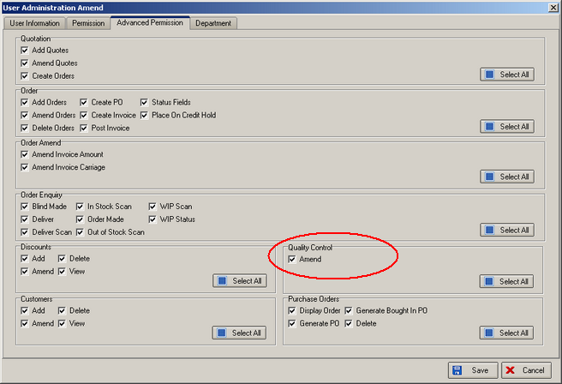

624. Financials > Post Invoices

Total figures are now printed at the bottom of the columns on the posted invoices report. This report prints out when Administration > Parameters > Use Sage Line 100 is switched on.

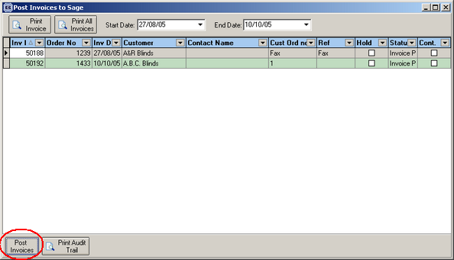

757. Order Processing > Production Documentation

The order status of an order now remains as “order entered” until every detail line label has been printed, and when the last detail line label is printed then the Order Status changes to Works Order Printed. This means the function looks at the order detail table as well as the order table. The status of the detail line changes from ‘Order Entered’ (code 0) to ‘Awaiting Manufacture’ (code 1) when the works order for that detail line is printed.

If a detail line is added to an order after the status of the whole order has changed to ‘Order Printed’, this status changes back to ‘Order Entered’.

We have also added an option ‘Exclude Orders on Credit Hold’ from the Production Documentation form.

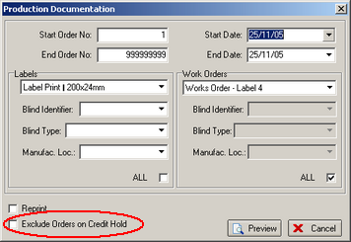

773. Login

A user is now stopped from logging on if the client PC is at a different release level to the database. A message appears saying ‘Please update Blindata to the correct version’, and the program closes.

783. Sales Lead / Fitters Sheet Individual Extra

There is a new sales lead report which also shows all the new information we have entered about enquiry type etc. This report can be set up in Administration > Parameters > Reports > Sales Lead / Fitter Sheet – Individual.

784. Sales Lead / Fitters Sheet Full > Rep/Fitters Sheet 10

There is a new version of this report, called Rep/Fitters Sheet 10, which will print up to 10 appointments on one page. This report can be set up in Administration > Parameters > Reports > Sales Lead / Fitter Sheet – Full.

785. Sales Lead Screen

It is now possible to define a background colour for an appointment, by clicking on ‘Change Colour of Appointment’ on the Sales Lead / Fitters Sheet screen.

786. Reports > Financial Reports > Deposits by Nominal Report

We are now able to distinguish between deposits and balances in the receipts records. There is a new field in Administration > System Tables > Receipt Description that flags a record as a deposit. This field is called ‘Deposit’.

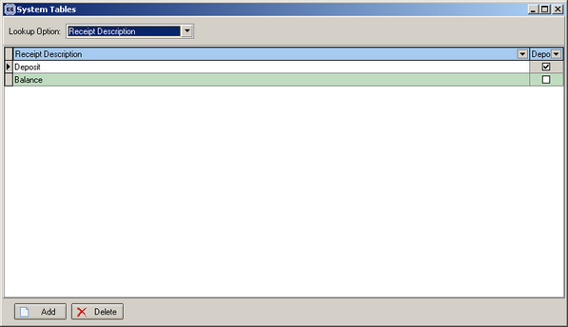

The Deposits by Nominal report now works. It itemises by nominal code (taken from the blind type in the detail line) the deposits that have been paid against an order.

787. Reports > Financial Reports > Balances by Nominal Report

This now works. It itemises by nominal code (taken from the blind type in the detail line) the balances (ie not deposits) that have been paid against an order.

790. Orders > Order Enquiry

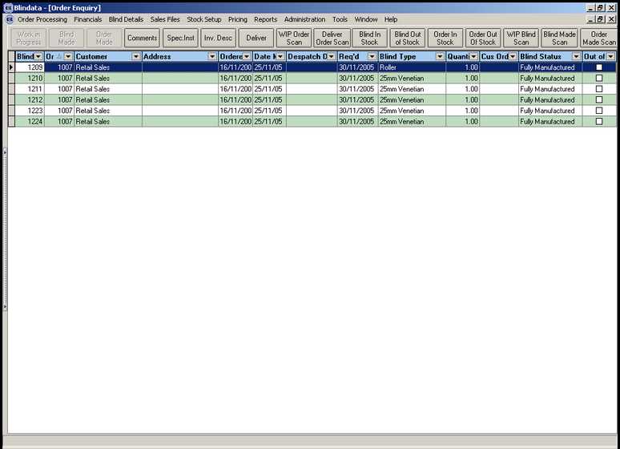

We have:

- Changed button description from WIP Scan to be WIP Order Scan.

- Added another button called WIP Blind Scan which changes the status of the individual detail lines to “Work In Progress”. The order status remains as “Works Order Printed” until every detail line status has been changed to “Work In Progress”, then the Order Status changes to “Work In Progress”.

- Added another button called Blind Made Scan which changes the status of the individual detail lines to “Blind Manufactured”. The order status remains as “Work In Progress” until every detail line status has been changed to “Blind Manufactured”. When the last detail line status is changed to “Blind Manufactured”, the Order Status changes to “Order Manufactured”.

- Added another button called Order Made Scan which when you scan one of the detail lines it changes the Order and Detail Line status’ to Order Manufactured.

- Changed button description from Deliver Scan to be Deliver Order Scan.

- Changed button description from Deliver Scan to be Deliver Order Scan.

- Changed button description from In Stock to be Blind In Stock.

- Changed button description from Out of Stock to be Blind Out of Stock.

- Changed button description from All In Stock to be Order In Stock.

- Changed button description from All Out of Stock to be Order Out of Stock.

791. Order Processing > Orders

When you are entering a new order and you want to enter a fitter date and time, you can now enter the start and end time without having to save the order and then go back into that order.

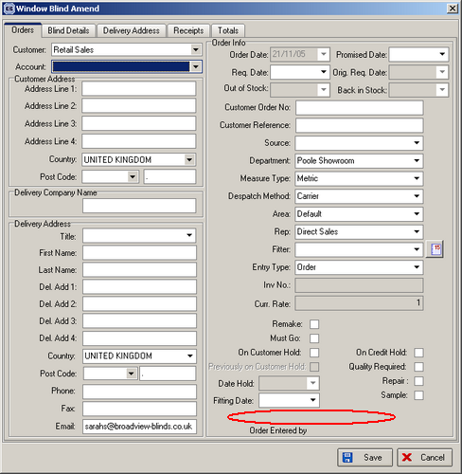

794. Sales Lead General Report

The text was overlapping. Also, we have removed ‘Balance’ from the sales lead. It only appears if it is a fitting.

New Work and Customer Requests

117. Rep/Fitter Commission Report

It is now possible to generate a commission report. This is based on a percentage of the selling price (ex. VAT) of the order. The percentage commission depends on whether the order has been discounted or not.

We now hold extra information against the rep/fitter: the discount % cut off point, the commission % for sales above the cut off, and the commission % for sales below the cutoff.

Commission is only calculated for orders where balance = 0.

There are two reports: rep commission report and fitter commission report. If all employees are both rep and fitter, only one report is required.

There may also be orders where bad mistakes have been made, so the commission has to be reduced or not paid at all. There is a method of overriding the commission % amounts that are held against the order. There is a new true/false field in the order table which can be flagged if commission is not to be paid. It is updateable in the Totals tab of the order and defaults to false.

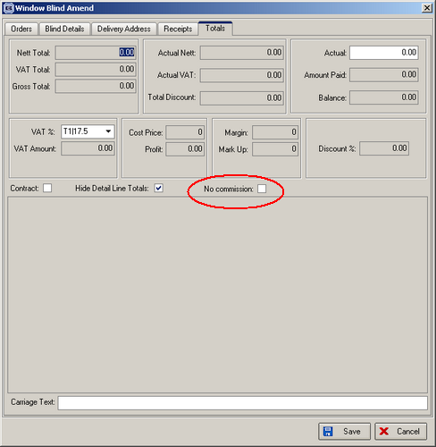

The reports are in Reports > Financials, and are grouped by rep/fitter, and should show the following:

The algorithm of this functionality is as follows:

- Fields Disc Point, Comm 1 (the commission % for sales below the cutoff), Comm 2 (the commission % for sales above the cutoff) are filled for employees in Employee table.
- Rep and/or Fitter is assigned to the order, and the client’s payments are added there.
- If ‘Fitters Are Also Rep’ parameter is off, then there will be two new reports on the form Reports > Financials Report: Rep Commission Report and Fitter Commission Report, if this parameter is on, there will be only one report there: Rep Commission Report.
- Before generating one of these reports, the user will need to select Start Paid Date and End Paid Date.

The report will select all orders, which meet the following criteria:

- A fitter or Rep is assigned to the order (depending on the type of the report).
- The Order Status is not Cancelled.
- There is at least one receipt, and the date of the last payment is within the time interval specified by the user before generating the report (Start Paid Date and End Paid Date).
- The balance is 0.
- The discount percent for the order is > 0.
- “No Commission” flag is not checked on Totals tab in the order.

Commission % is taken from the fields Comm 1 or Comm 2 of Employee system table depending on the discount percent in the order, after that it calculates the Commission amount.

