Blindata Release Note 2.5.0 

18 November 2005

Bug Fixes and Enhancements

765. Administration > Users > Permissions

The option 'Component Price Table' was missing from permissions – it is now there.

769. Order Processing > Sales Leads / Fitters Sheet

It is now possible to flag an employee record to say whether they should appear on the diary or not. This means we do not have to display all employees in the diary, so saving space on the diary screen.

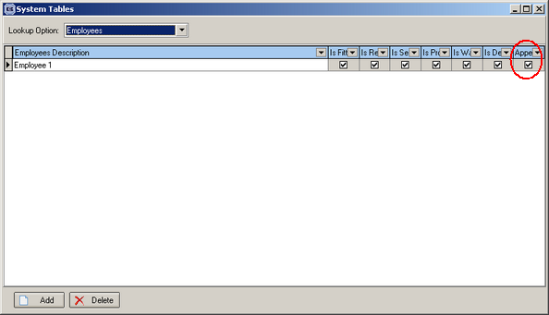

770. Order Processing > Quotations

When you want to convert a quote to an order, when you click on create order instead of stating ‘A new order has been created’, it states ‘Order <number> has been created’.

771. Stock Setup > Suppliers

When you go to add a supplier, the supplier window now comes up in the middle of the screen.

772. Order Processing > Orders

An error occurred when you tried to copy a detail line. Fixed.

774. Reports > Lead Times

Timeout errors were occurring when running the report by status. Fixed.

782. Administration > Users

There was an error when copying a user profile. This has been fixed.

New Work and Customer Requests

