Blindata Release Note 2.4.6 

8 November 2005

Bug Fixes and Enhancements

737. Works Order Label Blind Size

If an order has been entered as metric, and the works order prints out as blind size metric and imperial, the imperial size now prints out as a fraction instead of decimal places: 47 ¼ instead of 47.24 (it rounds to the nearest 1/8 inch).

738. Backup

It is now possible to define the folder where the backup is stored. Previously the backup went to to c:\program files\Microsoft SQL Server\MSSQL\data. Now you have a choice.

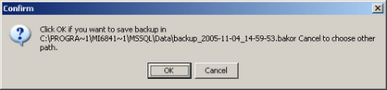

754. Works Order Label Blind Size

There is a new calculation on the big label, for vertical blind identifiers and vanes only identifiers only. It is called ‘Vane Length’ and goes below ‘Fabric Cut’. The calculation is:

Vane Length = Man Drop – Headrail Depth.

756. Order Processing > Orders > Detail Line Entry > Chain Length

The chain length has been moved to below drop.

New Work and Customer Requests

