Blindata Release Note 2.3.2 

26 September 2005

Bug Fixes and Enhancements

619. Work Order Label 1

There is now an option to print two labels per page or three labels per page.

642. Reports > Lead Times

There are now extra options to exclude ‘on customer hold’ and ‘on credit hold’ records. Also the lead time days is now calculated as follows:

Manufacturing Date – from order date to manufactured date
Delivery date – from order date to delivery (despatch) date
Invoice date – from order date to invoice date

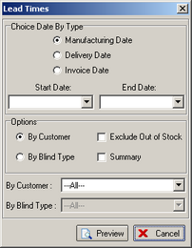

644. Reports > Credit Letters

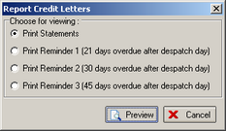

The rules are now as follows:

Print Statement – prints out if order has a despatch date, is at least status despatched and there is an outstanding balance. It must also be a retail sale.

646. Order Processing > Receipts

There was nothing appearing in the field receipt description when you tried to enter a receipt for an order, although there were records in the receipt description table. Fixed.

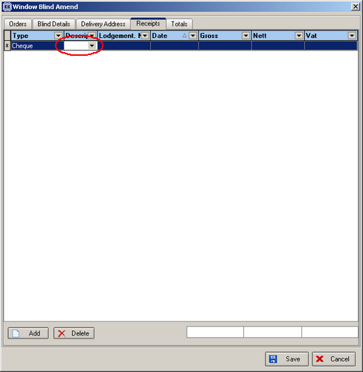

648. Delivery Docket – Laser Print (Letterhead Logo)

The report now says when it should say ‘Delivery Docket’ instead of ‘Order Acknowledgement’. Despatch date is now printing.

649. Individual Works Orders

There is a new works order label print report, which only prints one detail line per A4 page.

650. Order Processing Speed Issues

The order detail line entry has been speeded up in two places:

1. When choosing the Fabric, to then pull up the default options.
2. Tabbing down from the Fabric field to the location field.

New Work and Customer Requests

