Blindata Release Note 2.2.6 

2 September 2005

In this release the speed of the order entry form has been improved at the point where the detail line entry form is opened. The cancel process has also been optimized.

Bug Fixes and Enhancements

560. Order Processing > Fitters Sheet/Sales Lead > General Report

The rectangles on this report have been reformatted so the sales leads are easier to read.

568. Pricing > Discounts > Amend

Sort order now correct when sort on Customer / Account Code / Blindtype columns.

571. Stock Item > Amend > Product Blind Types

Sort order is now correct when sorting by Blind Type.

573. Order Processing > Order Enquiry > Blind Made / Order Made

"Stock in Hand" and "On Sales Order" quantities are now being reduced when blind is manufactured. Previously the figures are only reduced when ‘Order Made’ is done.

574. Purchase Order Regular – Standard

Now printing properly.

604. Works Order Label 1 / Order acknowledgement

The repair instructions now prints on the ticket and the order acknowledgement.

606. Repairs entry

You can now enter repairs at a nett price of Zero – previously it gave an error message.

609. Invoice - Laser Print (Letterhead)

For Velux blinds, Velux Code prints instead of Width/Drop.

610. Works Order - Label 2

For Velux blinds, Velux Code prints on largest (bottom left) works order label. Also, Velux code has been moved so that it prints above 'location' on the 2 small labels.

611. Works Order - Label 2

On Works Orders for Blind identifiers 'L' and 'O' the 'Operator' was overlaying the 'Drop' measurement and obscuring it. Fixed.

612. Purchase Order Bought In - Department

Drop measurement was truncating when purchase order was converted from imperial to metric. Width and drop are now rounded to nearest whole mm to prevent this truncation.

620. Stock Setup > Stock Items

When the stock items screen is displayed, the default code did not get shown. Fixed.

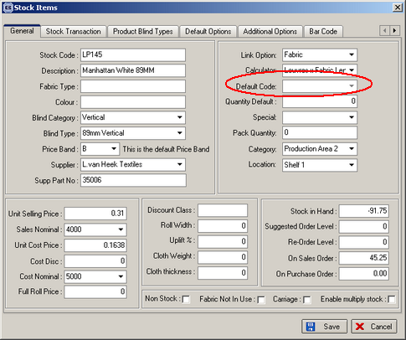

New Work and Customer Requests

