Blindata Release Note 2.2.1 

15 August 2005

Bug Fixes and Enhancements

553. Order Processing > Orders

There was a problem when you override the actual price in the totals tab for a trade order. Example:

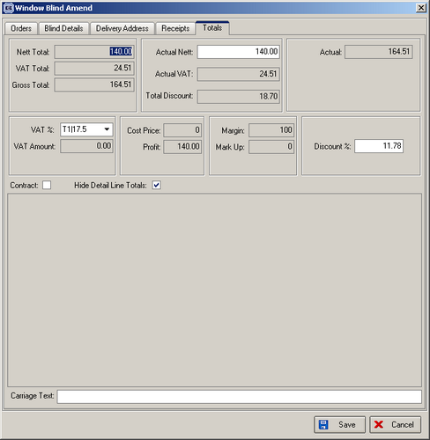

In this example, the actual total has been changed to 140.00. This means the detail line calculations can have rounding errors of 0.01. The program now adds or deducts 0.01 to the last detail line to make sure the detail lines add up to be the same as the actual amount.
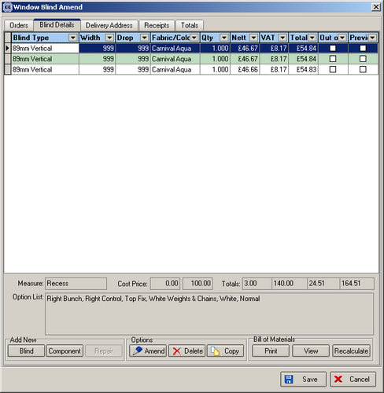

554. Stock Setup > Purchase Order Enquiry > Generate Bought In PO

‘Send Email' button has been activated.

555. Purchase Order Bought In (Department)

Measurements on this purchase order are now printed in metric even if the sales order has been entered in imperial.

561. Order Processing > Orders

After entering new customer, account code now appears on order entry immediately.

578. Invoice – Bespoke 1

Order acknowledgements and invoices were printing out without any invoice addresses. Temporary bug, introduced in 2.2.0 – now fixed.

New Work and Customer Requests

