Blindata Release Note 2.0.7-2.1.0 

19 July 2005

Bug Fixes and Enhancements

494. Order Processing > Orders

If an operator amends the required date to be a date prior to today’s date, then a warning message appears stating that the required date is in the past. The message says ‘You have entered a required date prior to the current date’. This will only happen if the operator has amended the required date, NOT if the order is just amended.

498. Order Processing > Orders

If you flag an order detail line as Out Of Stock, and then the sales order operator changes the fabric, reprint and re-releases the works orders, the system automatically unflags it from Out Of Stock and treats it as a 'PREVIOUSLY OUT OF STOCK' order.

502. Financials > Post Credits to Sage

Credit notes that had been validated are actually getting updated to Sage as full credit notes (as if ‘Post Full Invoice to Sage’ was switched on). If this is not switched on, the credit notes are now posted directly to the sales ledger.

504. Order Processing > Orders

Credit control is now working properly if Sage Line 50 is being used.

507. Financials > Invoice Print and Post

Orders with ‘Despatched’ status now appear on this screen.

509. Financials > Invoice Batch Print > Invoice – Laser Print (Letterhead)

The batch print was only printing out one invoice when there may be many more. This has been fixed.

510. Invoice – Laser Print (Letterhead)

The spaces in addresses were still being left on the invoice. This has been fixed.

514. Order Processing > Orders
The following error occurred when you try to copy a detail line. Now fixed.
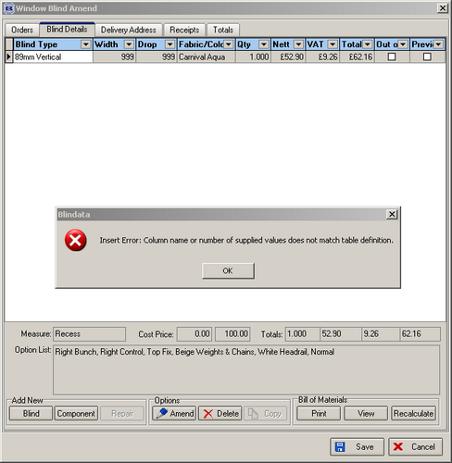
515. Acknowledgement – Laser Print

The name of the company rather than the name of the contact now appears on the delivery address on the Order Acknowledgement

516. Financials > Post Credits to Sage > Posted Credits Report

The Posted Credits report is now sorted by Acc Ref, the customer field extended so it does not run into the cust order no and other fields.

517. Order Processing > Credits

‘Sample’ no longer appears on the credit entry.

518 Stock Setup > Purchase Order Enquiry > Generate Bought In PO :

The "Purchase Order Bought In (Department)" print out was not picking up the correct Sales Order number in the right hand column. Fixed.

519. Stock Setup > Purchase Order Enquiry > Generate Bought In PO

Purchase orders no longer get generated for sales orders that are on customer hold..

520. Order Processing > Orders
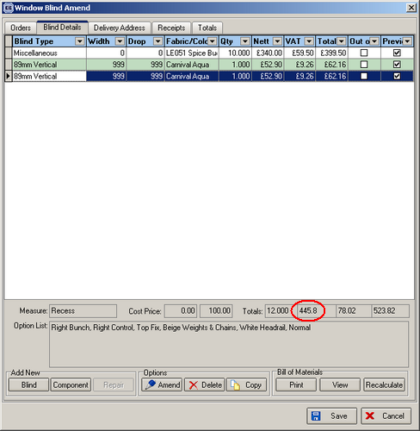
This figure now display to 2 decimal places.
522. Order Processing > Orders
When you try to add a new order, credit or quote the following message appeared. Now fixed.
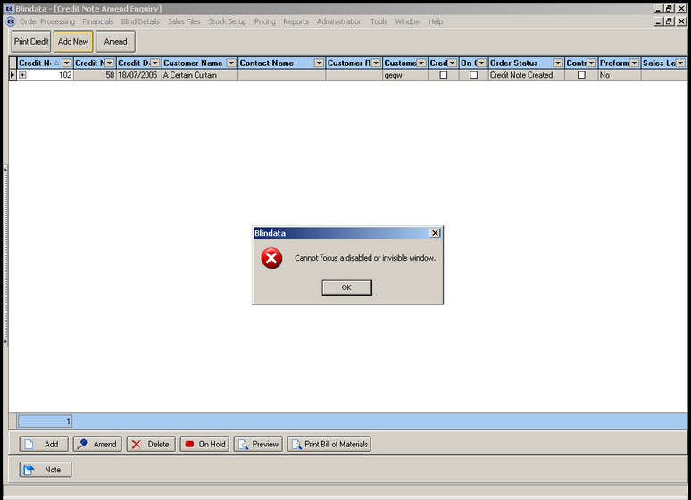
523. Administration > Export Data > Sales Invoice
The message now says ‘Data has been successfully exported’.
The sales invoice option now export records with status ‘Invoice Created’, ‘Invoice Printed’ and ‘Invoice Posted’.
527. Order Processing > Production Documentation

If you print a batch of works orders from here, the order status changed to ‘Order Printed’. If an order is ‘On Customer Hold’, it did not get printed, but the status still changed to ‘Order Printed’. This has been fixed.

529. Purchase Order Bought In (Department)

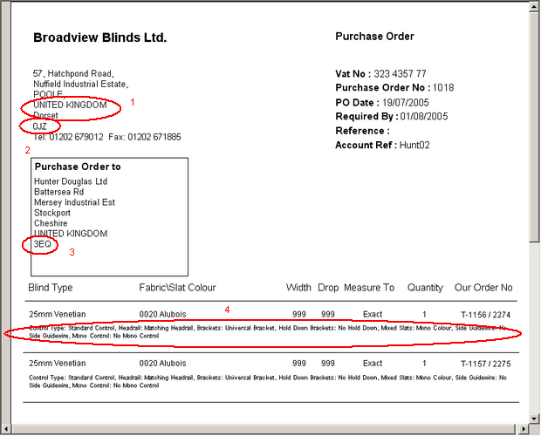

- These two fields were the wrong way round. Only the second half of the postcode is showing. It should be ‘BH17 0JZ’.
- Only the second half of the postcode was showing.
- Only the second half of the postcode was showing.
- The font is now bigger.

New Work and Customer Requests

86. Administration > Export Data

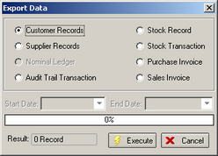

There is a new option that exports sales invoices to an Excel spreadsheet. There is an option to choose and start and end invoice date. The fields exported are order number, invoice number, customer, invoice date, customer reference, actual nett amount, actual VAT amount, actual total. The export file is called ‘Sales Invoices’.

90. Sample Flag

There is a new flag on the order table for "Sample" similar to the "Customer Hold" flag. This is a true/false tick box. The works order label says "SAMPLE" similar to "REMAKE" in exactly the same position. Flagging as a Sample has no Effect on the lead time calculation.

92. Order Processing > Must Go Function

If the Must Go Option is selected it now has no effect on the required date.

104. Administration > Parameters

There is a new parameter to allow Sage transaction details to taken from the 'Customer Order No' field instead of Customer Reference.

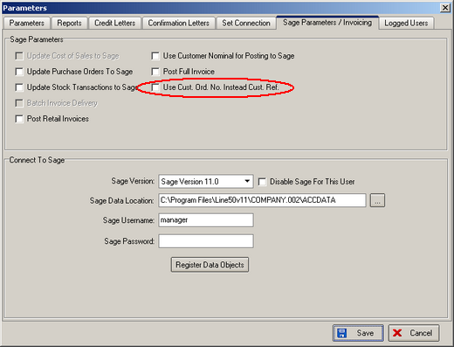

105. Works Order – Label 2

1) Removed 'Measure To:'
2) Removed 'No. of Vanes' from vertical blinds works orders.

