Blindata Release Note 2.0.4 

21 June 2005

Bug Fixes and Enhancements

483. Financials > Invoice Batch Print

When batch printing report ‘Invoice Laser Print (Letterhead), double the correct number of detail lines were printing on the invoices. Fixed.

490. Reports > Cancelled Orders

The report now includes who cancelled the order.

491. Blind Details > Blind Type Options

It is no longer possible to delete a blind type option here by using the delete key.

492. Order Processing > Orders

After you enter and save an order detail line for a bought in blind, the supplier can now be changed. It is possible to change the supplier until the purchase order has been generated.

495. Invoice Laser Print (Letterhead Logo)

There is a new invoice print, based on the ’11 detail lines’ layout but with the logo in place.
496. Invoice Laser Print 11 Detail Lines

This layout is now available in Administration > Parameters > Reports > Batched Invoice

New Work and Customer Requests

83. Order Processing > Orders > Detail Line Entry

There is a new field in the order detail table called ‘Fitting Instructions’.
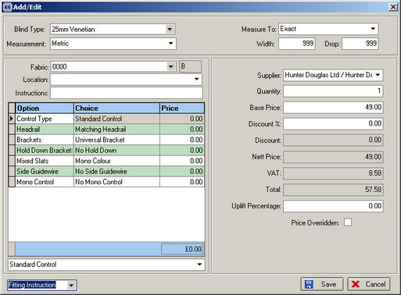

93. Administration > Import from Excel > Import Slat Tables

There are two new import options in Administration > Import from Excel that will allow the importing of vertical single/split bunch slats and also Venetian/pleated tables. The layout of the tables is as follows:

Vertical slats:

Slat table description, Width , Number of vanes, Single/split (True/False)

Venetian/Pleated:

Slat table description, Drop, Number of slats/pleats

94. Purchase Order Bought In (Department) Report

There is a new bought in purchase order layout – called ‘Purchase Order Bought In (Department). It is the same as the existing report except:

- Department appears in front of order number.
- Cost price does not display.

99. Order Processing > Production List

There is a new production list report called Production List Summary Preview by Manufacturing Location. This is similar to the current Production List Summary Preview Report but grouped by the Manufacturing Location with totals for each manufacturing location.

100. Order Processing > Production List

There is a new production list report called Production List Summary Preview by Required Date by Manufacturing Location. This is similar to the current Production List Summary Preview by Required Date Report but grouped by the Manufacturing Location with totals for each manufacturing location.

