Blindata Release Note 2.0.3 

21 June 2005

Bug Fixes and Enhancements

478. Invoice by Nominal Report

A report is now in Reports > Financial Reports that shows the following:

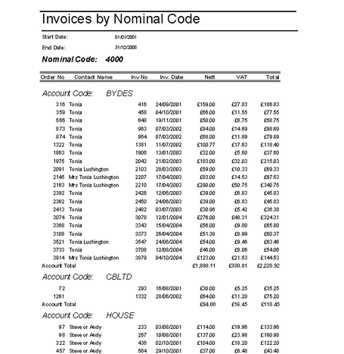

481. Order Processing > Orders

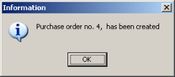

When creating a purchase order, the message no longer has a comma in the middle.

485. Financials > Post Credits to Sage

Audit Trail now shows credit transaction type as 'SC' . Text says 'credit notes' instead of 'invoices' where appropriate.

'Run Validation' screen text says 'credit notes' not 'invoices' where appropriate.

486. Credit Note (Letterhead)

This has exactly the same layout as ‘Invoice – Laser Print (Letterhead)’, but says Credit Note.

487. Works Order – Label 2

Blind Identifier string on large label now includes all of the following: A,C,H,L,M,O,P,R,V,X,E,W,B.

On works orders for blind identifier 'E', the following text is now below 'Height' :
" Date/Ord.No of Fabric: Date/Ord.No of H.ware: Date cover made: "

New Work and Customer Requests

62. Blind Details > Blind Types

Velux blinds – we can now show the following fields on a ‘Velux’ blind type:

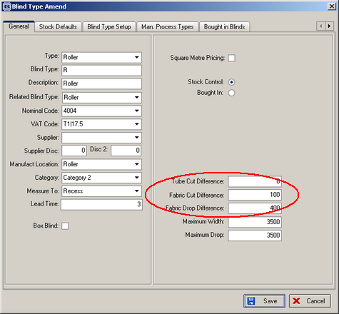

63. Works Order – Label 1 (Client 1757)

Roller and Velux blinds now show fabric cut size on works order label 1 (width and drop). The fabric cut size is calculated as follows:

Blind size width – fabric cut difference (dim_rfabcutdiff)= fabric cut width
Blind size drop + fabric drop difference (rrolladddiff)= fabric cut drop.

