Blindata Release Note 1.9.8-9 

13 June 2005

Bug Fixes and Enhancements

455. Invoice – Laser Print (Letterhead)

Second total no longer appears on detail line.

461. Financials > Post Credits to Sage

The audit trail now prints correctly for credit notes.

462. Financials > Complete Posting to Sage Line 100

Once Financials > Complete Posting to Sage Line 100 is run, credits now get changed to status ‘Credit Posted’ and can only be viewed in Archive Enquiry.

469. Acknowledgement Laser Print (Letterhead Logo)

The company address is now be taken from Company Details, not Department. Location is now being printed properly.

470. Works Order – Label 4

Process types have been moved up slightly as they were printing just off the bottom of the label.

471. Audit Trail Report

The following changes have been made:

The date formay is now dd/mm/yy.
Account Code, Nominal Code, Details columns have been moved slightly to the left.
Details column is now wider.
Nett price column is now slightly wider.
A smaller font has been used for all columns.

472. Acknowledgement – Laser Print (Letterhead)

The following changes have been made:

Removed company name
Moved address down a line so logo fits
Option list was missing
Number of vanes is now appearing properly for vanes only(was missing on first line)
Removed ‘Location’.

473. Works Order – Label 2
The following changes have been made:

Removed cord spacing for pleated blinds
Delivery address line 4 was missing.

474. Delivery Docket Laser Print (Letterhead)

The following changes have been made:

Right justified totals.

476. Financials > Post Invoices to Sage

The following message appeared if ‘Use Sage Line 100’ is switched on in Administration > Parameters and you tried to print an audit trail.

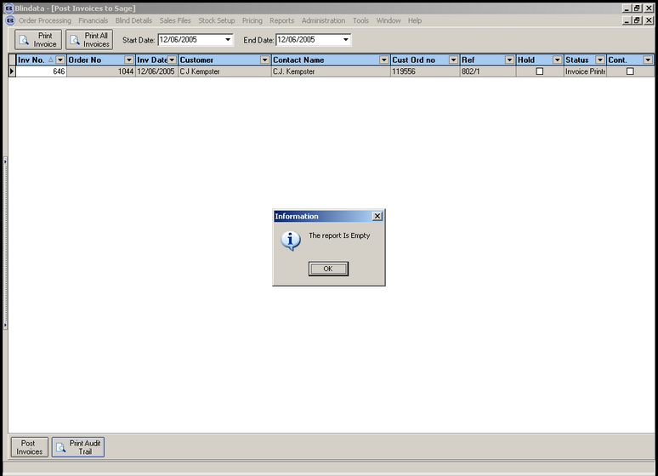

477. Audit Trail Report

The wrong nominal code was being brought up for detail lines that have been entered as components. The report was showing the nominal code from the blind type record instead of the one in the detail line. Fixed.

New Work and Customer Requests

53. Reports > Lead Times (Client 1757)

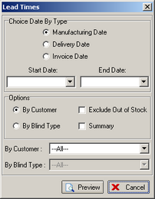

It is now possible to calculate lead times by either manufacturing date, delivery date or invoice date.

64. Order acknowledgement Laser Print (Client 1757)

Order acknowledgement option now shows option description before option choice, in the following style:

Bunch: Split, Headrail: White, Controls: Left

67. Order Processing > Orders (Client 1757)

When an order is cancelled, the system now stores the order status at the point of cancellation. This is now shown on Reports > Cancelled Orders.

73. Carriage Calculation (Client 9 & 1757)

In Administration > System Tables > Despatch Method, there is a new field called ‘Carriage Chargeable’ which defaults to True.

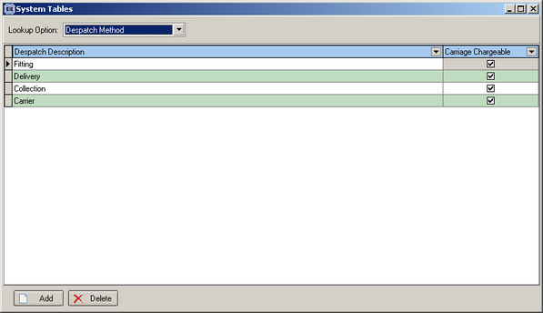

The carriage calculation routine in Financials > Create Invoices now looks at the despatch method for the order and then check whether carriage is chargeable for that order. This is in addition to all the existing rules about charging carriage.

