Blindata Release Note 1.9.6-7 

8 June 2005

Bug Fixes and Enhancements

407. Works Order – Label 4 (NEW REPORT)

There is a new works order – label, with the following changes:

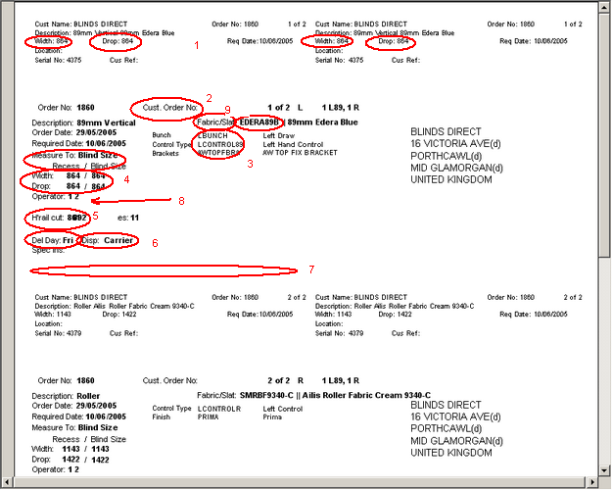

1. Width and drop on top two labels are entered size (so could be metric or imperial.
2. We have removed ‘Cust Ord No’ from the big label.
3. There are no stock codes shown for either fabric or options.
4. We only show metric blind size for both width and drop on the big label.
5. H’rail cut has been tidied up.
6. We have removed ‘Del Day’ and ‘Carrier’.
7. We have included process types.
8. Fabric cut figure prints for roller blinds (man drop + fabric drop difference)
9. We have changed ‘Fabric/Slat’ to say ‘Fabric’.

408. Order Acknowledgement (Letterhead Logo) (NEW REPORT)

We can now store a company logo in the company details table and get it to print on various reports. There is a new order acknowledgement report called Letterhead Logo.

420. Invoice Print and Post > Create Invoices

Invoices that are under £500.00 (carriage free under amount) before VAT are now being charged carriage.

421. Reports > Sales Analysis > Sales Analysis by Category

This report is now grouped properly.

429. Financials > Daily Sales Report

This report now has a column for the base currency amount and the totals are only be for the base currency column (otherwise you are potentially adding up different currencies which makes no sense).

432. Order Processing > Order Enquiry

When ‘Despatch’ is clicked (and Despatch Scan and Order Made), screen (and records) are now refreshed before you attempt to despatch the order. We needed this because a lot of orders were being taken off credit hold, but are not despatched because the system still thinks they are on credit hold, because the order enquiry screen was not being refreshed.

435. Order Processing > Orders

Occasionally an order goes on credit hold when it shouldn’t. We have tightened up the logic.

438. Order Processing > Orders

We have made printing of Works Order compulsory for orders where a blind type detail line is included. We already made a change here so that the works order print can be missed out for an order that has a component detail line. The problem is that you can have orders with blind type detail lines and component lines together. The following parameter must be switched on:

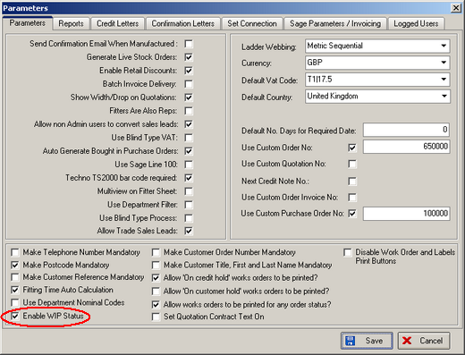

451. Order Processing > Quality Control

We no longer show records on this form if status = ‘Invoice Posted’.

452. Acknowledgement – Laser print (Letterhead)

- The totals box only appears on the last page of the report.
- We can now fit 6 detail lines on each page.

453. Works Order – Label 2

For blind identifier = ‘External’, we no longer print ‘H’rail cut’, ‘Vanes’, ‘Fabric Cut’ or ‘No of Vanes’ on any label.

Instead of using the blind type code above, we now use blind identifier i.e. 1L, 1V, 2R.

454. Delivery Docket – Laser Print (Letterhead)

This report only shows one price per detail line (base and option summed).

456. Financials > Post Invoices to Sage

The report now only shows records between the two dates on the ‘Post Invoices to Sage’ form.

There is a new button for individual Invoice Print.

We have made more space for nett, VAT, gross totals in the audit report. Large figures were being cut off.

457. Order Processing > Order Amend Enquiry

On order amend enquiry, we now display blind status and order detail id in drilldown.

In Focus – after all order amend enquiry searches, the record focus goes to the record that has been found.

458. Order Processing > Order Enquiry

Blind quantity is now on screen.

In Focus – after all order enquiry searches, the record focus goes to the record that has been found.

459. Order Processing > Archive Enquiry

We now display total number of orders on screen.

460. Order Processing > Total of Orders Outstanding Report

Live total was adding ‘on credit’ and ‘on customer hold’ twice if both are flagged. This has been fixed.

465. Order Processing > Archive Enquiry

The Must go column is now showing correct values.

466. Order Processing > Archive Enquiry

The Remake column is now showing correct values.

469. Financials > Update Invoices to Sage Line 50

When an invoice with a component line is entered, the nominal code that is used in the update to Sage is now the nominal code in the order detail line, not from the blind type code.

470. Financials > Update Invoices to Sage Line 50

Sage invoice 'details' are now the customer references from Blindata.

471. Order Processing > Archive Enquiry

Header descriptions are not showing correct text.

New Work and Customer Requests

42. Administration > Parameters (Client 9)

There is now a parameter to blank out label and works order print preview from Order amend enquiry screen.

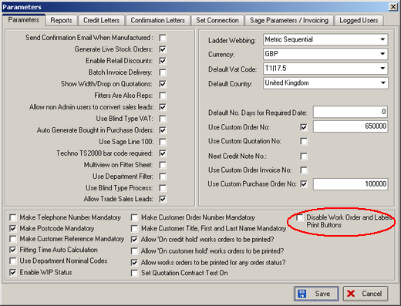

60. Number of Vanes Calculation

It is now possible to calculate number of vanes for vertical blinds based on headrail used, rather than blind type. If you want to use this method, you should set the following:

Administration > System Tables > Option Names

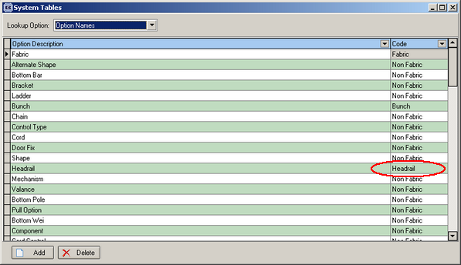

Then records must be set up that relate the slat descriptions to the vertical headrails. This is also done in Administration > System Tables > Headrail Slat Tables:

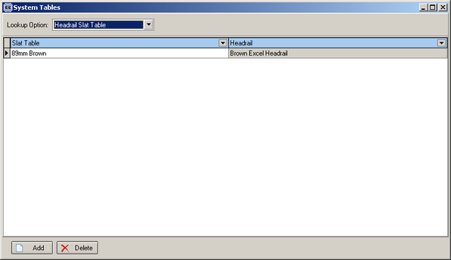

Once these records have been set up, the system will calculate the number of vanes this way, rather than from the blind type record.

